**Talend installation**

Step 1: Download the talend tool from internet. Search talent open studio in chrome browser then select first link.



Step 2: Go to the talend website then go in open source solution section and select data integration tool for windows.

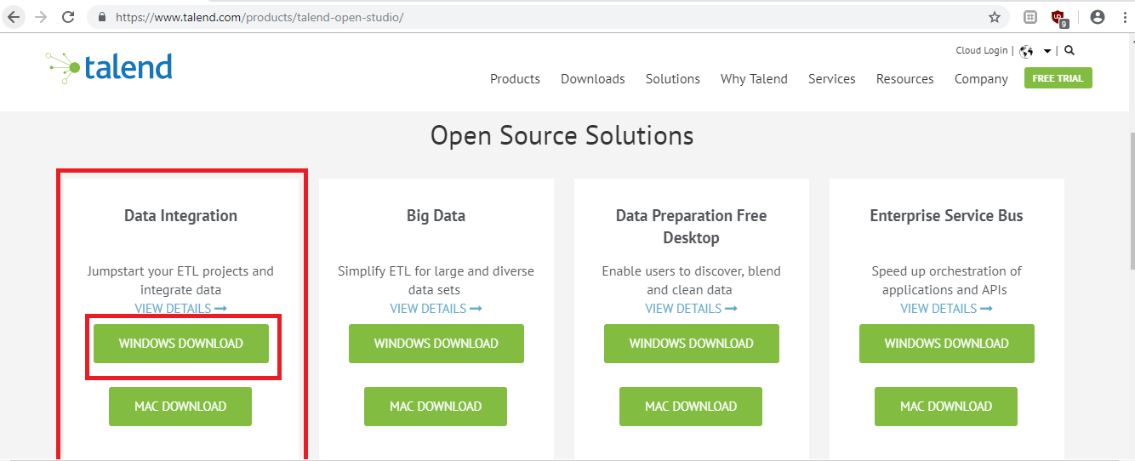

Step 3: Start downloading of talend tool.

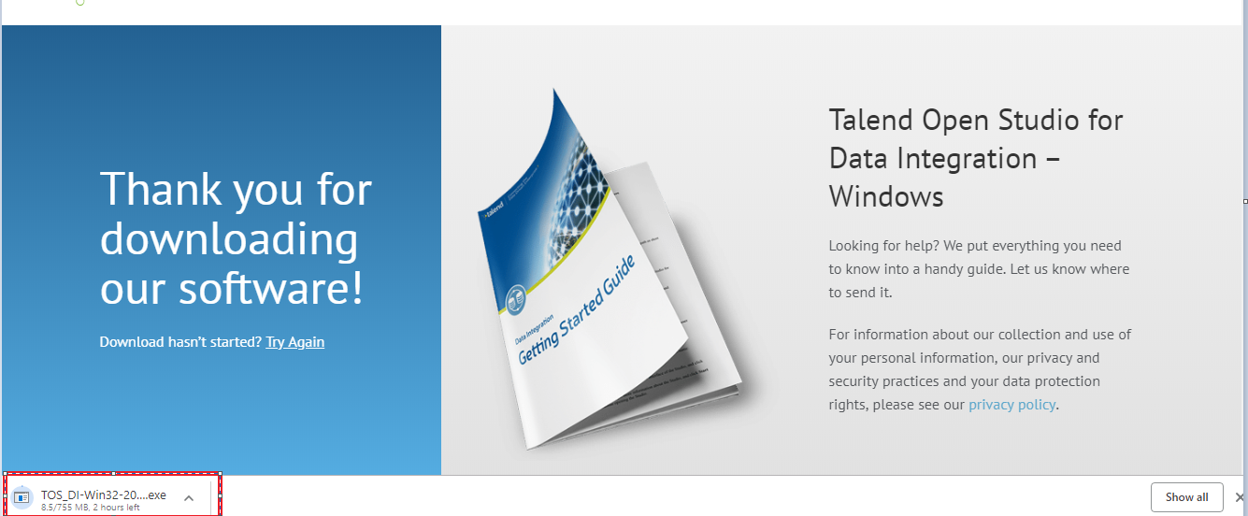

Step 4: After the downloading we execute that .exe file.

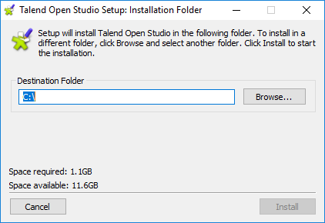

Step 5: Create the folder and browse then click on install button.

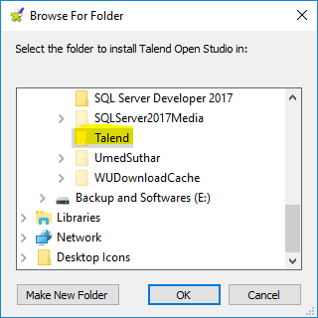

Step 6: Extracting file automatically.

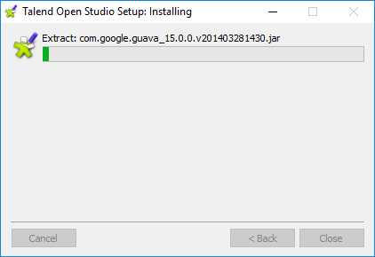

Step 7: Click on Close button.

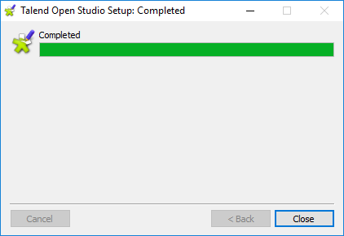

Step 8: See the setup file in destination folder.

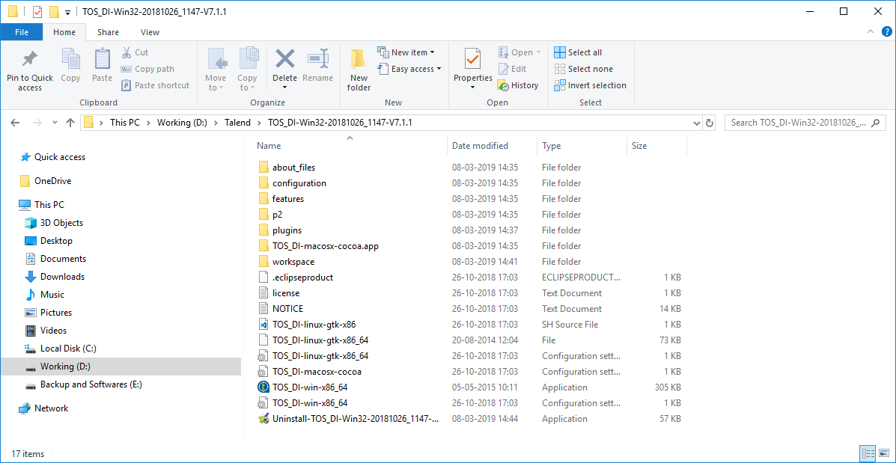

Step 9: Download the java jre from internet. Search jre download in chrome browser then select first link.

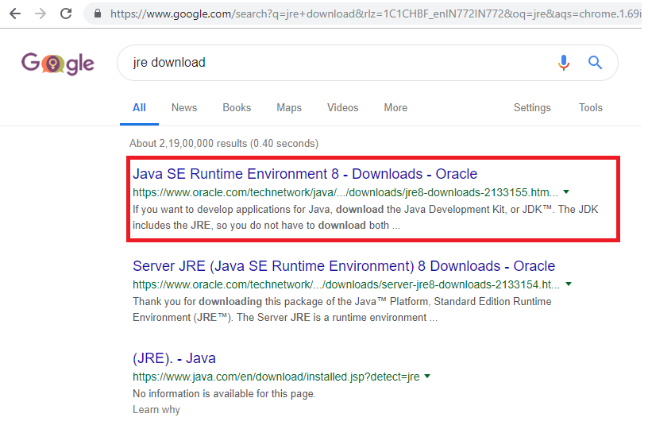

Step 10: Go to the jre website then select accept radio button then click on windows 64.exe file.

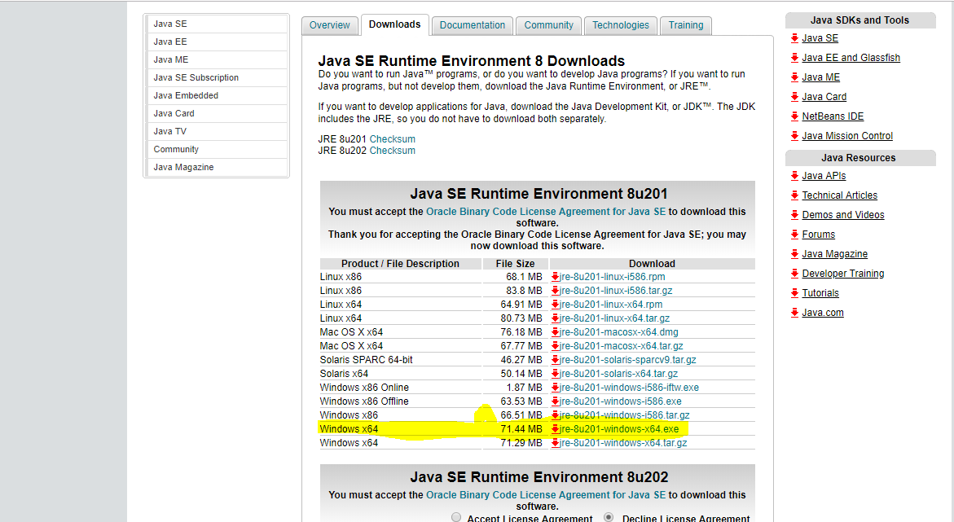

Step 11: Start jre download.

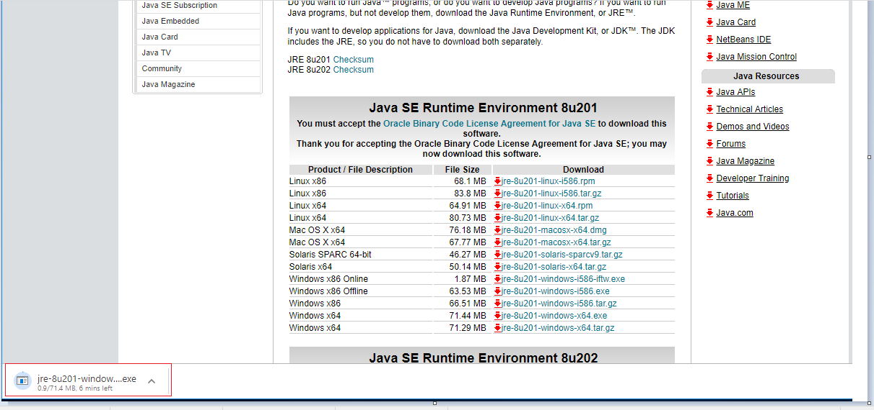

Step 12: Execute the jre.exe file. Click on install button.

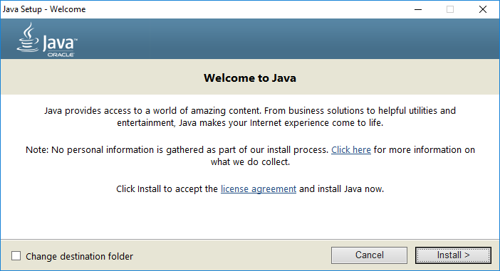

Step 13: See the installation.

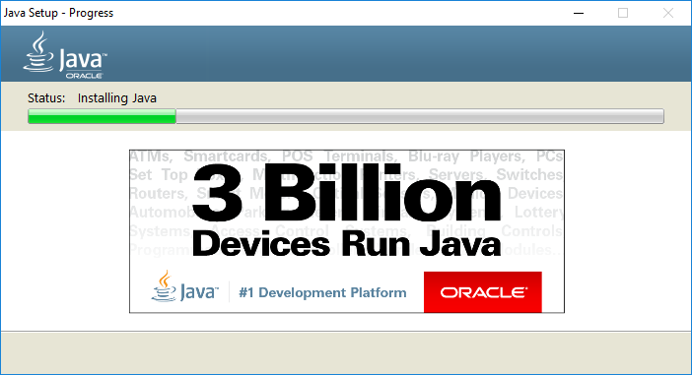

Step 14: Click on close button.

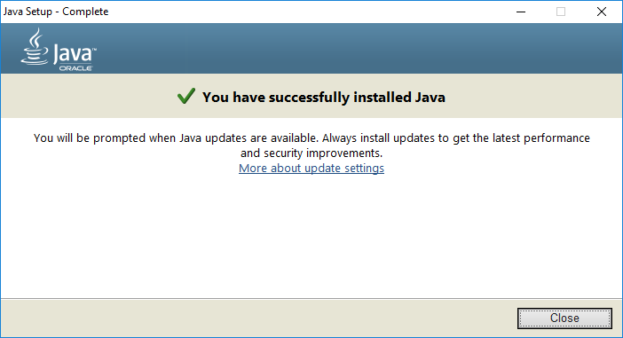

Step 15: Find the java folder.

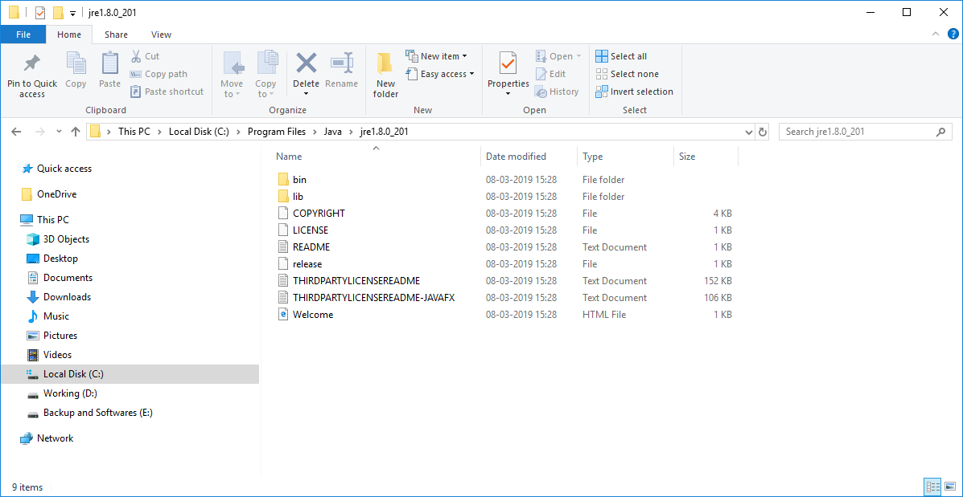

Step 16: Open start menu and type Environment Variable.

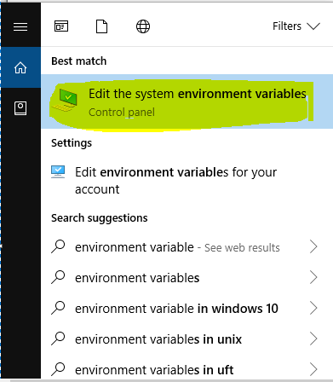

Step 17: Click on Environment variable.

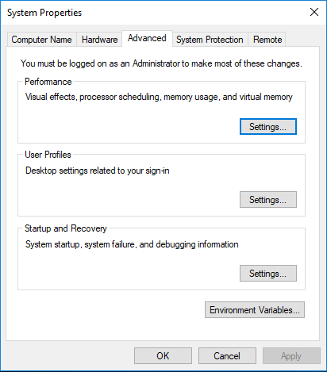

Step 18: Click on new button.

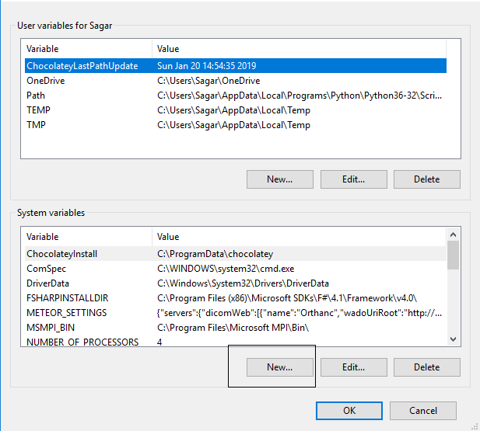

Step 19: Give name and path. Click o OK.

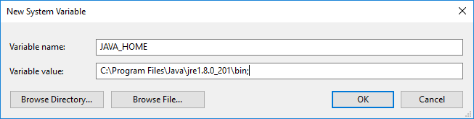

Step 20: Click on ok.

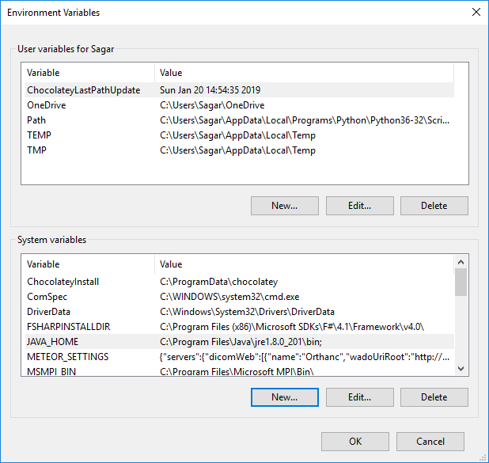

Step 21: Click on ok.

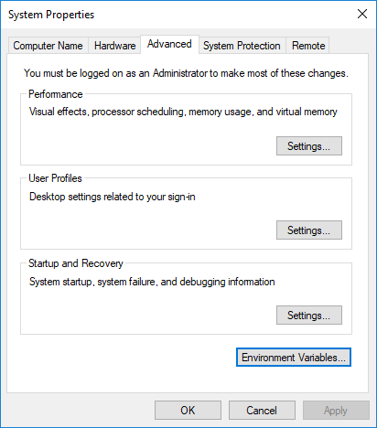

Step 22: Double click on application file.



Step 23: Click on Accept button.

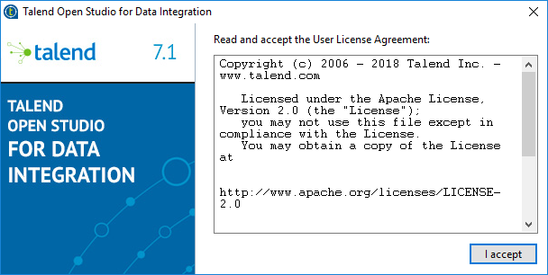

Step 24: Create project and click on finish.

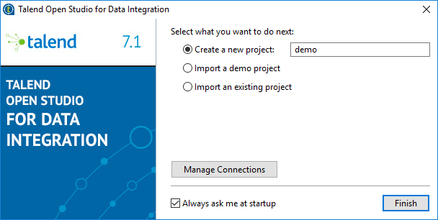

Step 25: Click on allow access.

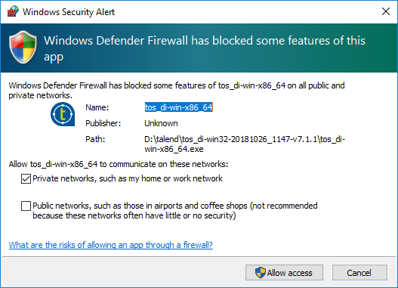

Step 26: See the studio.

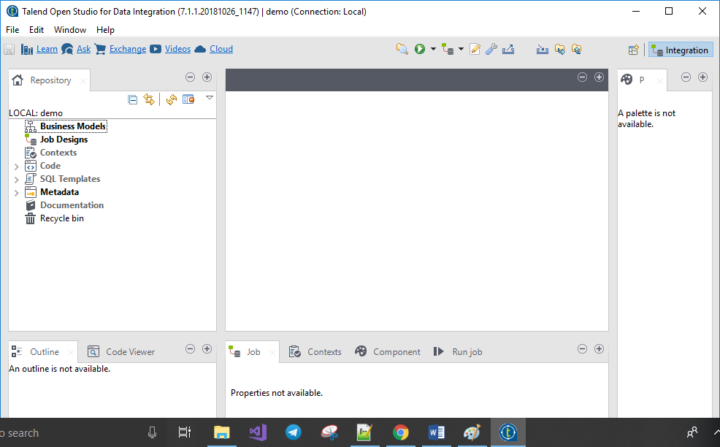

Step 27: Download the jtds jar file from internet. Search jtds jar file in chrome browser then select first link.

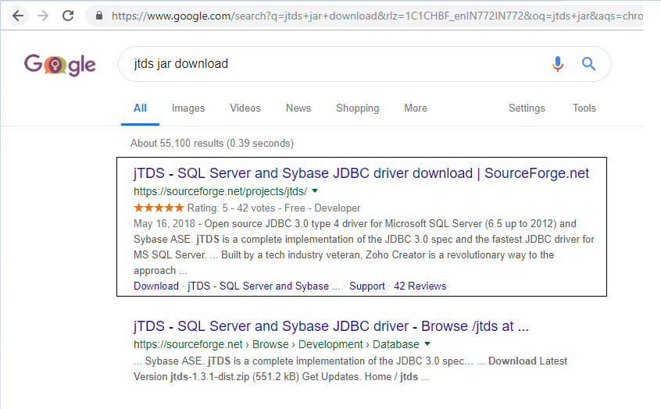

Step 28: Click on download button.

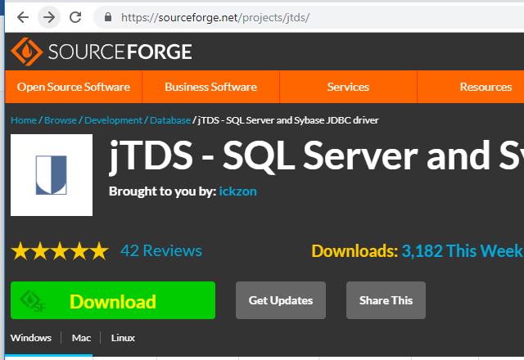

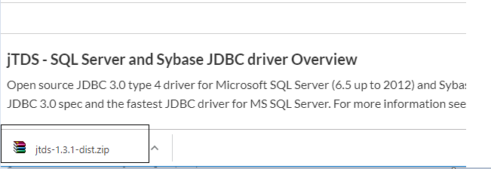

Step 29: Extract file.

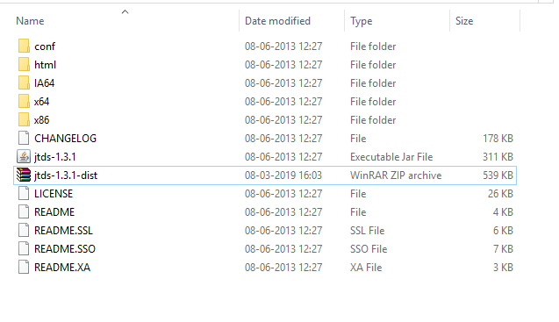

Step 30: Copy jtds jar file and paste in plug in folder of talend.

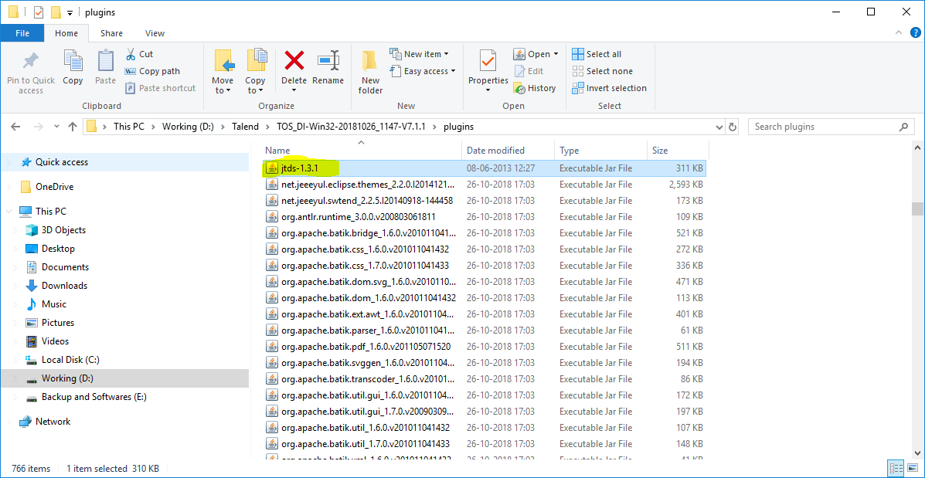

Step 31: Copy ntmauth.dll file into the jre bin folder.

Copy from jtds extracting folder -> x64 folder -> sso folder

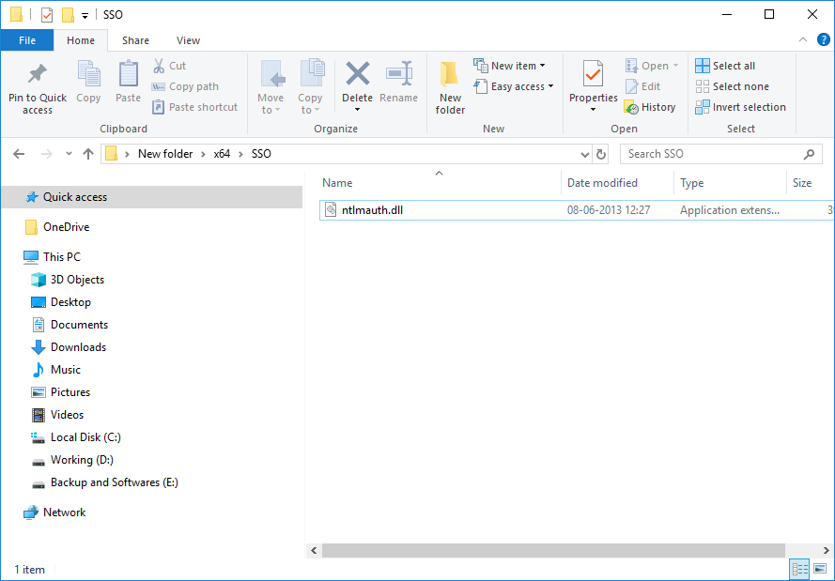

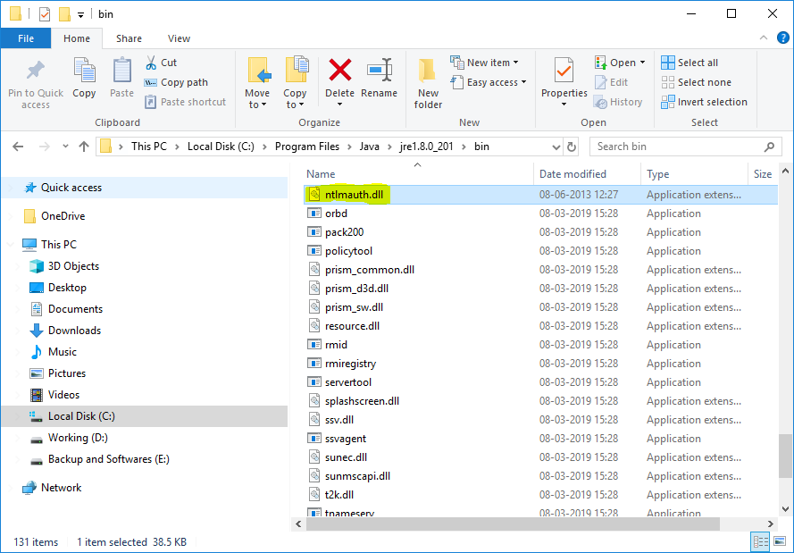

**Map and Upload CSV file in Talend.**

Step 1: Expand the metadata and select file delimitated and create new file.

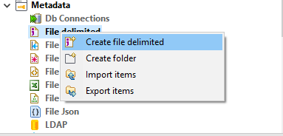

Step 2: Give name to file and click on next.

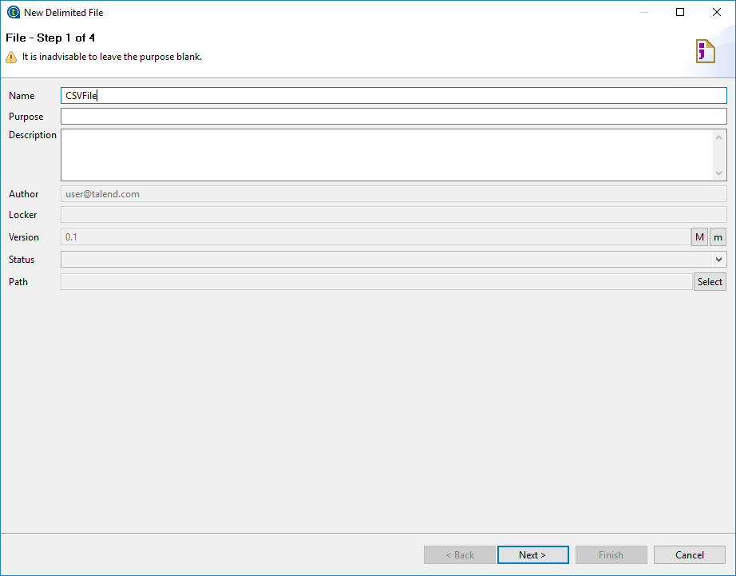

Step 3: Browse CSV file and set format as Windows. Click on next.

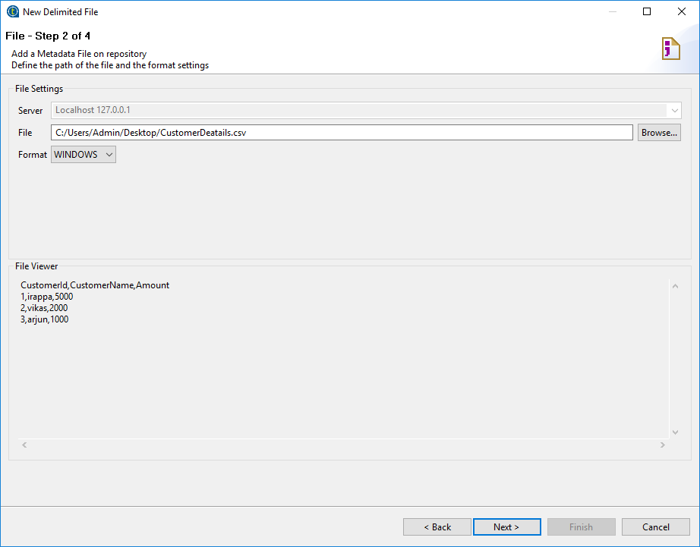

Step 4: Select Encoding, Field separator and Row separator as shown in below snapshot. Click on next.

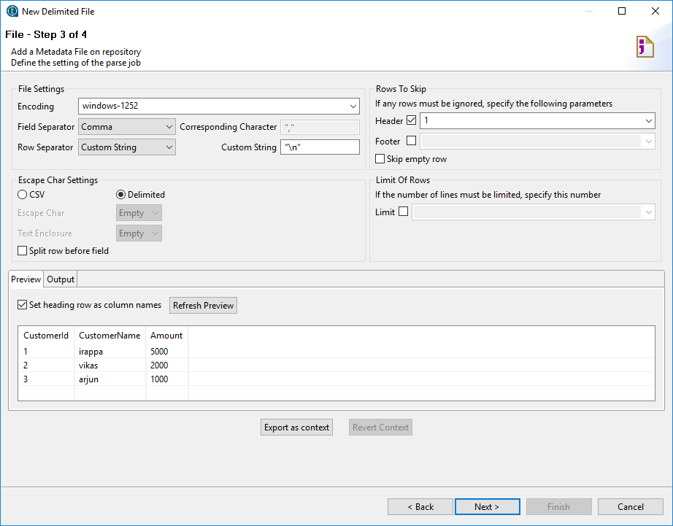

Step 5: Give name and click on finish.

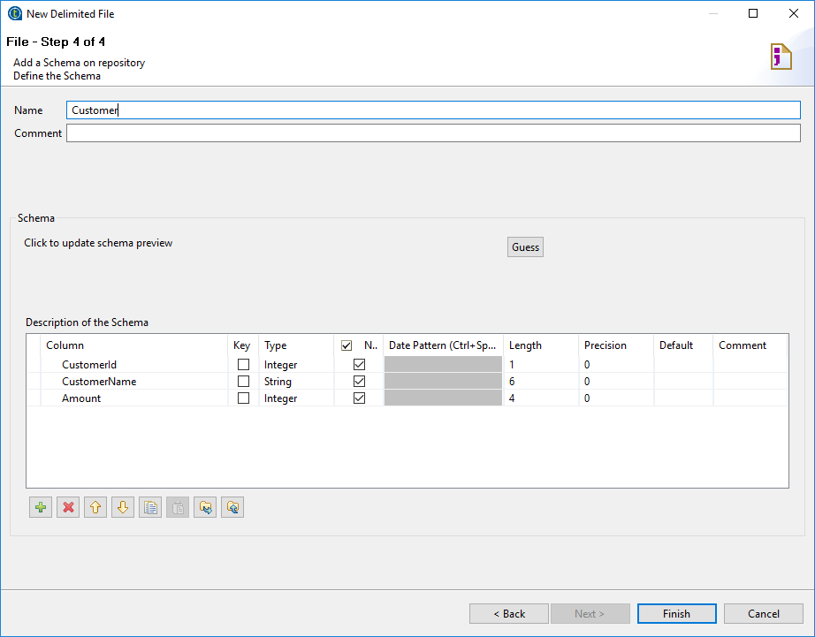

Step 6: Drag and drop csv file select as tFileInputDelimited into workspace.

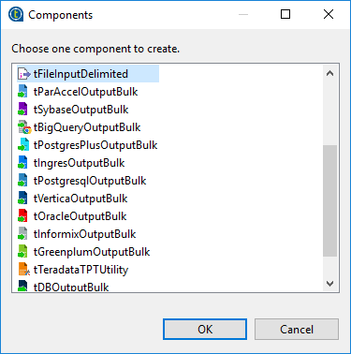

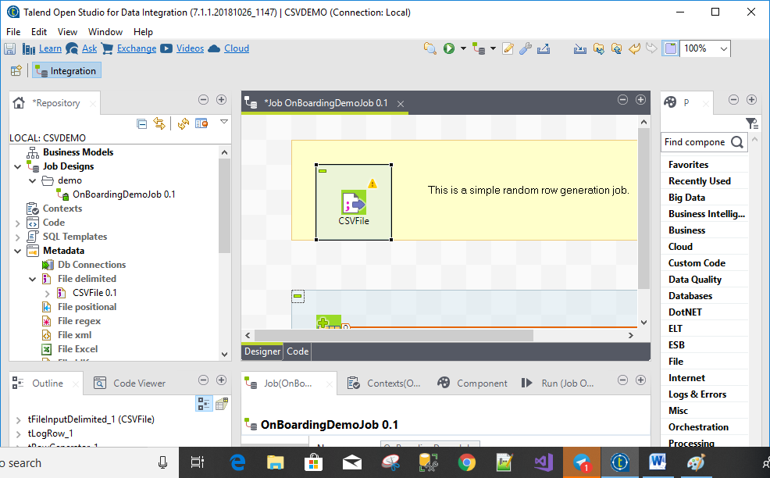

Step 7: Create New DBConnections.

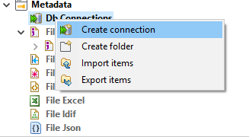

Step 8: Give name and click on next.

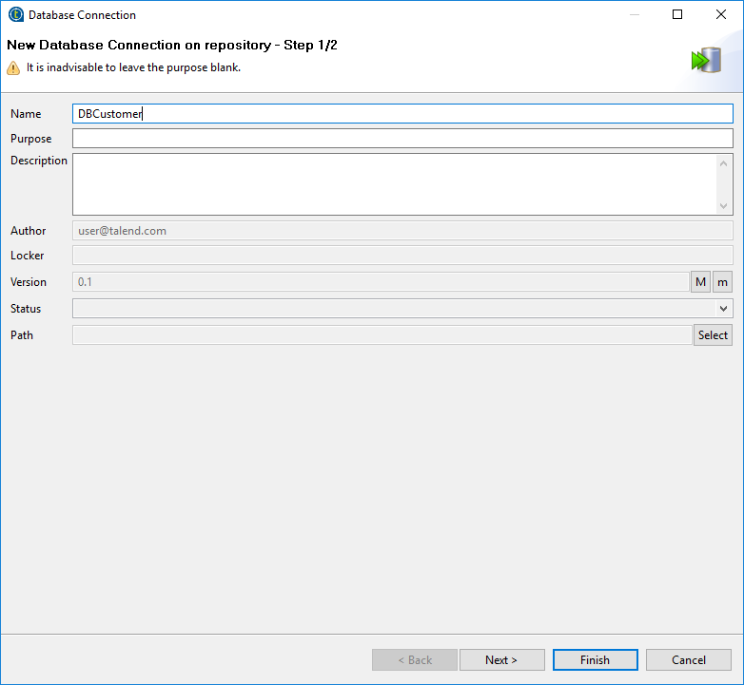

Step 9: Select DBType and fill other information.

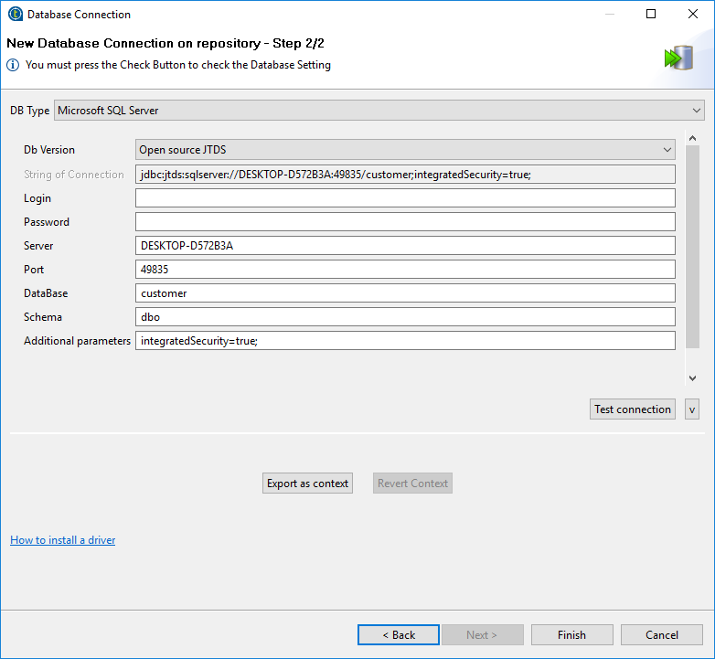

Step 10: Check Test connection.

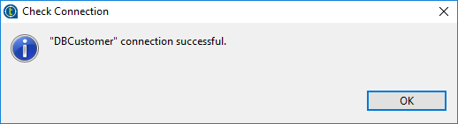

Step 11: Click on finish.

Step 12: Expand dbconnection and select dbconnection file then Right click on DBConnection file. Select Retrive schema.

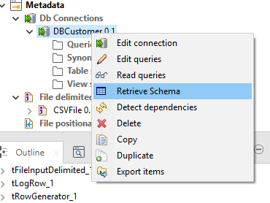

Step 13: Click on next.

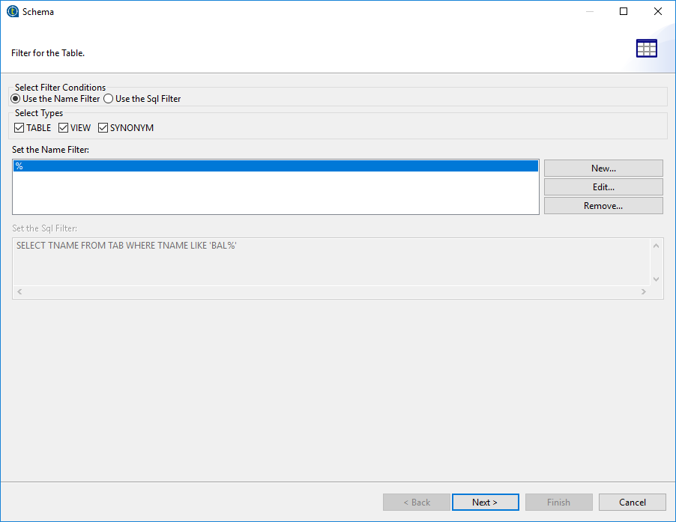

Step 14: Select database and click on next.

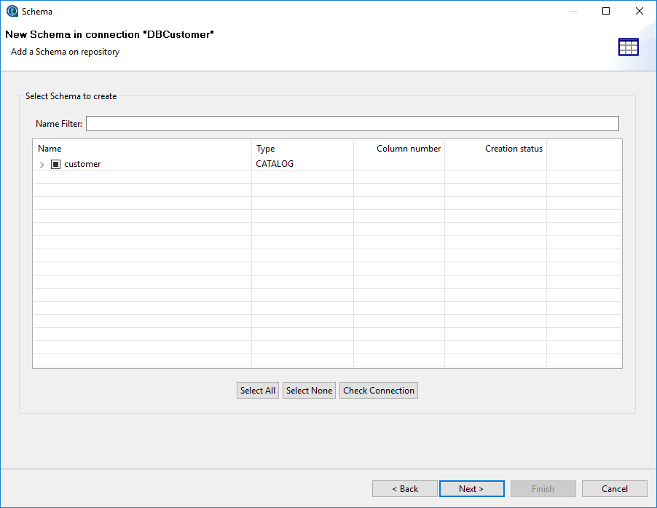

Step 15: Click on finish.

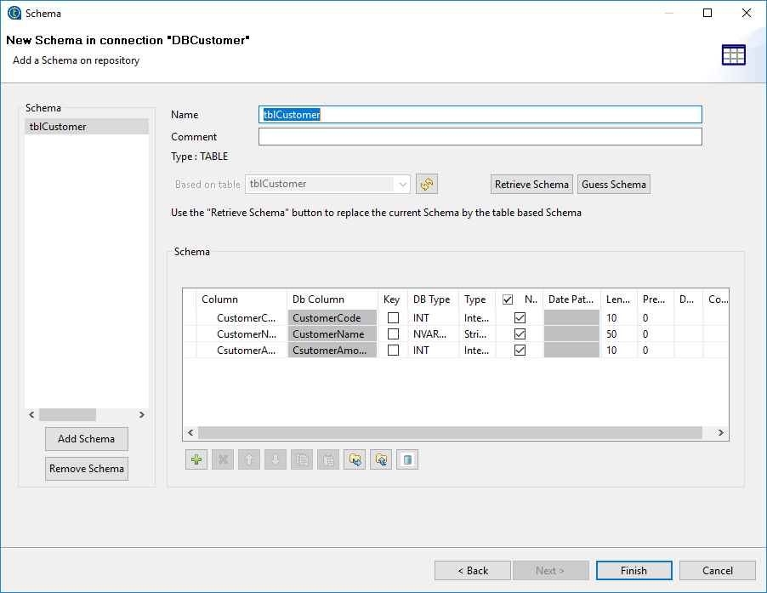

Step 16: Drag and drop dbconnection file select as tDBOutput.

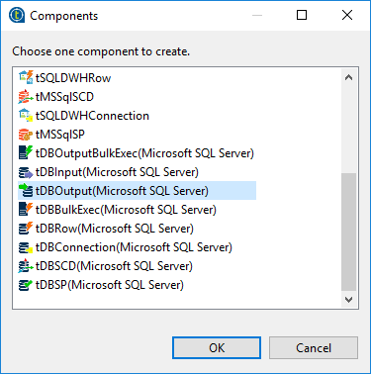

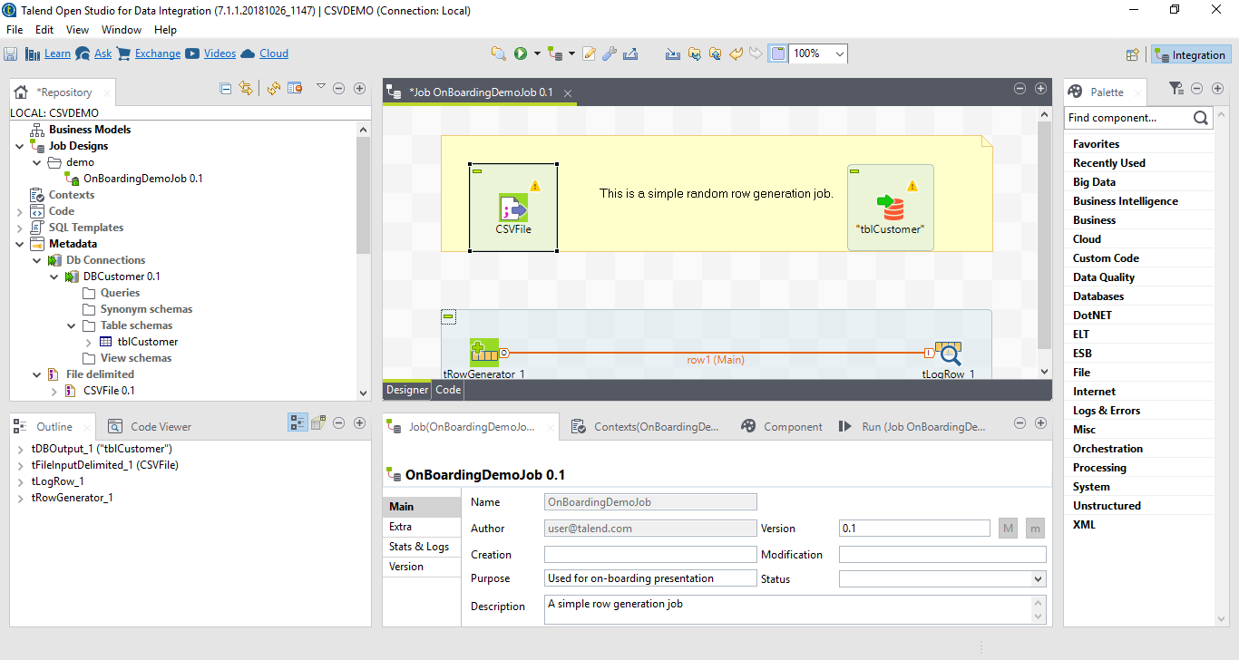

Step 17: Right hand side expand processing field and drag and drop map component to workspace.

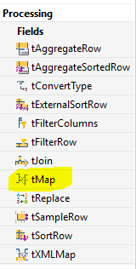

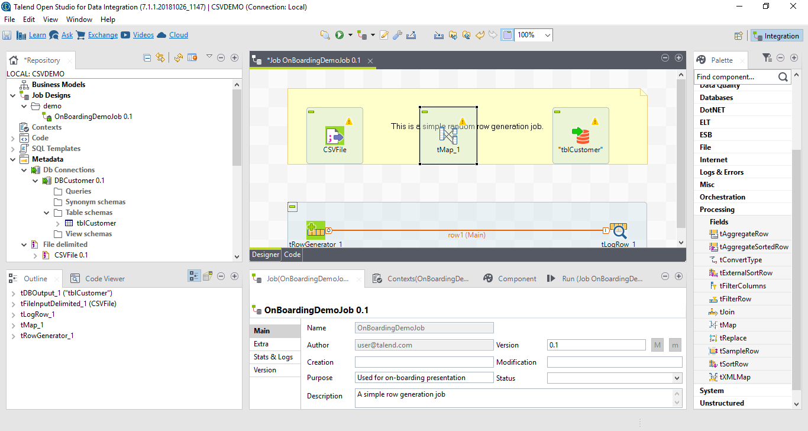

Step 18: Make connection between CSV file, Map component and SQL Table. Give name to the output.

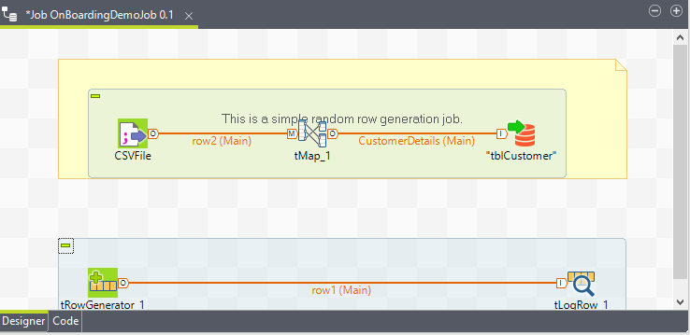

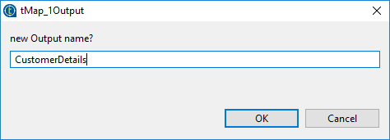

Step 19: Double click on map component. Mapping to column and click on Apply and ok.

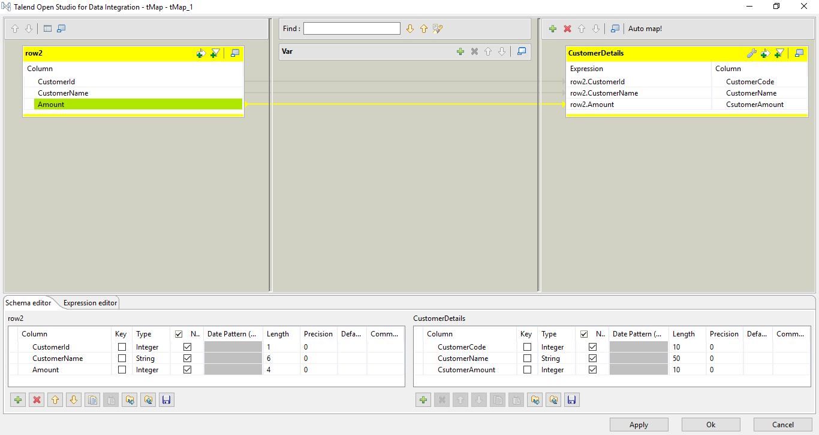

Step 20: Run the Job.



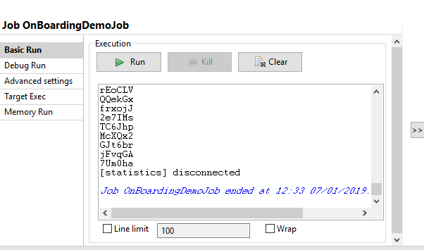

Step 21: Check the database data is present or not.

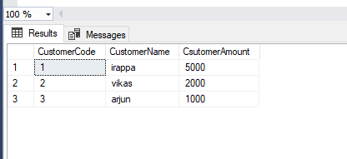

**Implementing SCD Type 1 in Talend**

Slowly Changing Dimensions (SCD): -

In SCD type 1 is used for no history is stored in the database table. New data can be overriding the old data.

Step 1: Expand the metadata and select file delimitated and create new file.



Step 2: Give name to file and click on next.

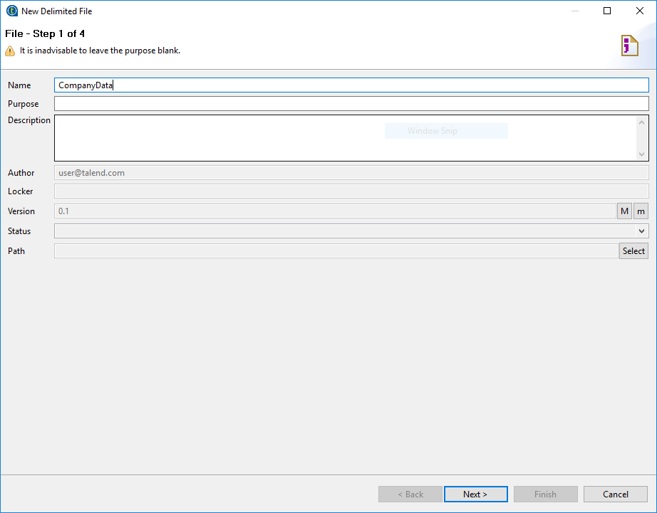

Step 3: Browse CSV file and set format as Windows. Click on next.

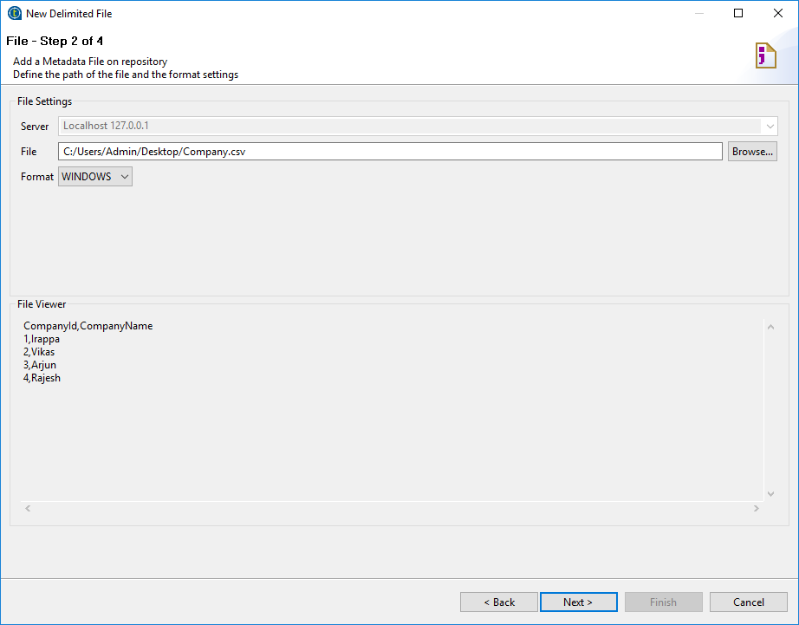

Step 4: Select Encoding, Field separator and Row separator as shown in below snapshot. Click on next.

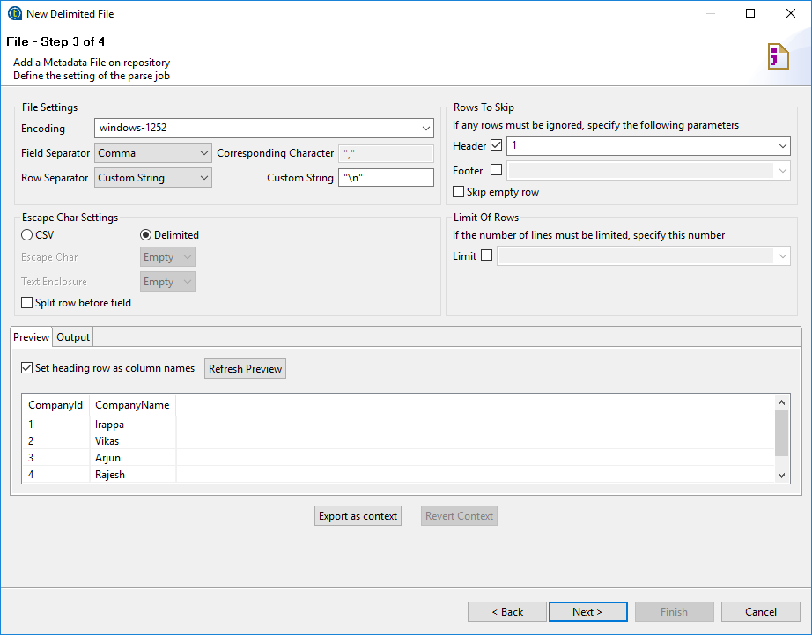

Step 5: Give name and click on finish.

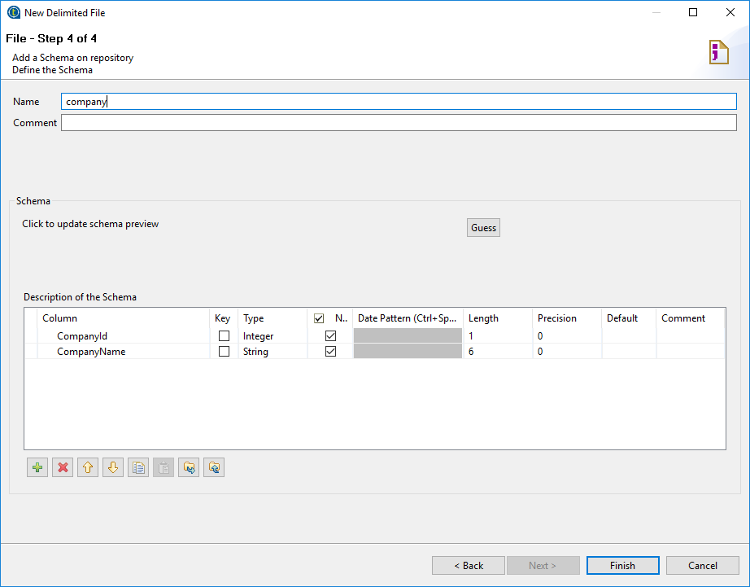

Step 6: Drag and drop csv file select as tFileInputDelimited into workspace.



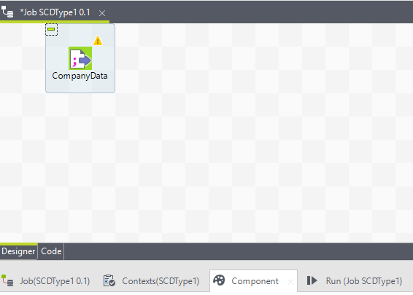

Step 7: See the right hand side ‘Business Intelligence’ option click on it and select the ‘DB SCD’ option click on it and select ‘tMSSqlSCD’ component and drag and drop it on workspace.

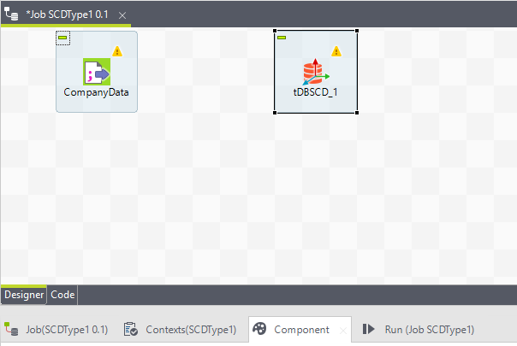

Step 8: Make the link between File delimited component to DBSCD component.

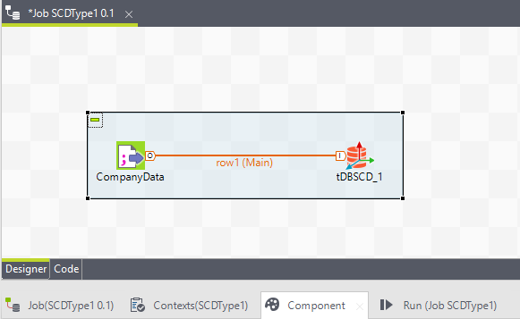

Step 9: Select the SCD component and see the below the component tab is here and click on it and fill the information.

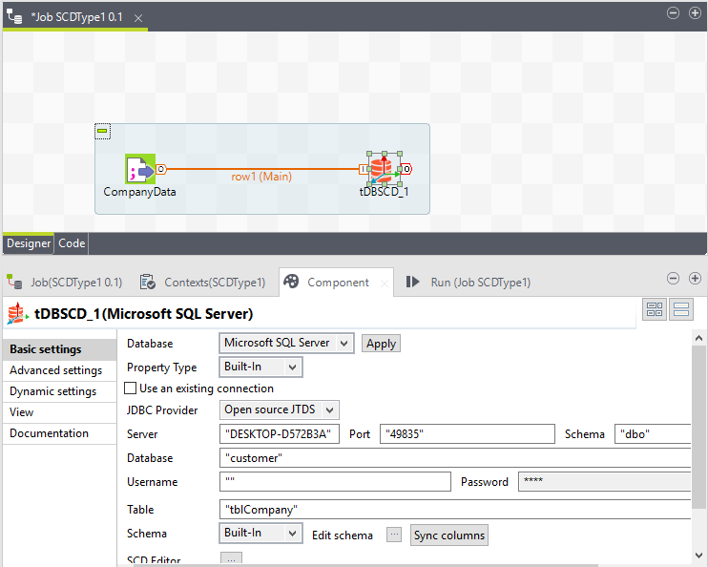

Step 10: Double click on DBSCD component and select the type and drag the column on that type. Click on ok.

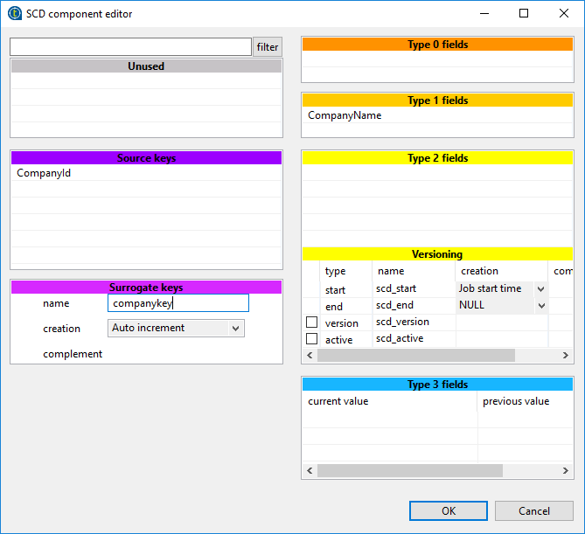

Step 11: Click on Run button and check data is present or not in a table.

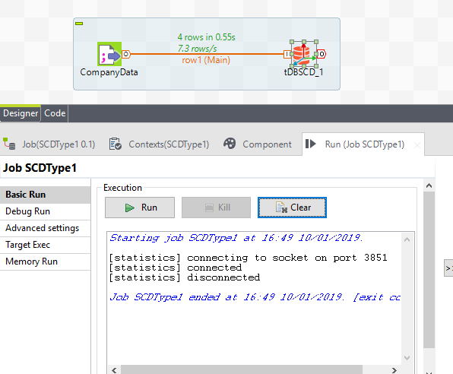

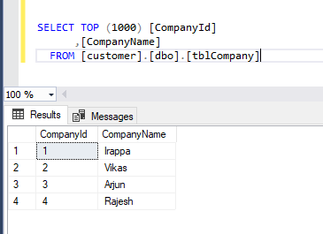

Step 12: Changing in the csv file and Run the job again and see the changes in table.

Before changing csv file:

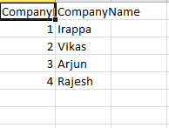

After the change in csv file:

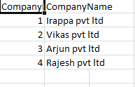

See the changes in table:

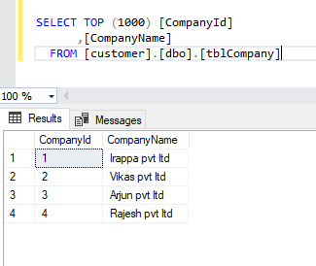

**Implementing SCD Type 2 in Talend**

Slowly Changing Dimensions (SCD): -

In SCD type 2 is used for maintain the history in the database table.

Step 1: Expand the metadata and select file delimitated and create new file.



Step 2: Give name to file and click on next.

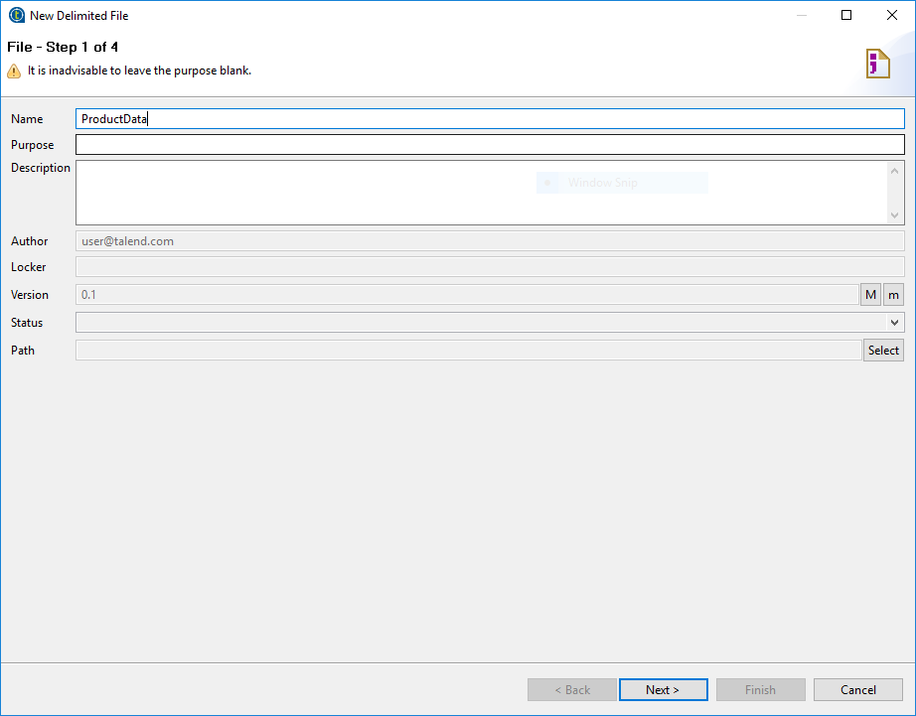

Step 3: Browse CSV file and set format as Windows. Click on next.

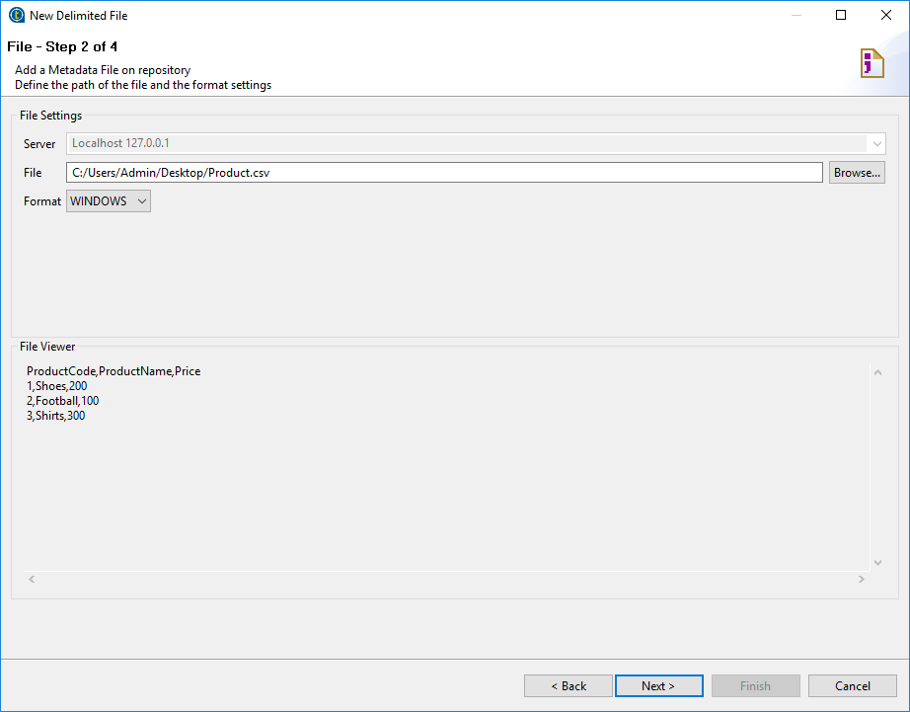

Step 4: Select Encoding, Field separator and Row separator as shown in below snapshot. Click on next.

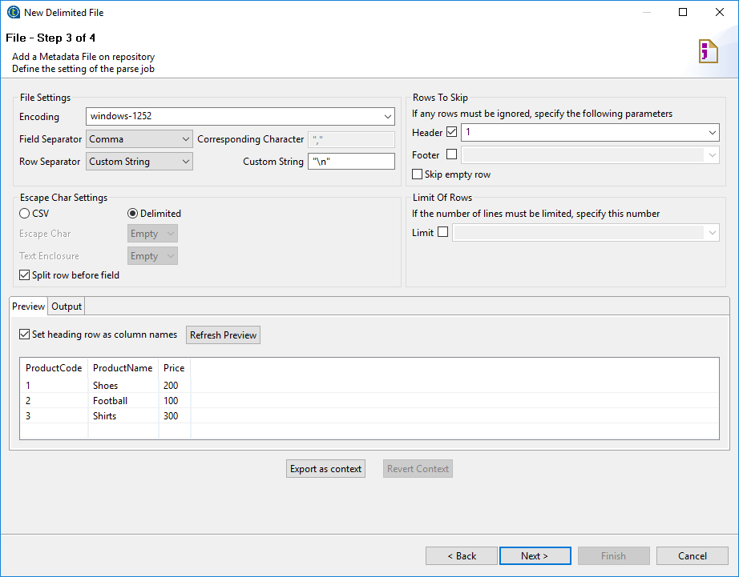

Step 5: Give name and click on finish.

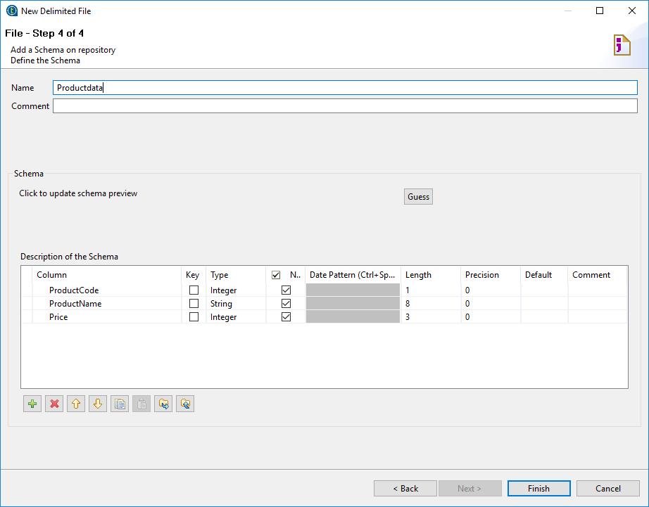

Step 6: Drag and drop csv file select as tFileInputDelimited into workspace.



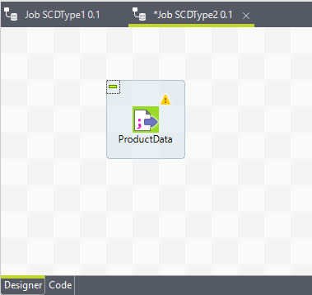

Step 7: See the right hand side ‘Business Intelligence’ option click on it and select the ‘DB SCD’ option click on it and select ‘tMSSqlSCD’ component and drag and drop it on workspace.

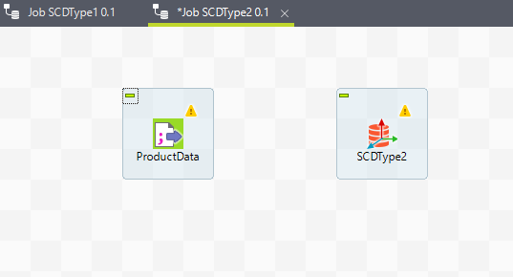

Step 8: Make the link between File delimited component to DBSCD component.

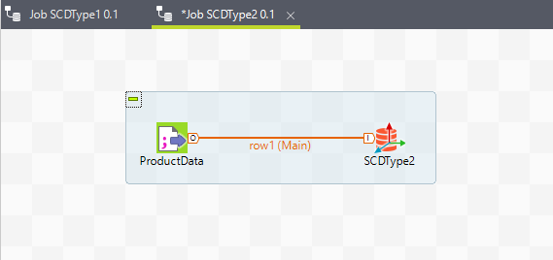

Step 9: Select the SCD component and see the below the component tab is here and click on it and fill the information.

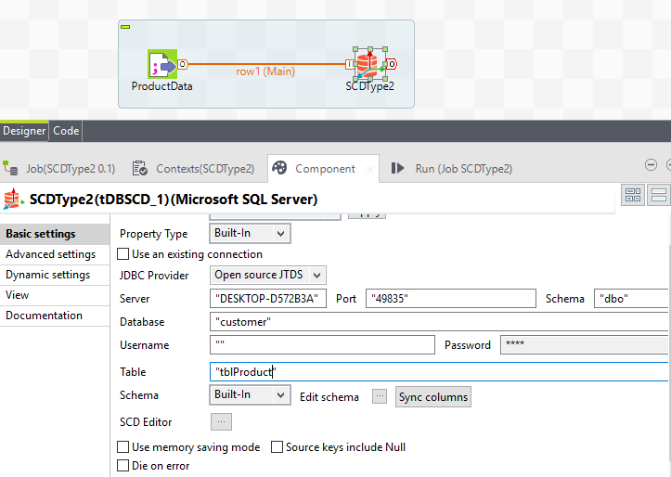

Step 10: Double click on DBSCD component and select the type and drag the column on that type. Click on ok.

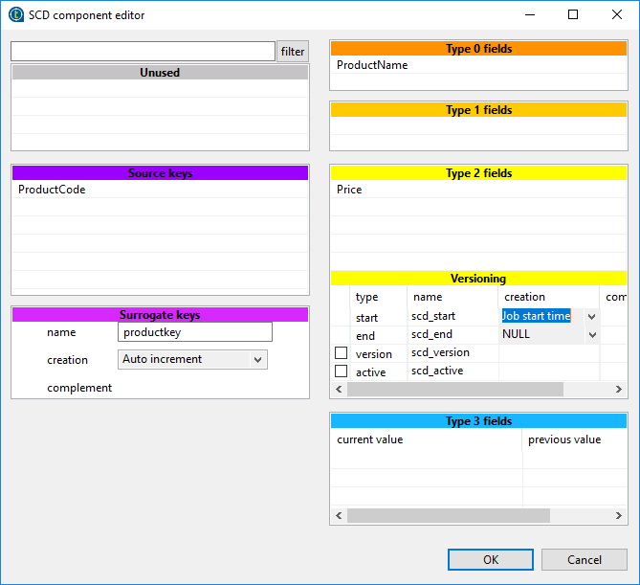

Step 11: Click on Run button and check data is present or not in a table.

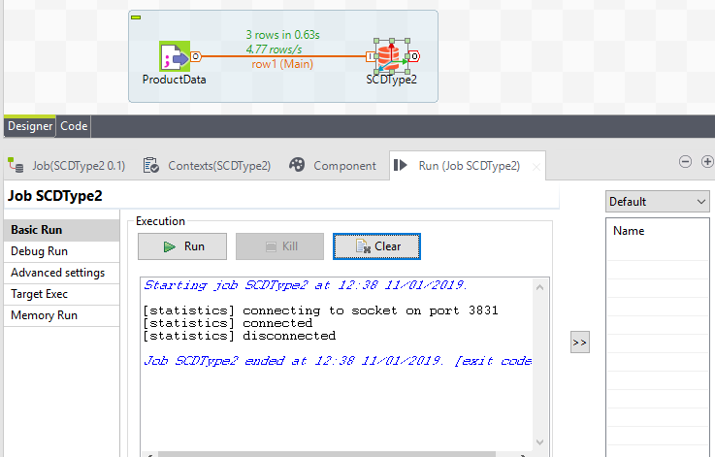

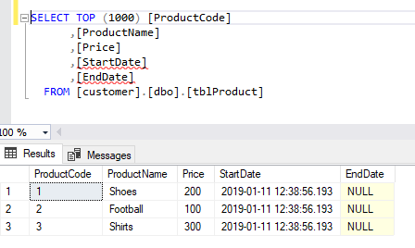

Step 12: Changing in the csv file and Run the job again and see the changes in table.

Before changing csv file:

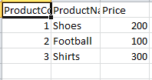

After the change in csv file:

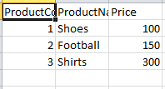

See the changes in table:

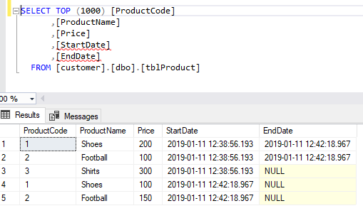

**Implementing SCD Type 3 in Talend**

Slowly Changing Dimensions (SCD): -

In SCD type 3 is used for maintain the previous value in the database table.

Step 1: Expand the metadata and select file delimitated and create new file.



Step 2: Give name to file and click on next.

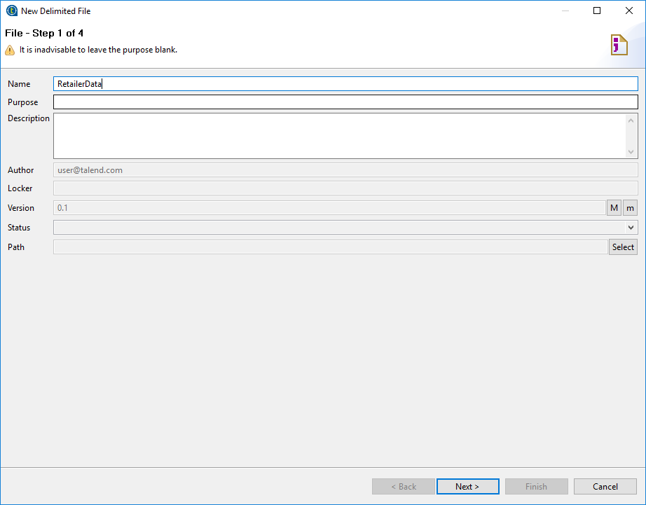

Step 3: Browse CSV file and set format as Windows. Click on next.

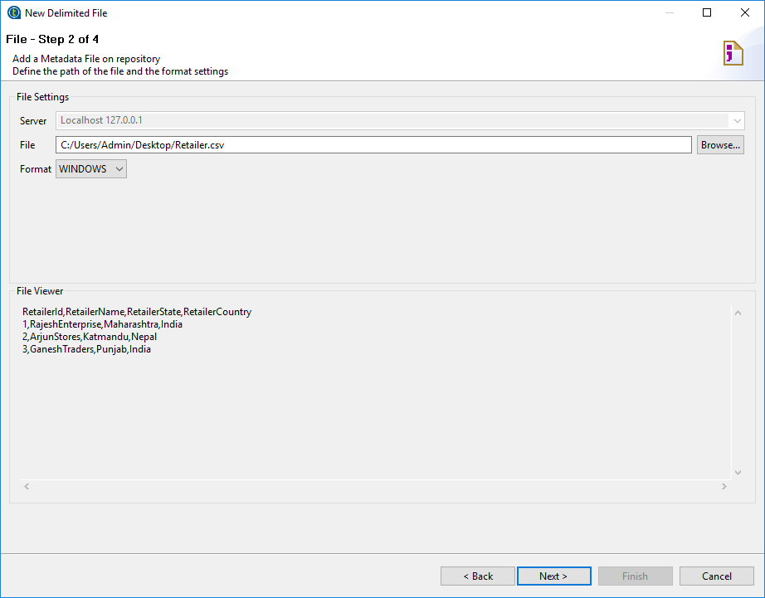

Step 4: Select Encoding, Field separator and Row separator as shown in below snapshot. Click on next.

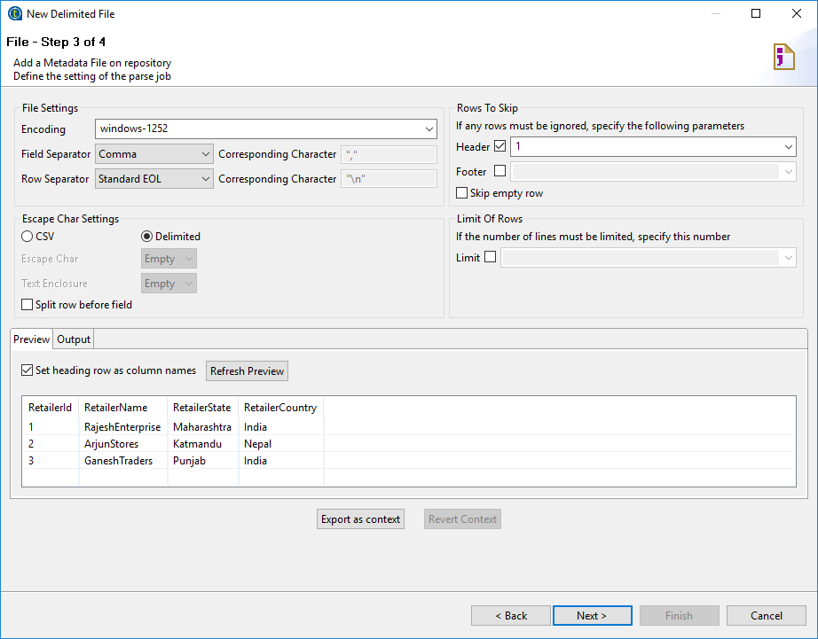

Step 5: Give name and click on finish.

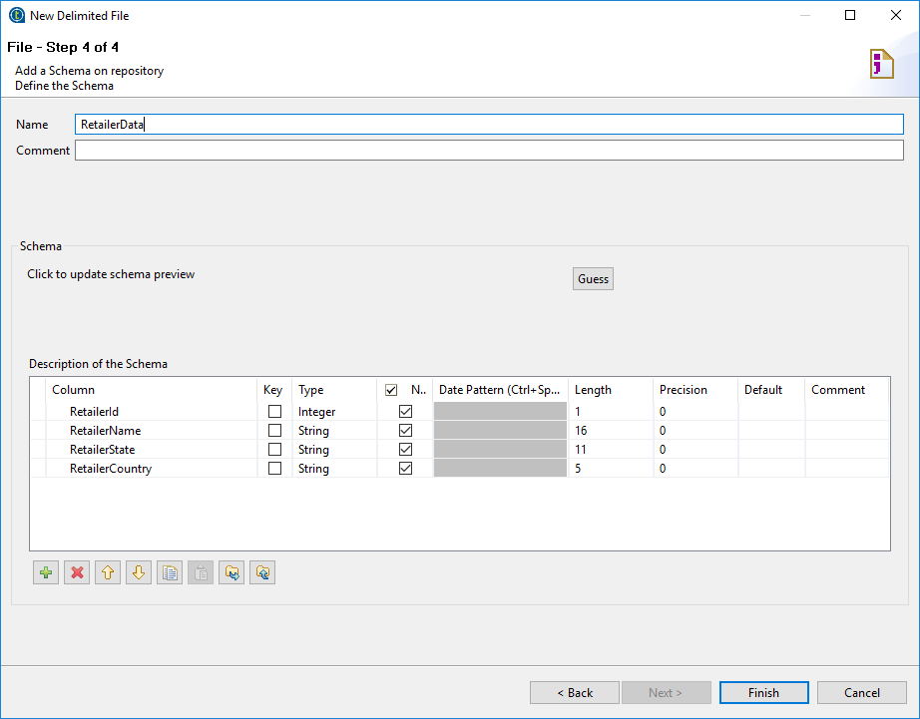

Step 6: Drag and drop csv file select as tFileInputDelimited into workspace.



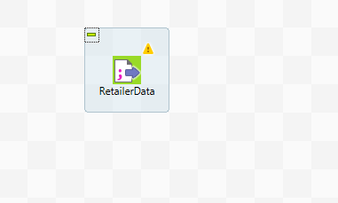

Step 7: See the right hand side ‘Business Intelligence’ option click on it and select the ‘DB SCD’ option click on it and select ‘tMSSqlSCD’ component and drag and drop it on workspace.

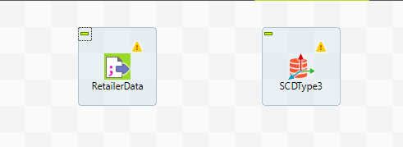

Step 8: Make the link between File delimited component to DBSCD component.

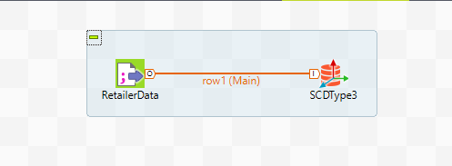

Step 9: Select the SCD component and see the below the component tab is here and click on it and fill the information.

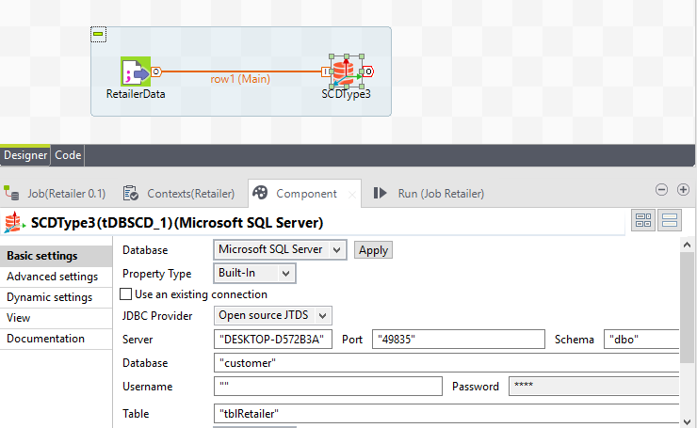

Step 10: Double click on DBSCD component and select the type and drag the column on that type. Click on ok.

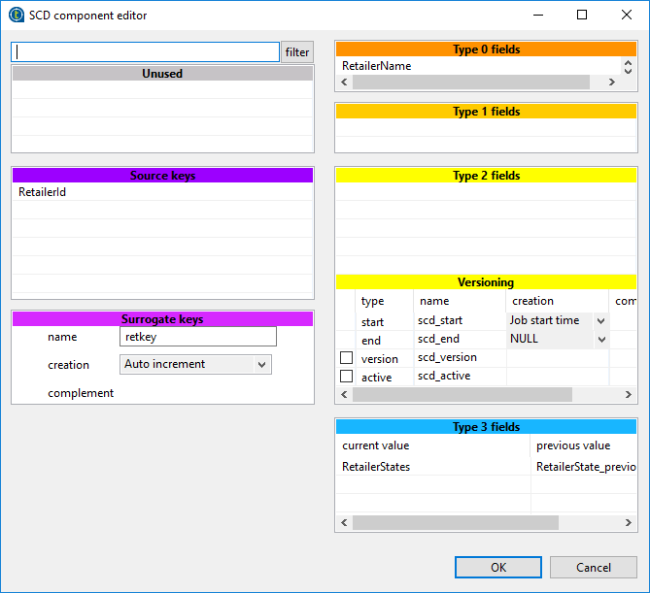

Step 11: Click on Run button and check data is present or not in a table.

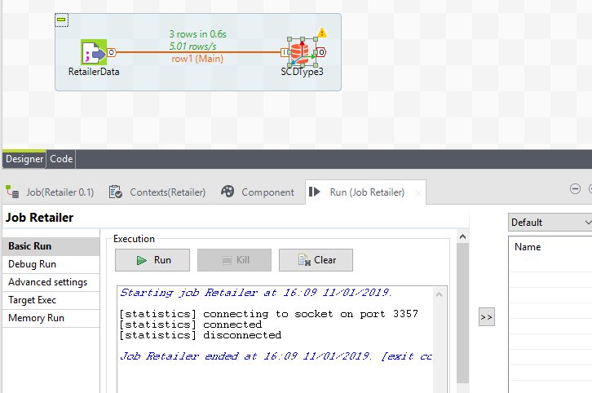

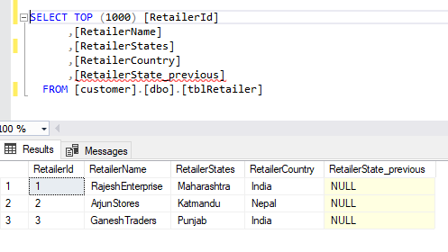

Step 12: Changing in the csv file and Run the job again and see the changes in table.

Before changing csv file:

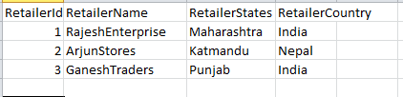

After the change in csv file:

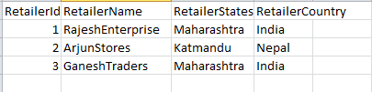

See the changes in table:

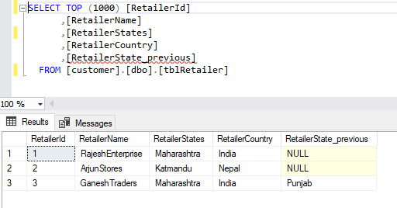

**Transpose rows into columns in Talend**

Step 1: Expand the metadata and select file delimitated and create new file.



Step 2: Give name to file and click on next.

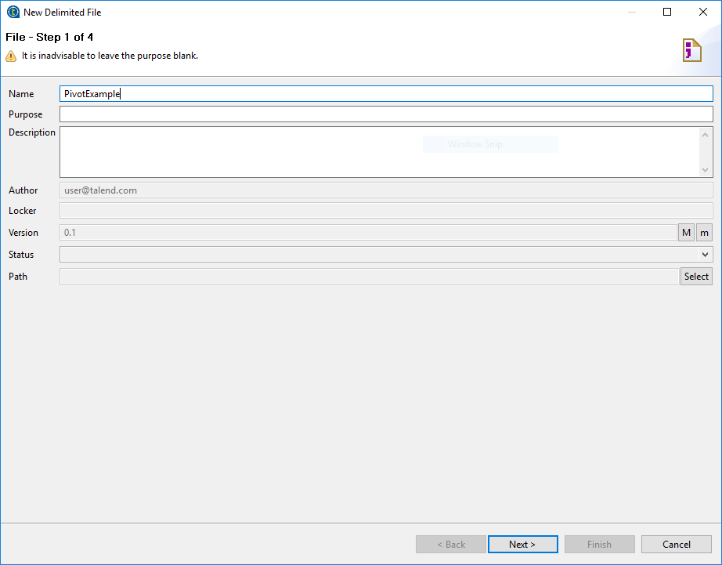

Step 3: Browse CSV file and set format as Windows. Click on next.

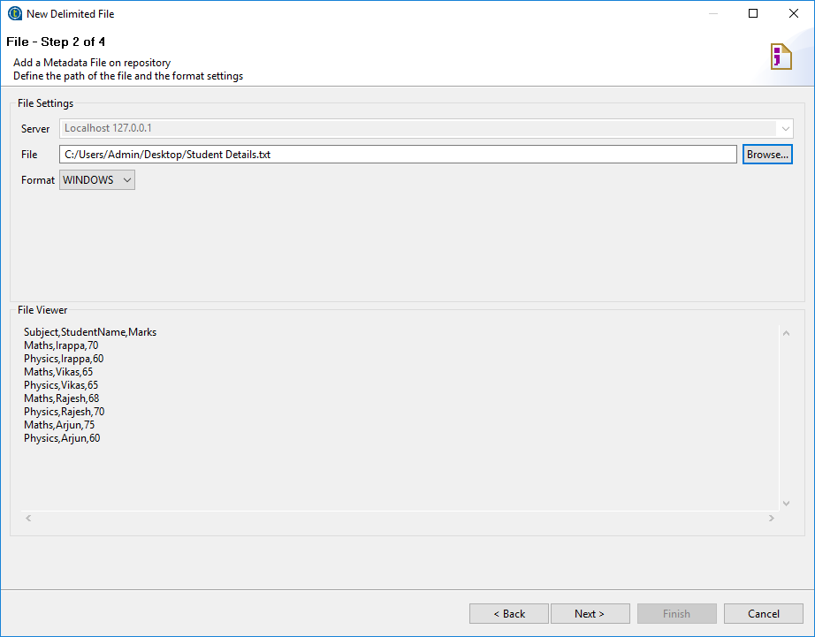Step 4: Select Encoding, Field separator and Row separator as shown in below snapshot. Click on next.

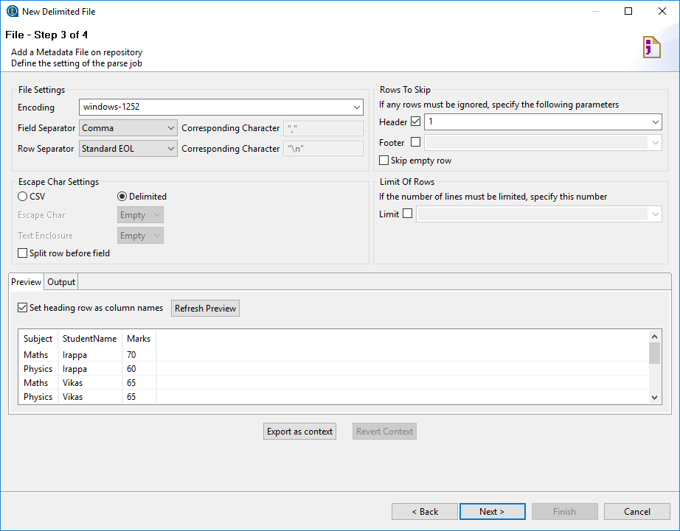

Step 5: Give name and click on finish.

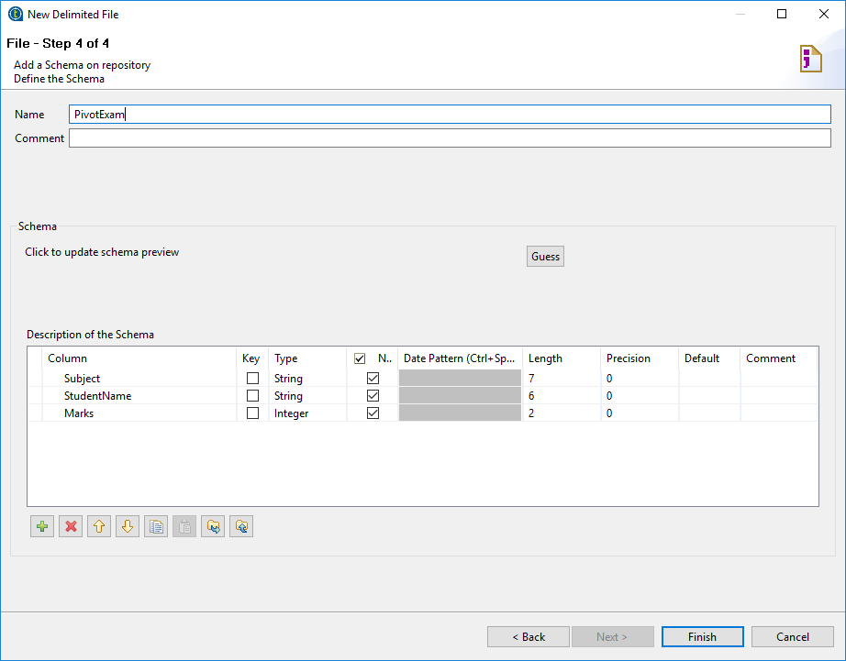

Step 6: Drag and drop csv file select as tFileInputDelimited into workspace.



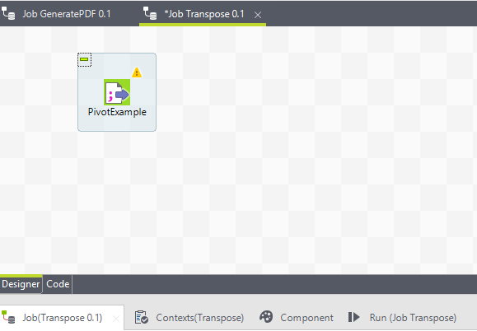

Step 7: See the right side hand ‘Processing’ field click on and select ‘tSortRow’ component.

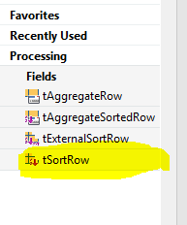

Step 8: Drag and Drop ‘tSortRow’ to workspace.

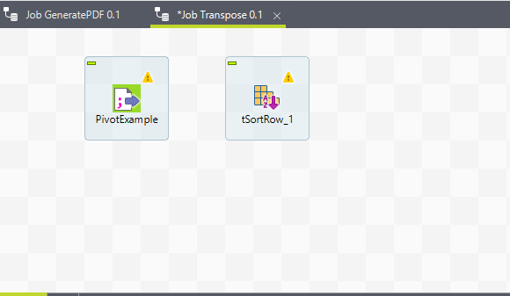

Step 9: Connect to the Delimited file to sort component.

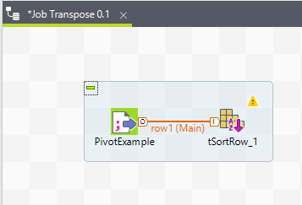

Step 10: Select the ‘tSortRow’ component and the columns to apply sorting order as shown below.

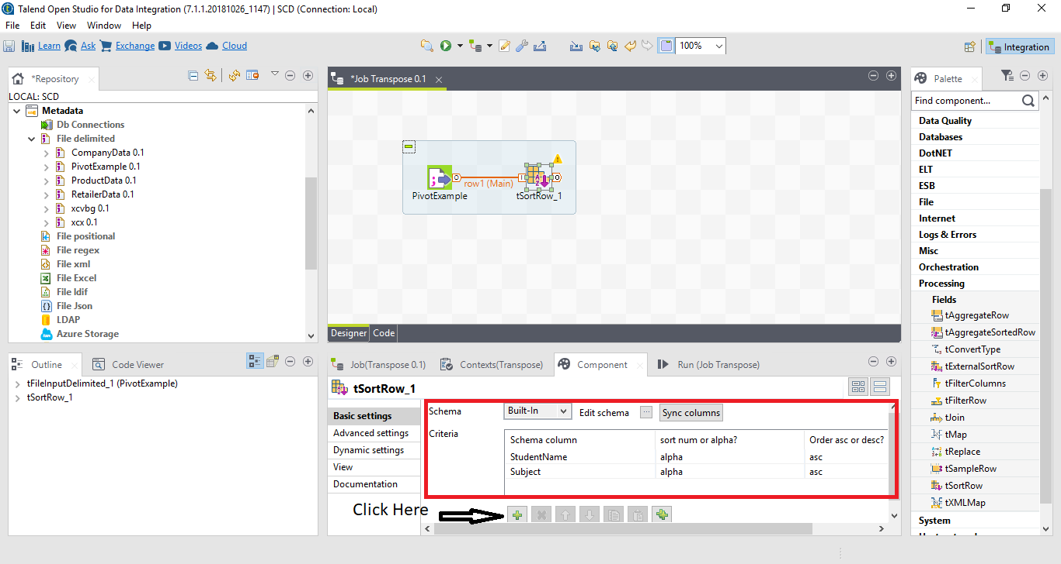

Step 11: See the right side hand ‘File’ field click on and select ‘Output’ field and select ‘tPivotToColumns’ component.

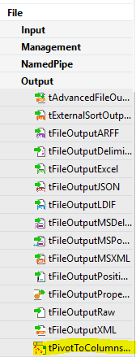

Step 12: Drag and Drop ‘tPivotToColumns’ component to work space and connect to ‘tSortRow’ component.

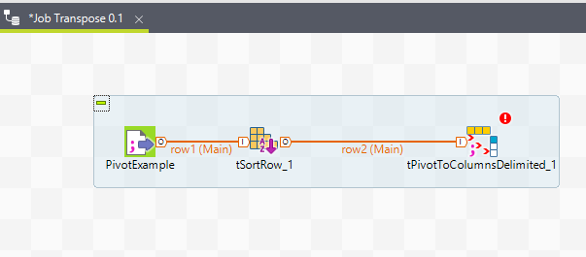

Step 13: Select the pivot column, Aggregation column, and Aggregation function and group by column as shown below.

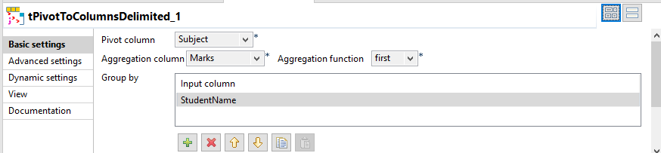

Step 14: Select the path for output file.

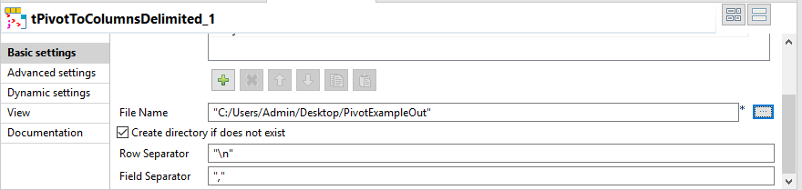

Step 15: Run the job.

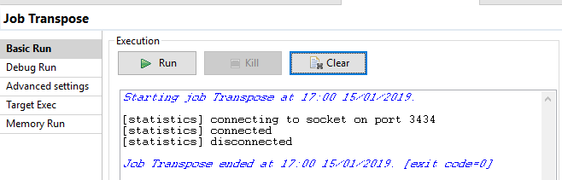

Step 16: See the output file.

Before Transpose rows to columns:

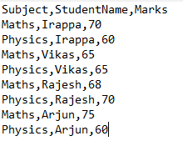

After Transpose rows to columns:

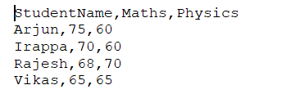

**How to Generate sample data in Talend**

Step 1: Drag and Drop the ‘tRowGenerator’ component on workspace.

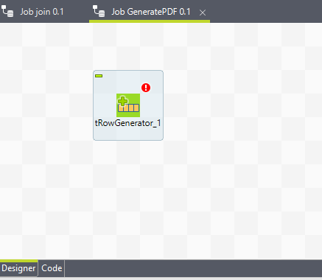

Step 2: Double click on ‘tRowGenerator’ component and add the columns.

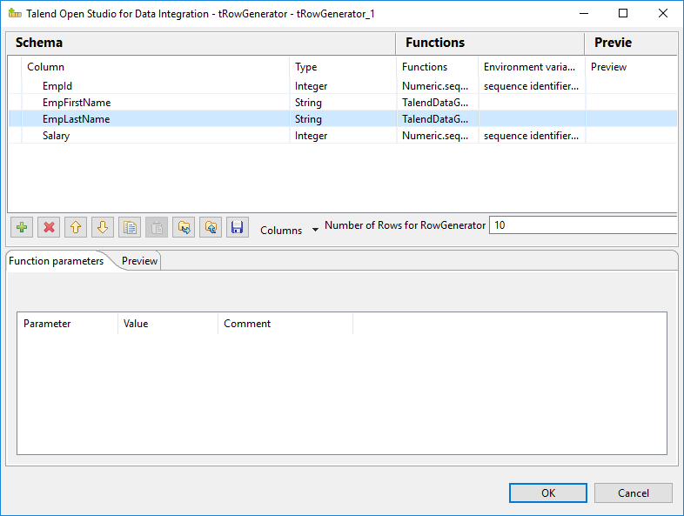

Step 3: Select the function to get the sample data.

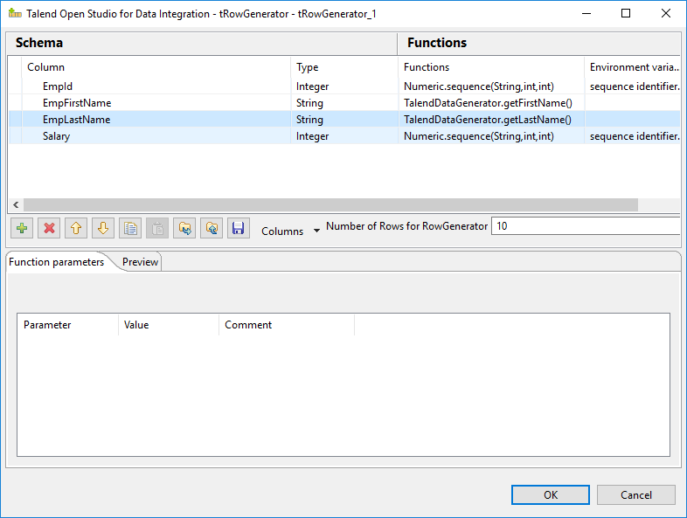

Step 4: Click on preview tab and see the sample data.

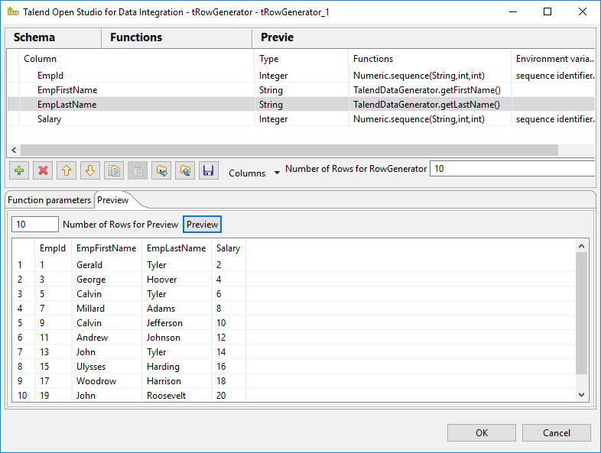

Step 5: Drag and Drop the ‘tFileOutputDemilited’ component and connect with ‘tRowGenerator’ component.

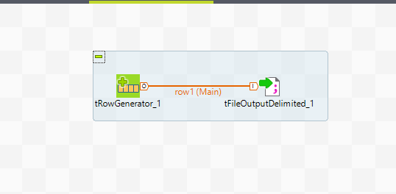

Step 6: Select the ‘tFileOutputDelimited’ component and set the path for output file.

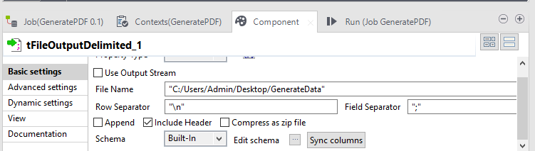

Step 7: Run the job.

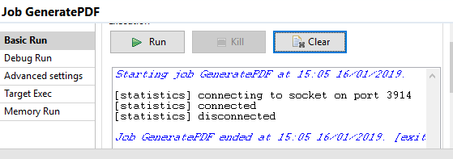

Step 8: See the output file.

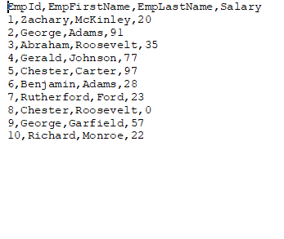

**Join in Talend**

Step 1: Expand the metadata and select file delimitated and create new file.



Step 2: Give name to file and click on next.

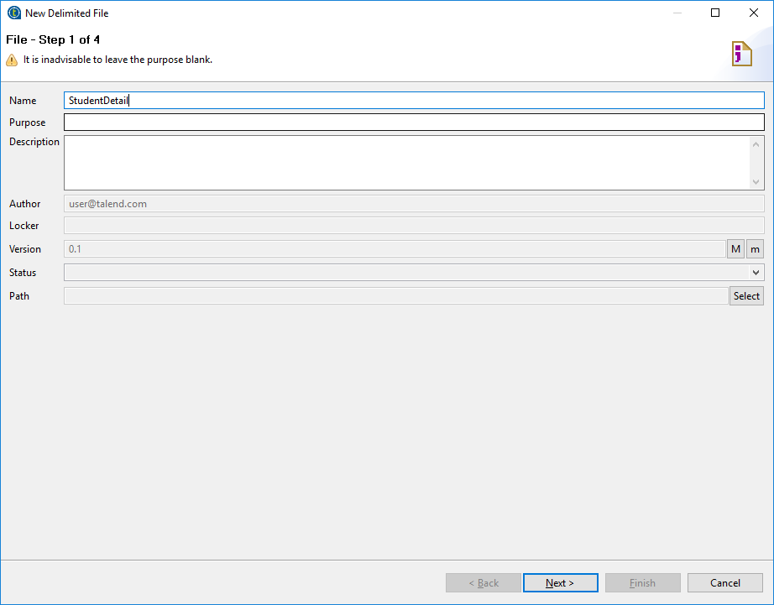

Step 3: Browse CSV file and set format as Windows. Click on next.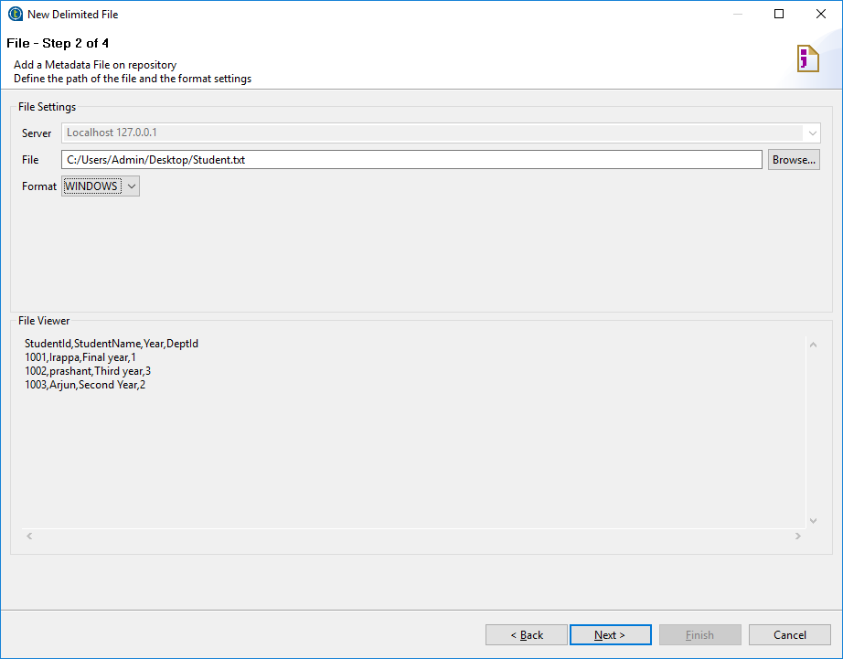Step 4: Select Encoding, Field separator and Row separator as shown in below snapshot. Click on next.

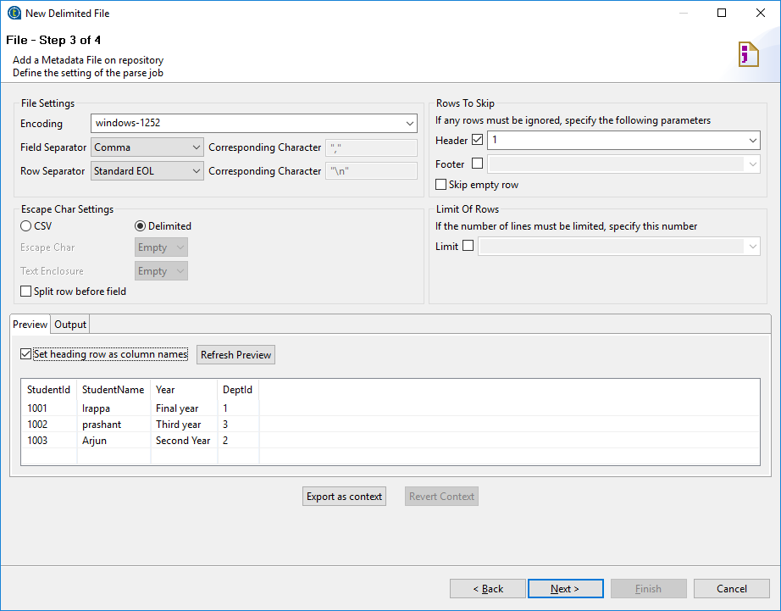

Step 5: Give name and click on finish.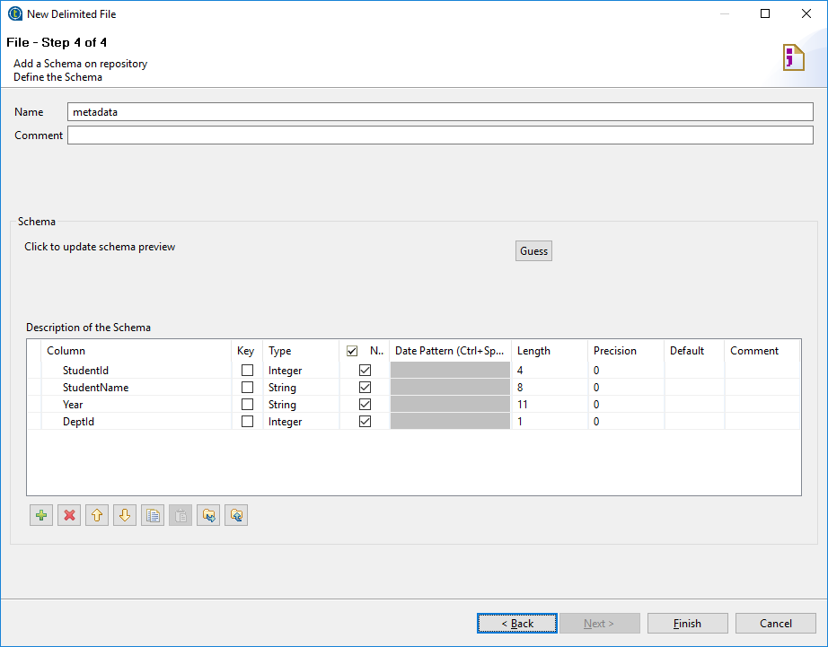

Step 6: Drag and drop csv file select as tFileInputDelimited into workspace.



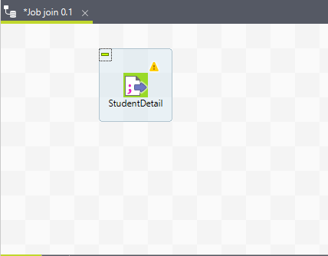

Step 7: Above steps are similar to second file ‘DepartmentDetail’.

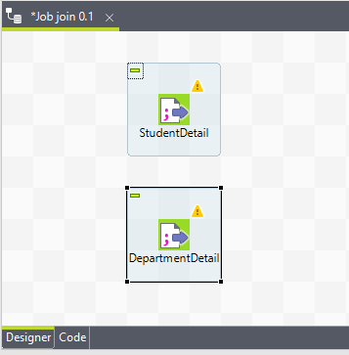

Step 8: Drag and Drop the ‘tJoin’ component in workspace and connect the both ‘StudentDetail’ and ‘DepartmentDetail’ files to ‘tJoin’ component.

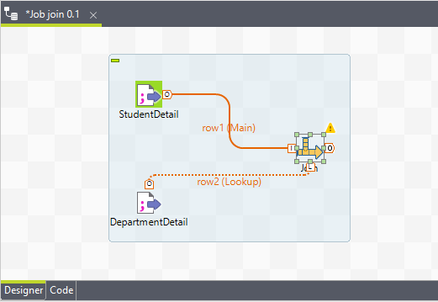

Step 9: Drag and Drop the ‘tFileOutputDelimited’ component in workspace and connect to the ‘tJoin’ component.

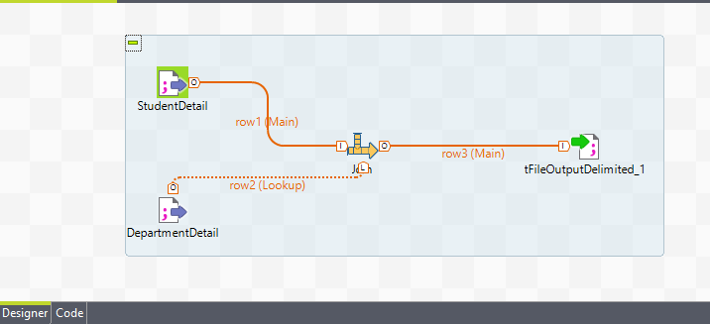

Step 10: Edit schema and select the columns.

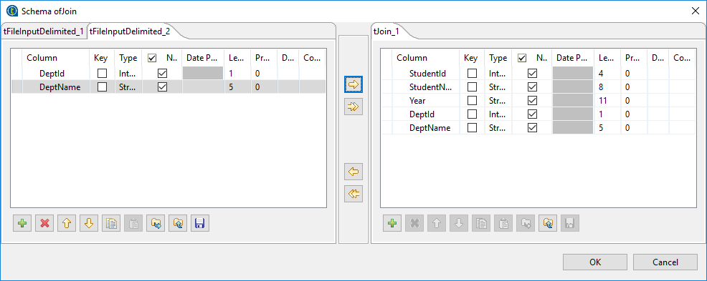

Step 11: Select the ‘tJoin’ component and select column mapping and key to apply join.

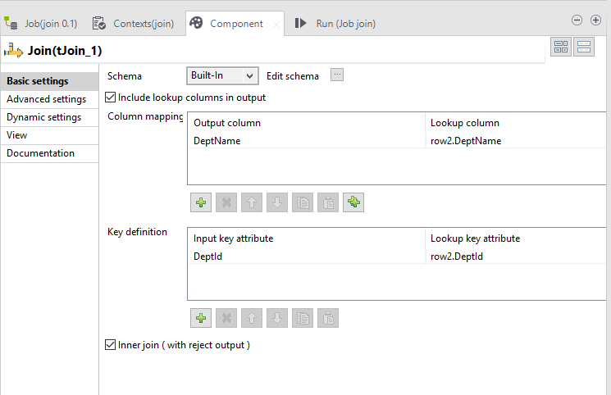

Step 12: Select the ‘tFileOutputDelimited’ component and set path to store the output file on that location.

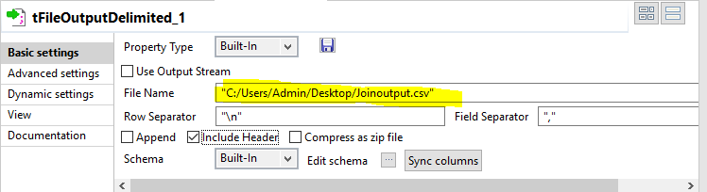

Step 13: Run the job.

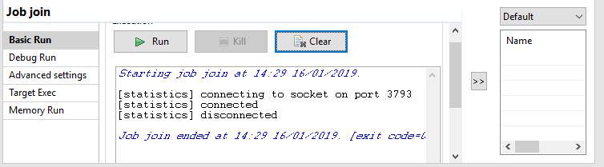

Step 14: See the output file data is proper or not.

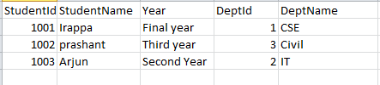

**Aggregation in Talend**

Step 1: Expand the metadata and select file delimitated and create new file.



Step 2: Give name to file and click on next.

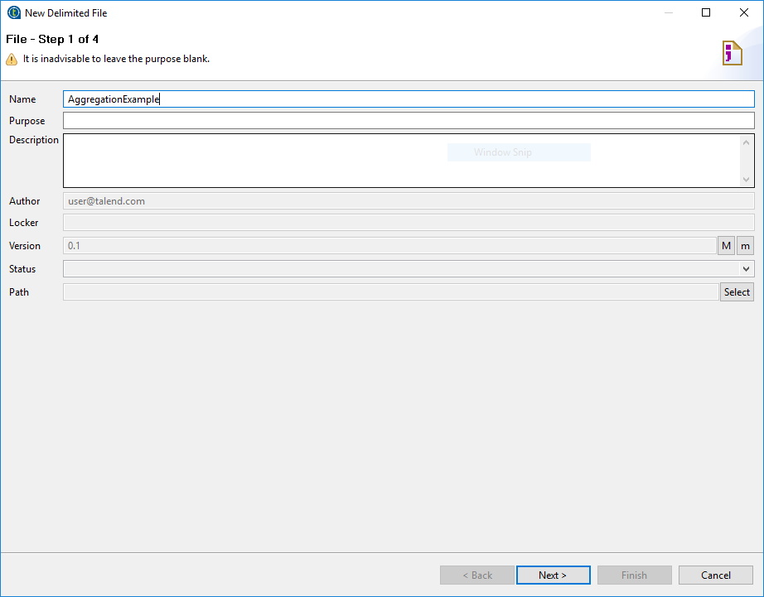

Step 3: Browse CSV file and set format as Windows. Click on next.

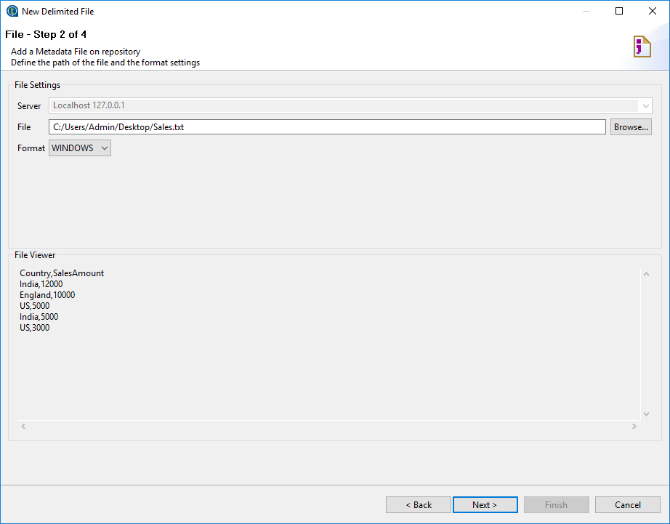

Step 4: Select Encoding, Field separator and Row separator as shown in below snapshot. Click on next.

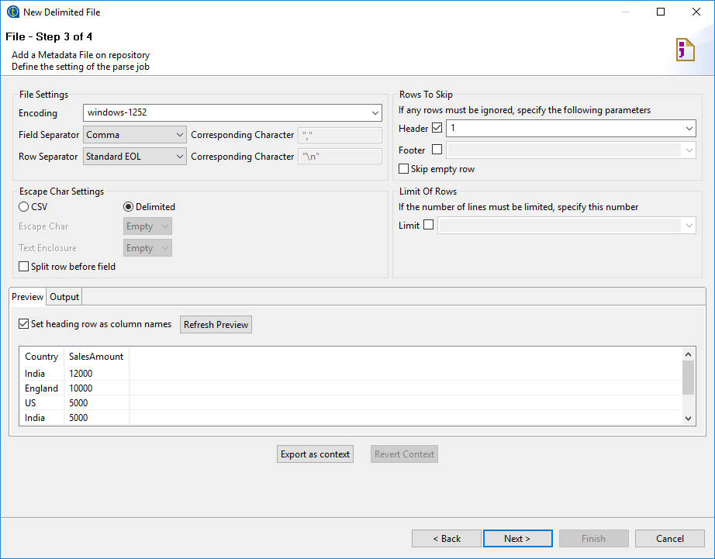

Step 5: Give name and click on finish.

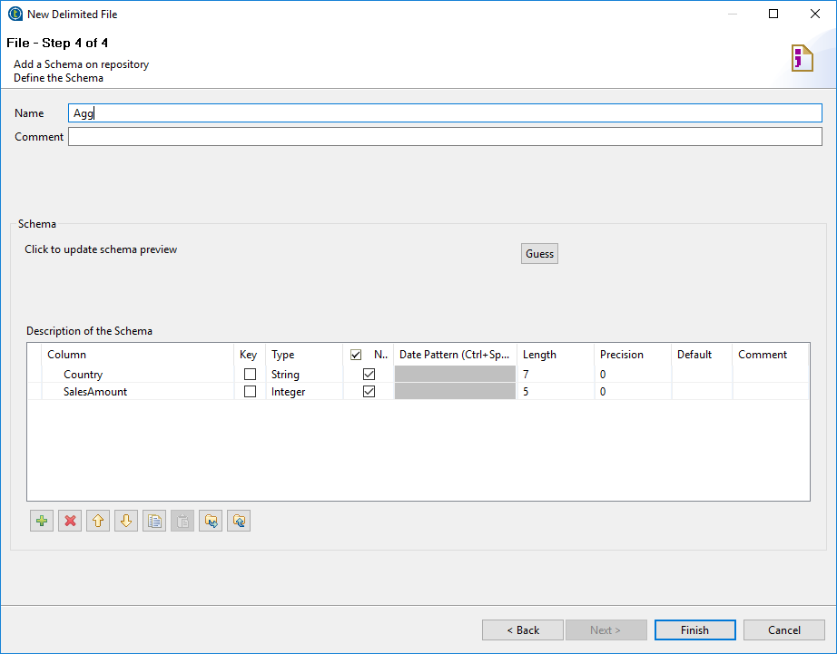

Step 6: Drag and drop csv file select as tFileInputDelimited into workspace.



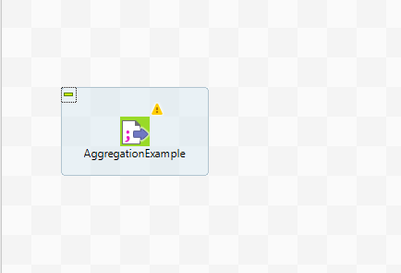

Step 7: Drag and Drop ‘tAggregateRow’ component and connect with ‘File InputDelimited’ component.

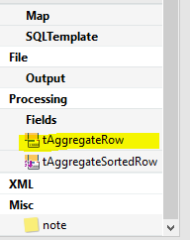

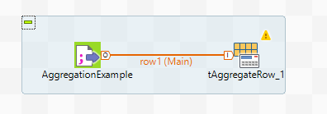

Step 8: Drag and Drop ‘tFileOutputDelimited’ component and connect with ‘tAggregatesRow’ component.

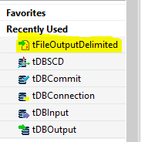

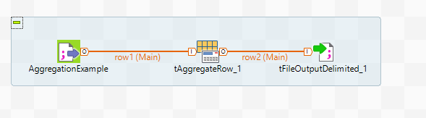

Step 9: Select the ‘tFileOutputDelimited’ component and set the path for store the output file on that location.

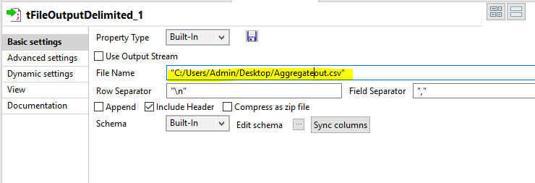

Step 10: Select the ‘tAggregateRow’ component and add the ‘Country’ column in group by section and ‘SalesAmount’ column add in the operation section.

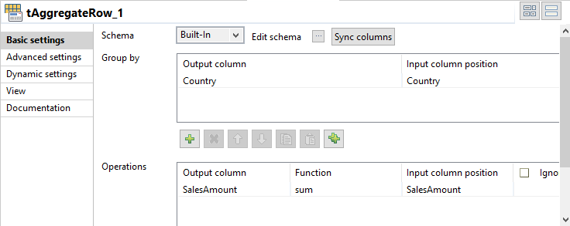

Step 11: Run the job.

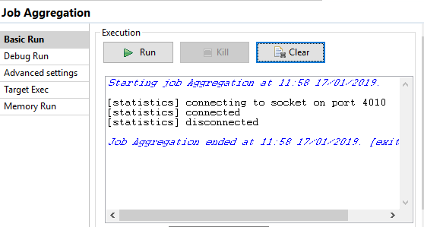

Step 12: See the output file.

Before Aggregating Data:

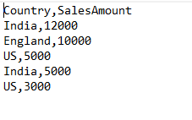

After Aggregating Data:

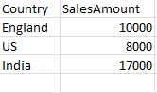

**IF Else using tMap in Talend**

Step 1: Expand the metadata and select file delimitated and create new file.



Step 2: Give name to file and click on next.

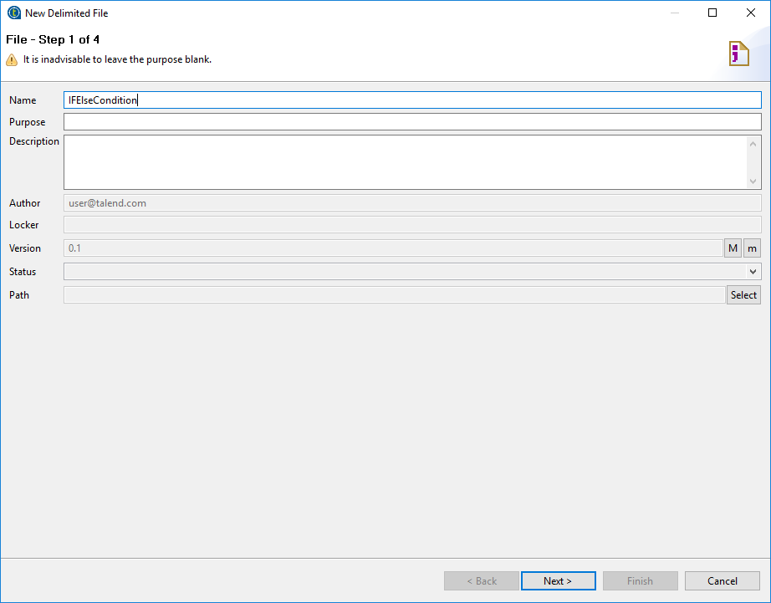

Step 3: Browse CSV file and set format as Windows. Click on next.

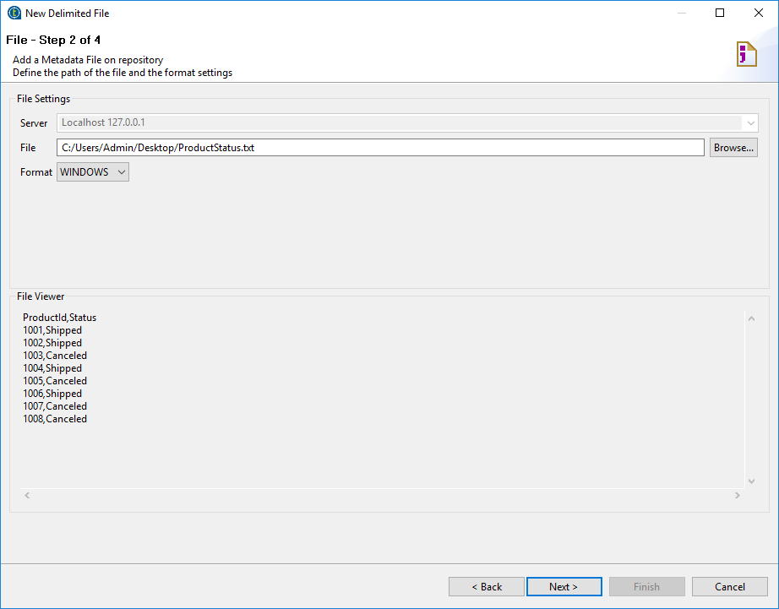

Step 4: Select Encoding, Field separator and Row separator as shown in below snapshot. Click on next.

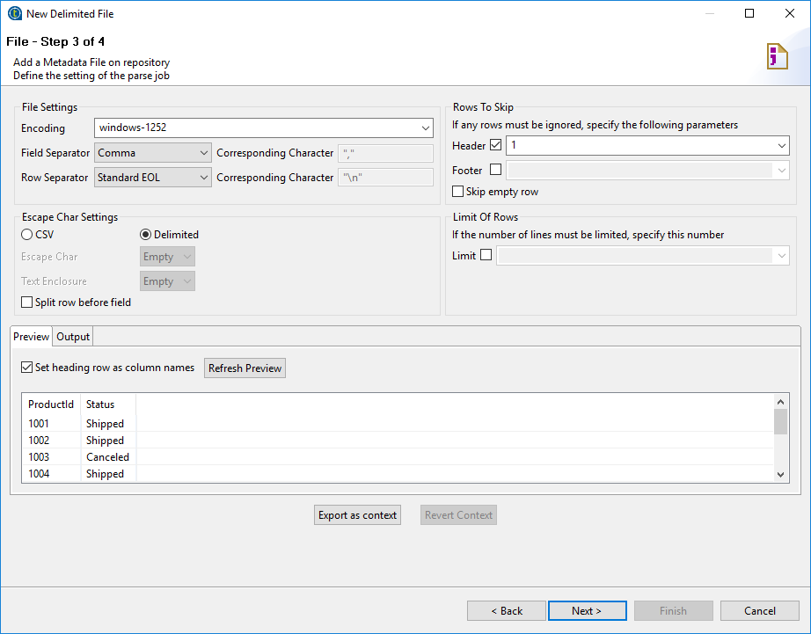

Step 5: Give name and click on finish.

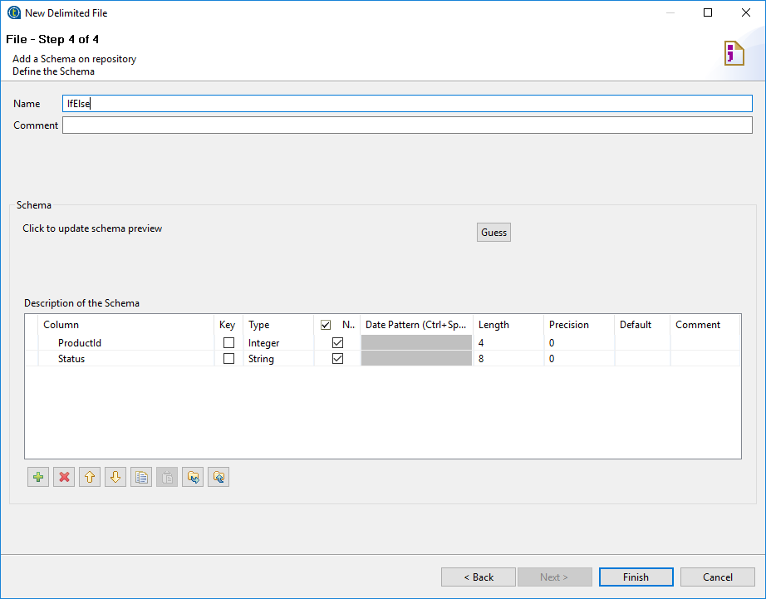

Step 6: Drag and drop csv file select as tFileInputDelimited into workspace.



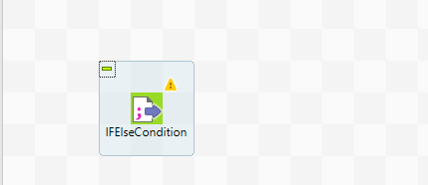

Step 7: Drag and Drop ‘tMap’ component and connect to the ‘tFileInputDelimited’ component.

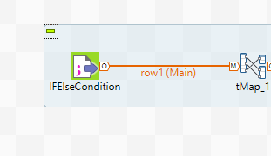

Step 8: Drag and Drop ‘tLogRows’ component and connect to the ‘tMap’ component.

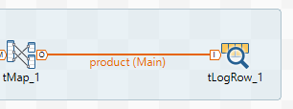

Step 9: Double click on ‘tMap’ component and set the condition and mapping it.

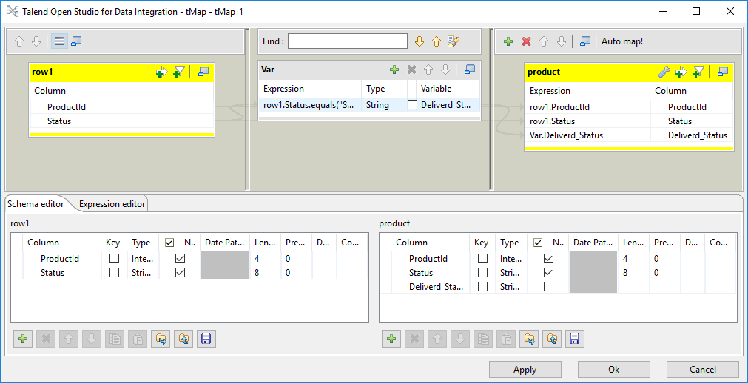

Step 10: Run the job and see the output.

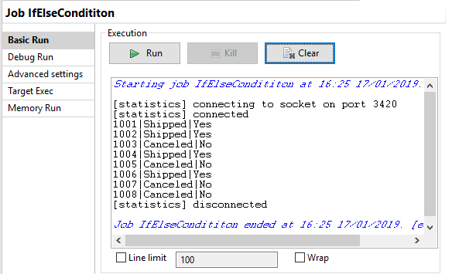

**Normalization Data in Talend Studio**

Step 1: Expand the Metadata and select the File Excel and create new file.

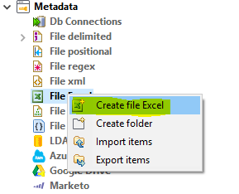

Step 2: Give the name to file and click on Next.

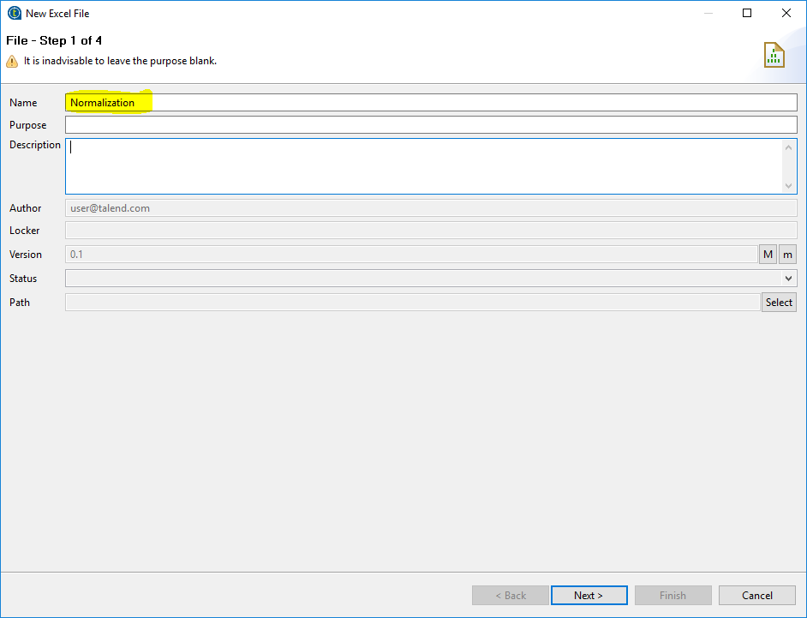

Step 3: Browse the file and select the sheet. Click on Next.

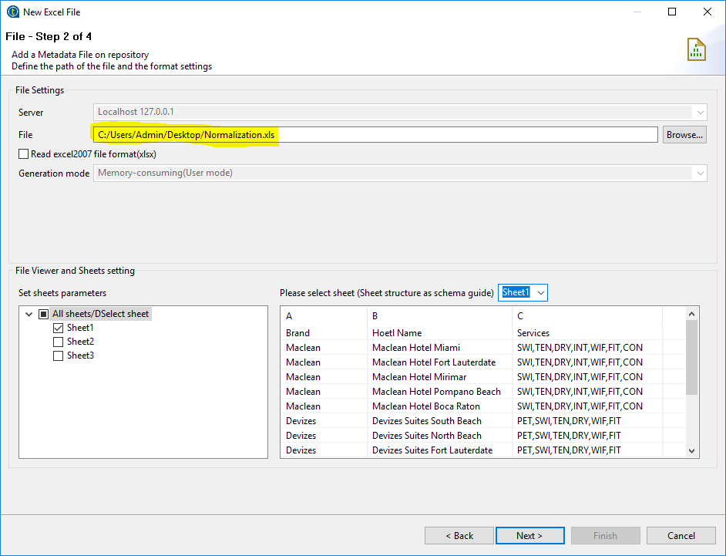

Step 4: Select Encoding as shown below and click on Next.

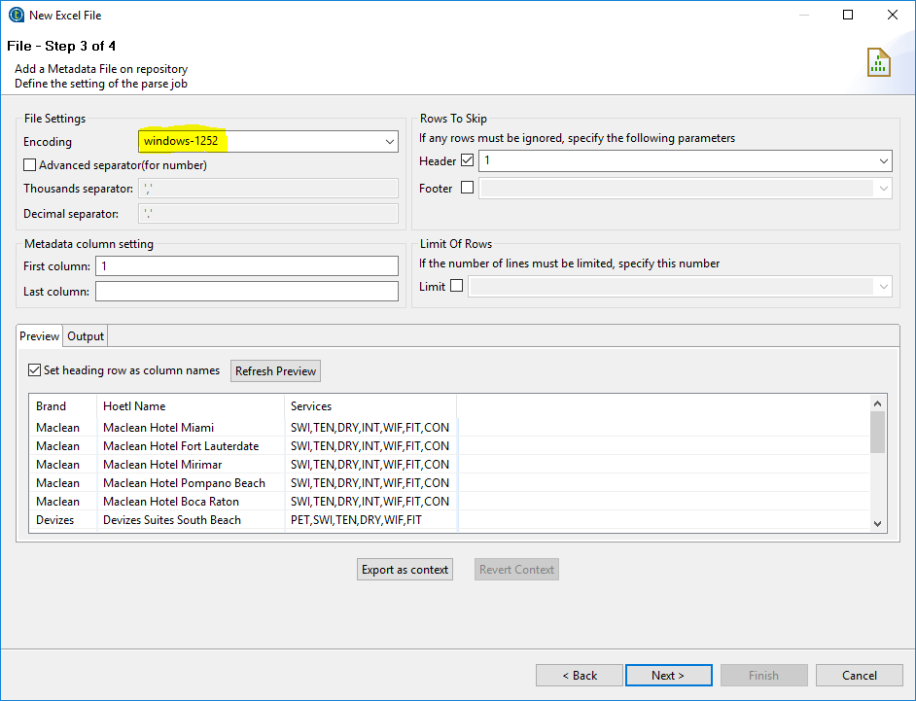

Step 5: Give the name and click on finish.

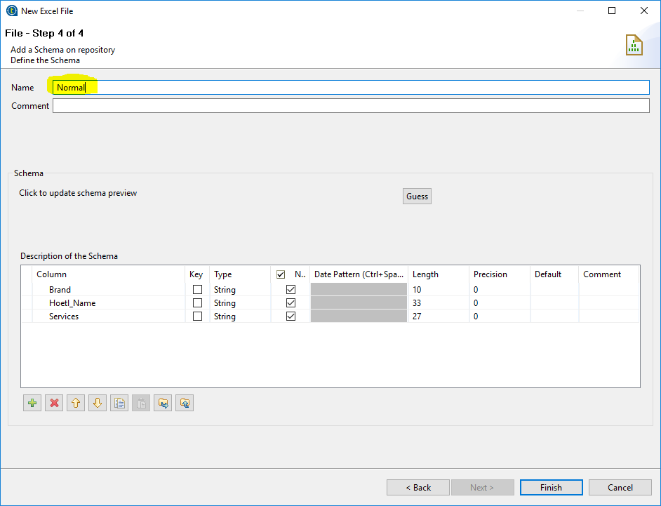

Step 6: Drag and Drop Excel File into the workspace.

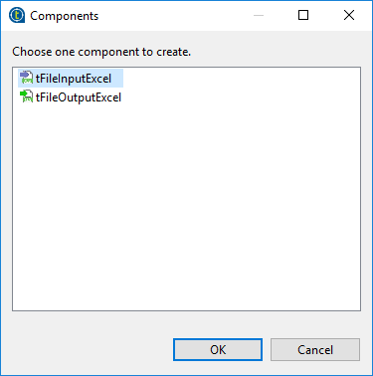

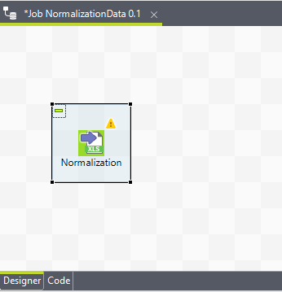

Step 7: Drag and Drop the ‘tNormalize’ component and connect with excel file.

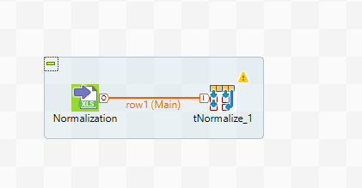

Step 8: Select the ‘tNormalize’ component and change properties ‘column to normalize’ of the componenet.

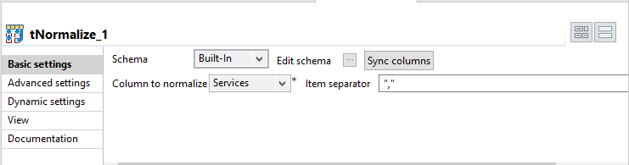

Step 9: Drag and Drop the ‘tFilterColumn’ component to workspace and connect with ‘tNormalize’ component.

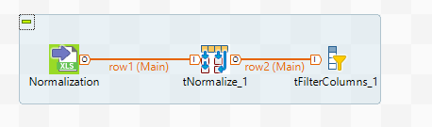

Step 10: Select ‘tFilterColumns’ component and select the ‘Edit Schema’ option and select the columns to display it as shown below snap.

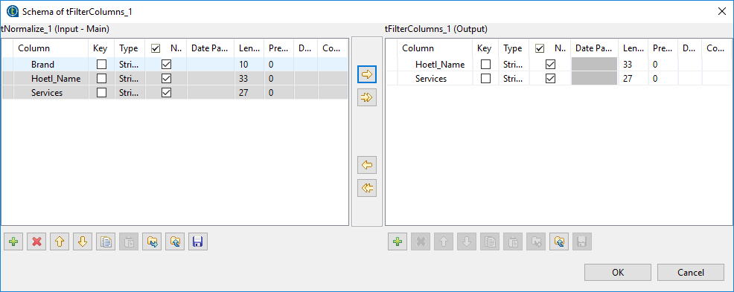

Step 11: Drag and Drop the ‘tLogRow’ component and connect with ‘tFilterColumns’ component.

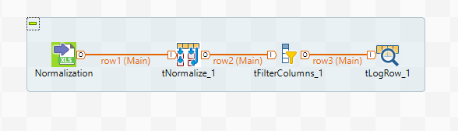

Step 12: Run the job and see the output.

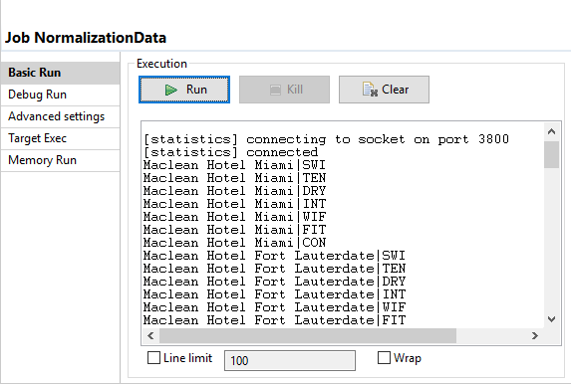

Conversion component in Talend

Step 1: Drag and Drop ‘tFileInputDelimited’ component and Double click on component.

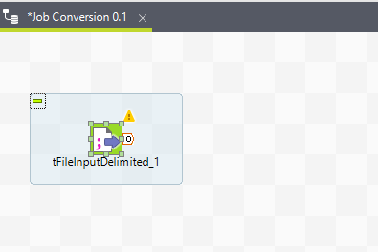

Step 2: Set the properties of ‘tFileInputDelimited’component as shown below.

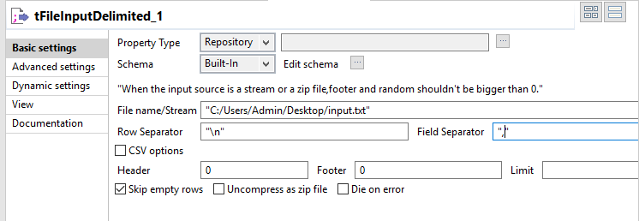

Step 3: Click on ‘Edit Schema’ and add columns. Click on ok.

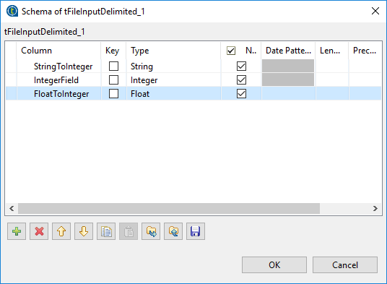

Step 4: Drag and Drop ‘tConvertType’ component and Double click on component and connect with ‘tFileInputDelimited’ component.

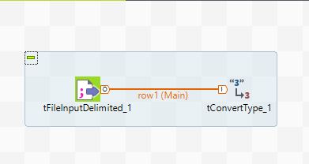

Step 5: Set the properties of ‘tConvertType’component and click on sync columns as shown below.

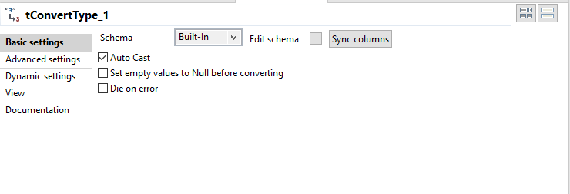

Step 6: Click on ‘Edit Schema’ and add columns. Click on ok.

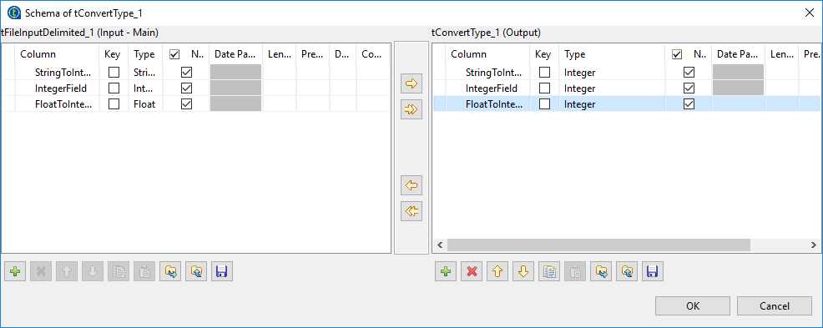

Step 7: Double click on ‘tMap’ component and click on map editor. Add the columns on mapping side.

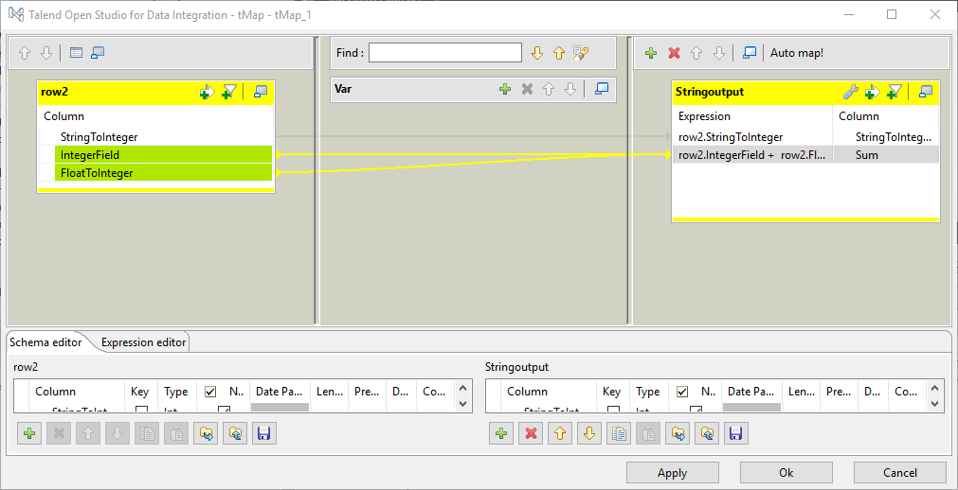

Step 8: Drag and Drop ‘tLogRow’ component and connect with ‘tMap’ component.

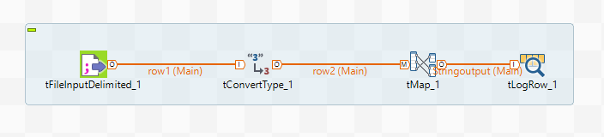

Step 9: Run the job and see the output.

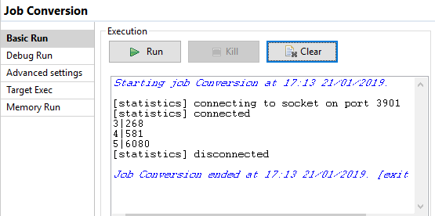

**Deployment in Talend**

Step 1: Drag and Drop ‘tJava’ component on workspace.

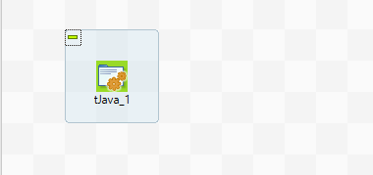

Step 2: Drag and Drop ‘tFileInputDelimited’ component.

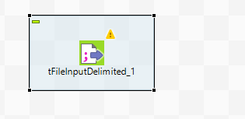

Step 3: Double click on ‘tFileInputDelimited’ component and set the file path.

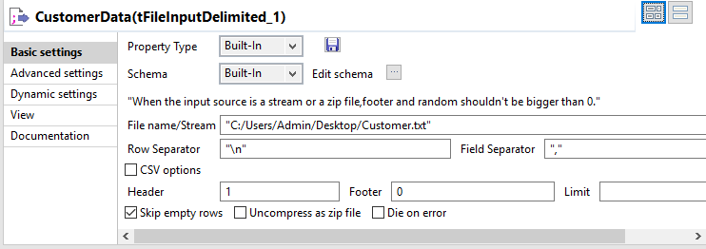

Step 4: Drag and Drop ‘tLogRow’ component in workspace and connect with ‘tFileInputDelimited’ component.

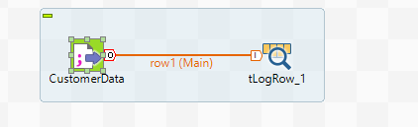

Step 5: Create the context group.

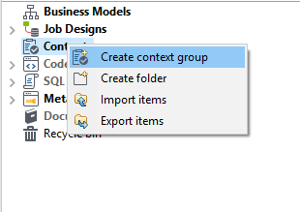

Step 6: Give name and click on Next.

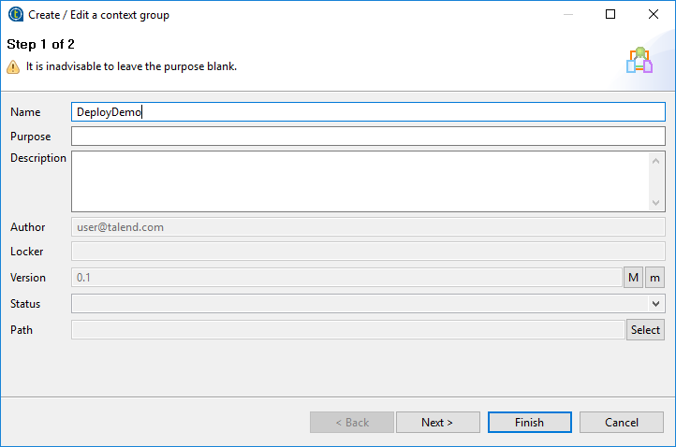

Step 7: Click on plus sign and add variable.

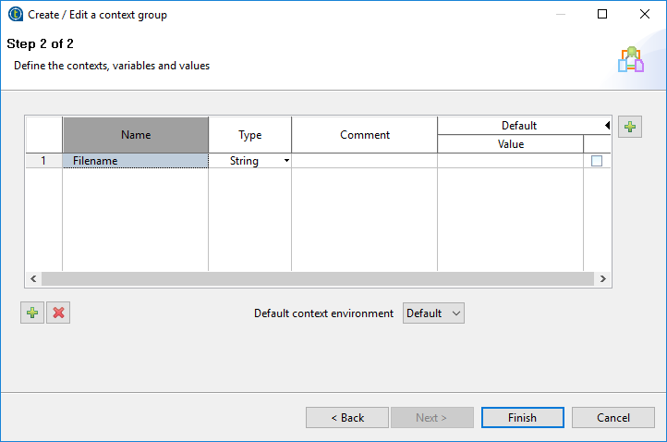

Step 8: Click on plus sign on right hand side and add context. Click on New button and Give the name to context.

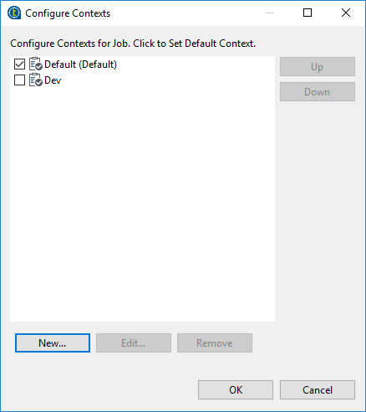

Step 9: Set the path of input file in context and click on Finish.

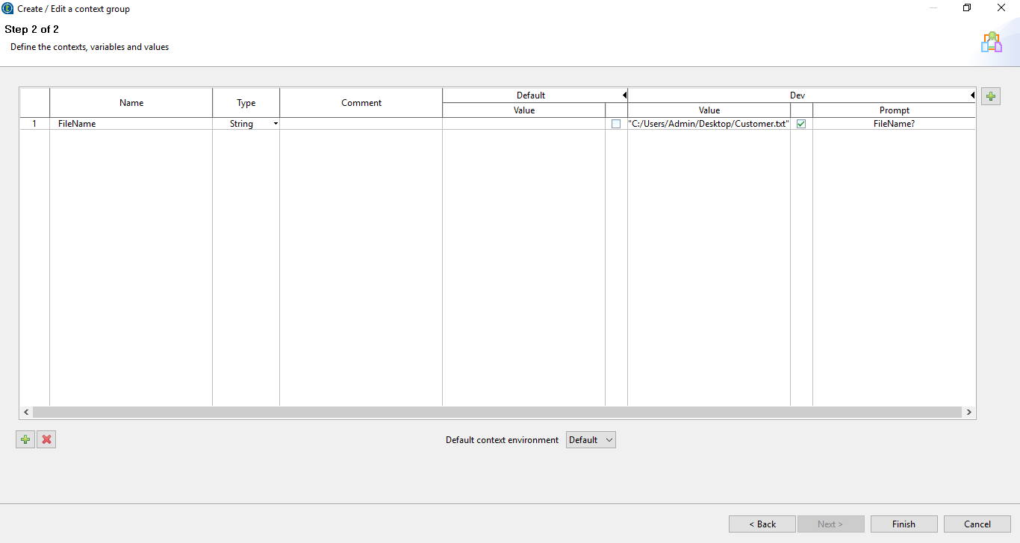

Step 10: Double click on ‘tJava’ component and write the code as shown below.

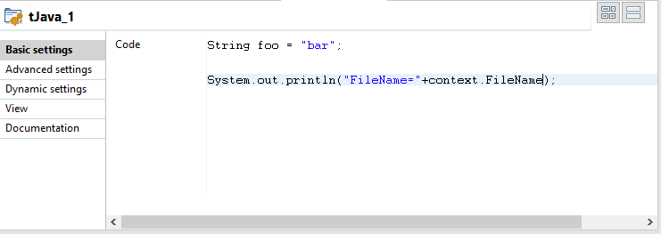

Step 11: Double click on ‘tFileInputDelimited’ component and change the Filename.

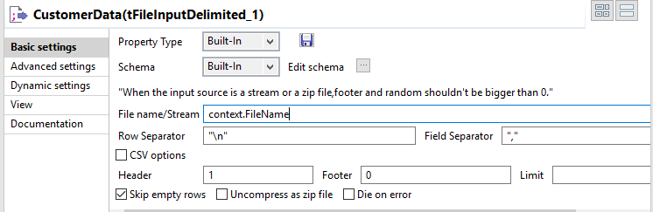

Step 12: Deactivate the ‘tFileInputDelimited’ and ‘tLogRow’ component.

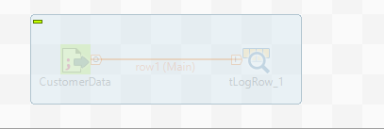

Step 13: Click on Context and select the context.

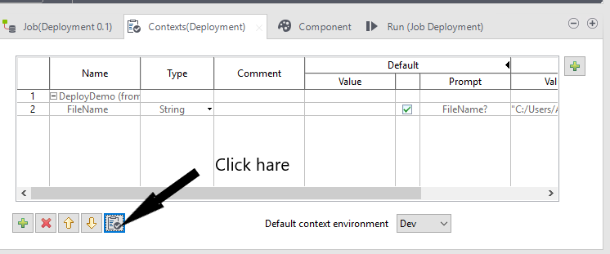

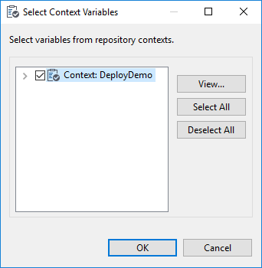

Step 14: Run the job and give the filename as shown below.

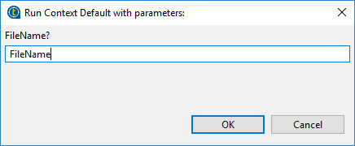

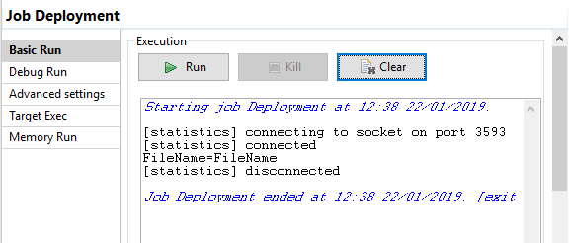

Step 15: Activated ‘tFileInputDelimited’ and ‘tLogRow’ component.

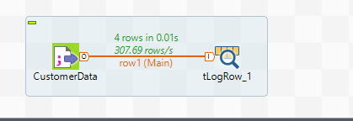

Step 16: Select Run tab and select the context in right hand side.

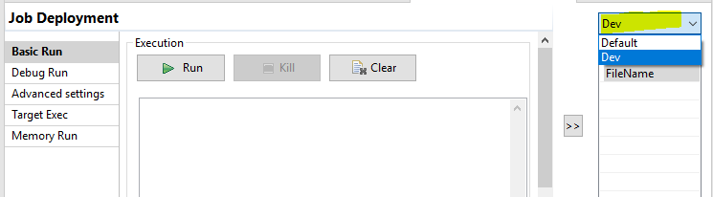

Step 17: Run the job.

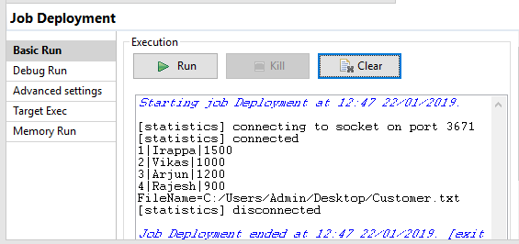

**Loop and FileRowCount component in Talend**

Step 1: Drag and Drop ‘tFileRowCount’ to the workspace.

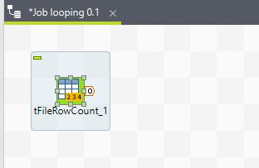

Step 2: Double click on ‘tFileRowCount’ and set path for input file.

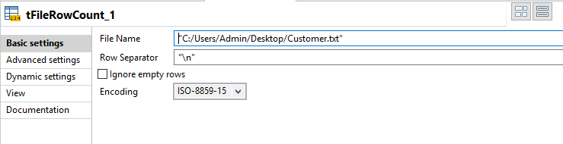

Step 3: Drag and Drop ‘tLoop’ component in to the workspace.

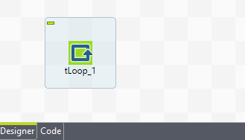

Step 4: Click on context tab. Create the context variables as shown below.

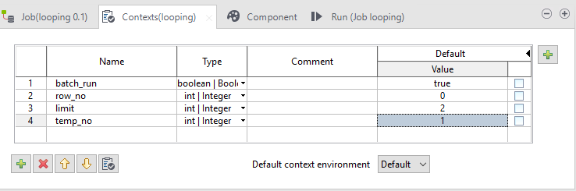

Step 5: Double click on ‘tLoop’ component and set the condition.

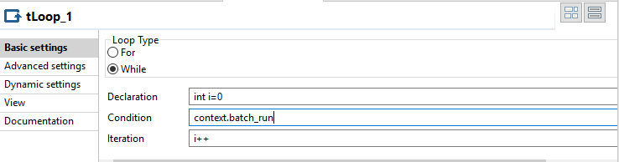

Step 6: Right click on ‘tFileRowCount’ component and select Trigger then select ‘on subjob ok’ option and connect arrow with ‘tLoop’ component.

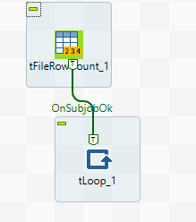

Step 7: Drag and Drop ‘tFileInputDelimited’ component in to the workspace and right click on ‘tLoop’ component select Row then select ‘Iterate’ option and connect with ‘tFileInputDelimited’ component and also drag and drop ‘tLogRow’ component and connect with ‘tFileInputDelimited’ component.

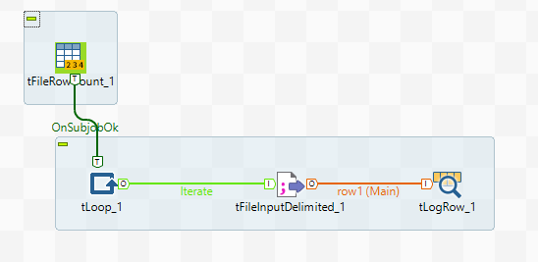

Step 8: Double click on ‘tFileInputDelimited’ component and set the path of file and Edit the schema and add columns in schema.

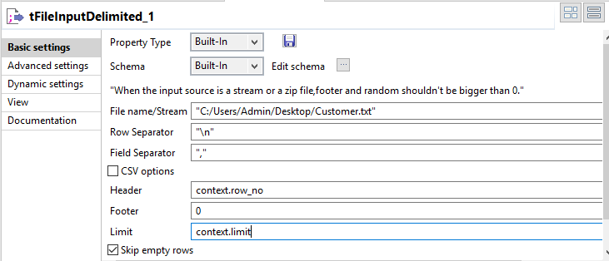

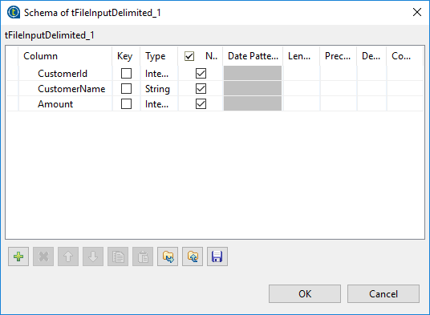

Step 9: Drag and Drop ‘tJavaFlex’ component and connect with ‘tLogRow’ component.

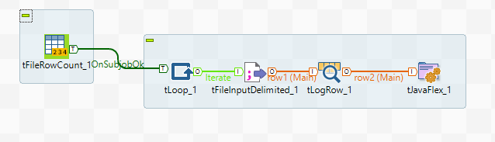

Step 10: Double click on ‘tJavaFlex’ component and write the code as shown below.

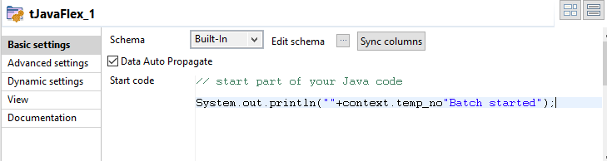

Step 11: Drag and Drop ‘tJava’ component and Right click on ‘tFileRowCount’ component and select Trigger then select ‘on component ok’ option and connect arrow with ‘tJava’ component.

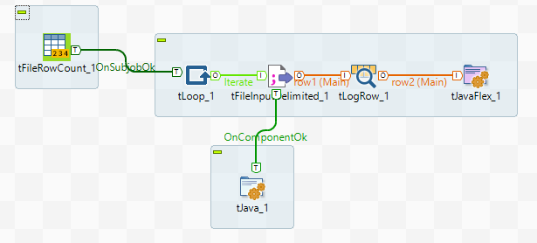

Step 12: Double click on ‘tJava’ component and write the code as shown below.

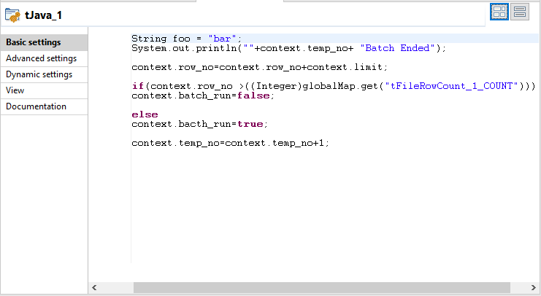

Step 13: Run the job.

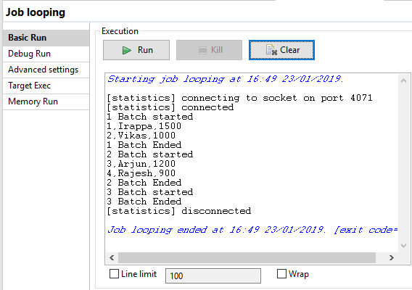

**Pass parameter and variable to child job in Talend**

Step 1: Right click on job designs and select create job. I have created two jobs ‘Parent_context’ and ‘Child_context’.

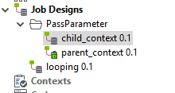

Step 2: In the parent job we have drag and drop ‘tFileInputDelimited’, ‘tLogRow’ and ‘child job’ also connecting to each other.

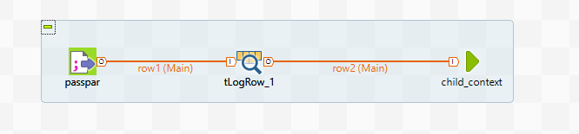

Step 3: Double click on ‘tFileInputDelimited’ component and set the file name and other fields as shown below.

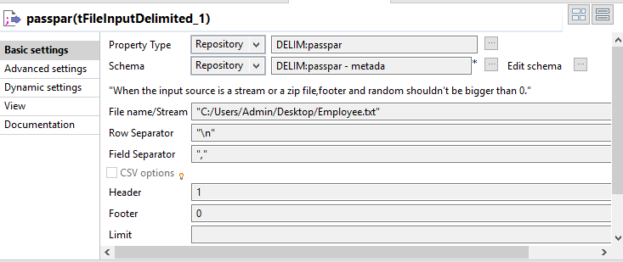

Step 4: Double click on ‘tLogRow’ component and Edit the schema.

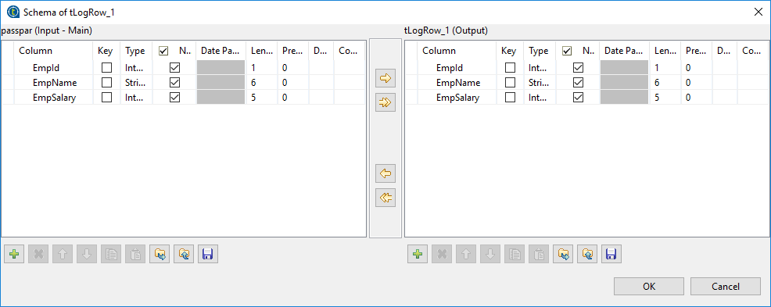

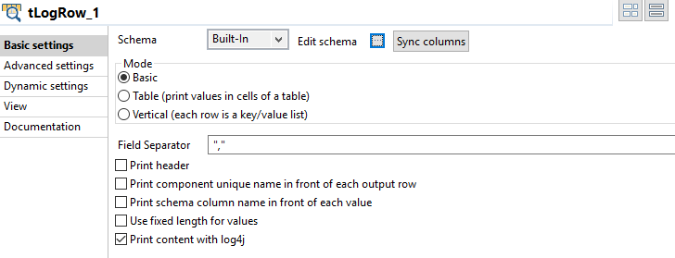

Step 5: In the child job we have drag and drop ‘tJava’ component.

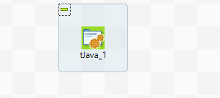

Step 6: Double click on ‘tJava’ component and write the code as shown below.

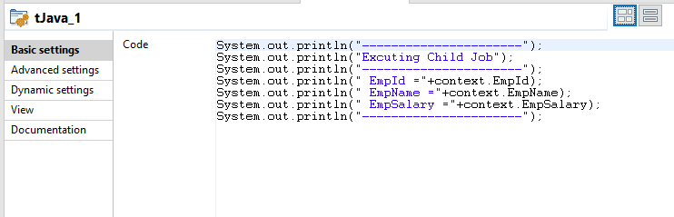

Step 7: In the parent job select the ‘child_context’ component and select the component tab and set the parameter.

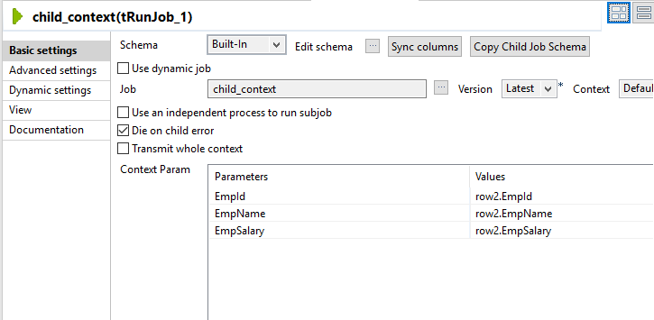

Step 8: Run the job.

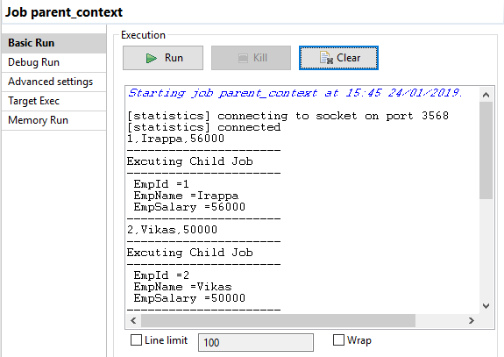

**Buffer output usage in Talend**

Step 1: Right click on job designs and select create job. I have created two jobs ‘BufferOutput_Parent’ and ‘BufferOutput_child’.

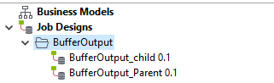

Step 2: Drag and Drop ‘tFixedFlowInput’ component into the workspace.

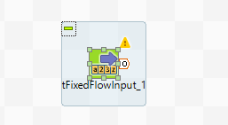

Step 3: Double click on ‘tFixedFlowInput’ component and Edit the schema then add columns.

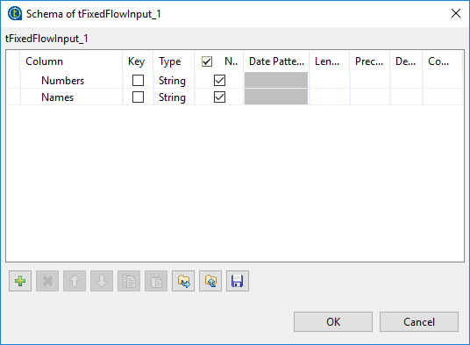

‘Use inline table’ option and add values.

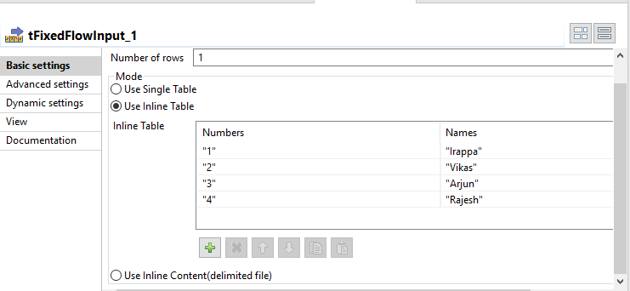

Step 4: Drag and Drop ‘tBufferOutput’ component in to the workspace and connect with ‘tFixedFlowInput’.

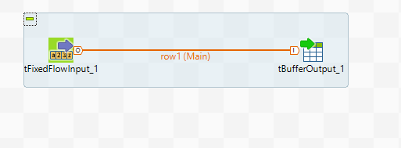

Step 5: Drag and Drop the child job into the parent job.

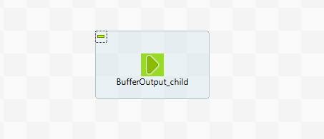

Step 6: Drag and Drop ‘tJavaRow’ and ‘tLogRow’ into the workspace then connect component each other.

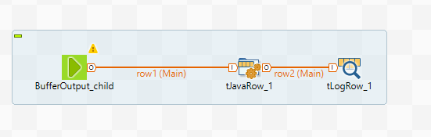

Step 7: Double click on ‘BufferOutput_child’ component and click on copy child schema button then edit schema.

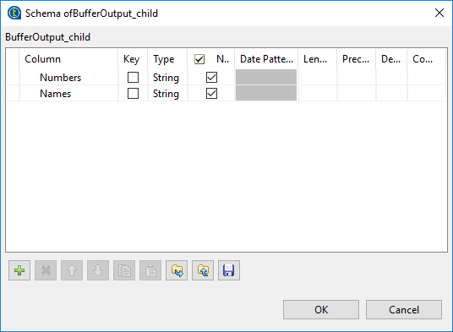

Step 8: Double click on ‘tJavaRow’ component and edit schema then click on double arrow button.

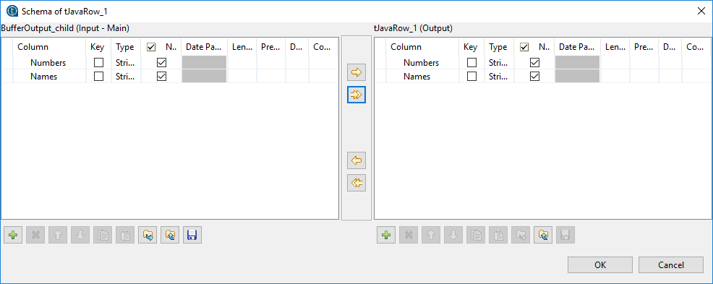

Step 9: click on generate code button.

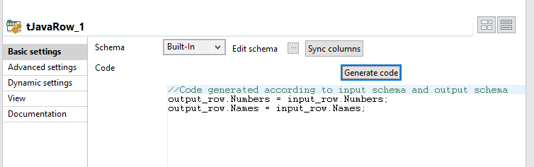

Step 10: Run the job.

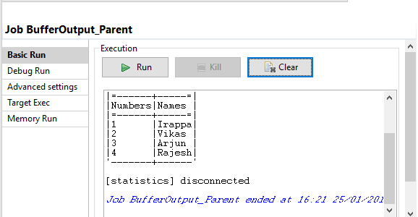

**Sending Mail in Talend**

Step 1: Drag and Drop ‘tFixedFlowInput’ in to the workspace.

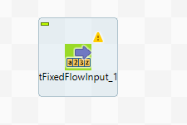

Step 2: Double click on ‘tFixedFlowInput’ component and edit the schema then add columns.

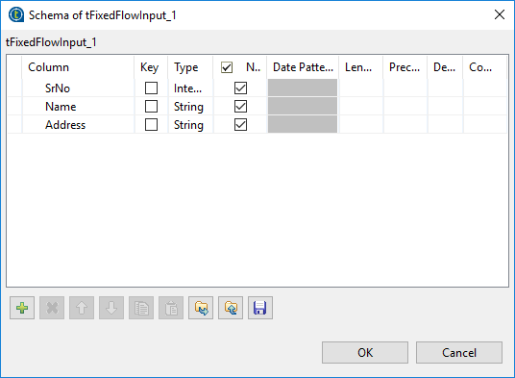

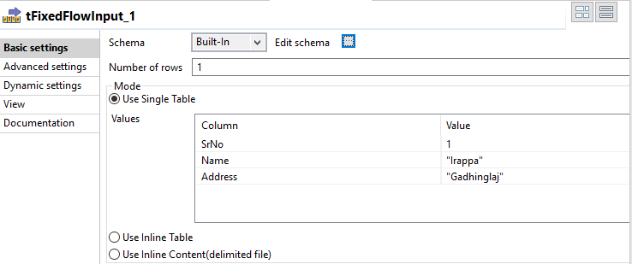

Step 3: Drag and Drop ‘tSendMail’component into the workspace and connect with each other.

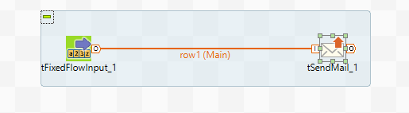

Step 4: Double click on ‘tSendMail’ component and set the properties of that component as shown below.

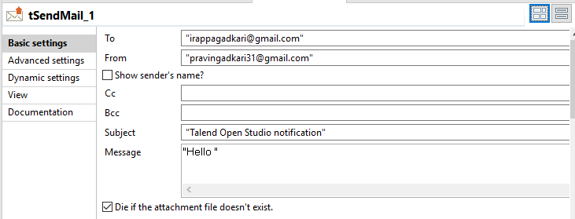

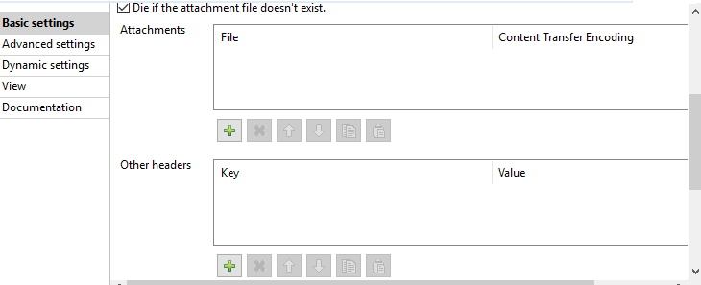

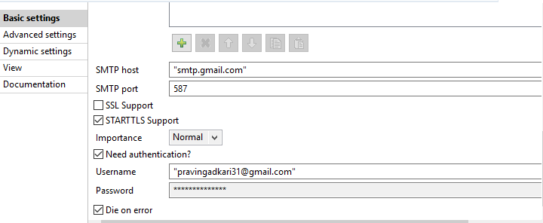

Step 5: Run the job.

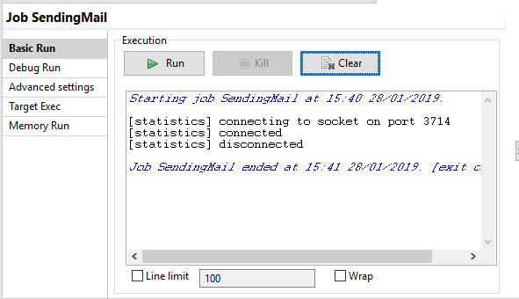

Step 6: See the Mail.

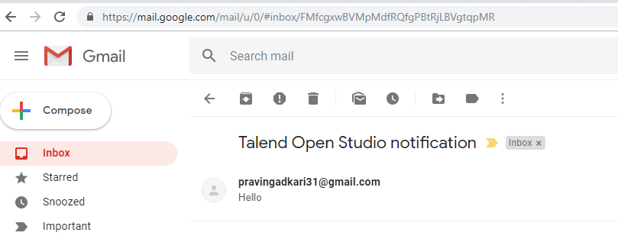

**File Processing in Talend**

Step 1: Create the new job. Click on Finish

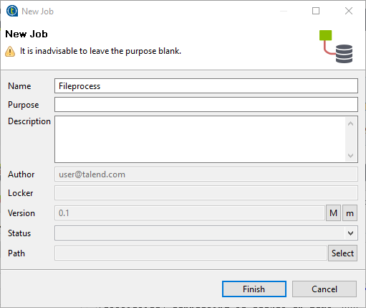

Step 2: In the metadata right click on ‘File Excel’ and select ‘create file excel’ option.

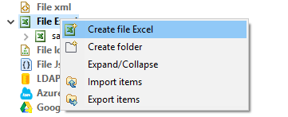

Step 3: Give name to the file and click on next.

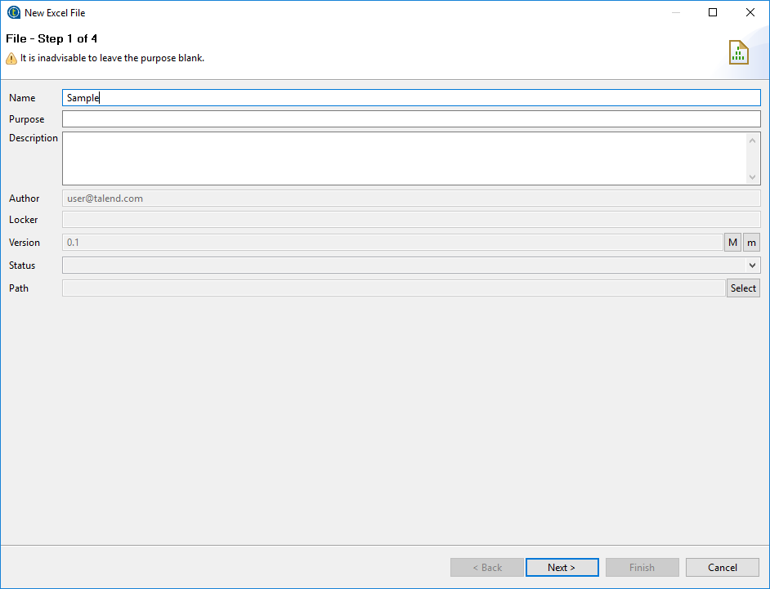

Step 4: Brows file and select the sheet then click on next.

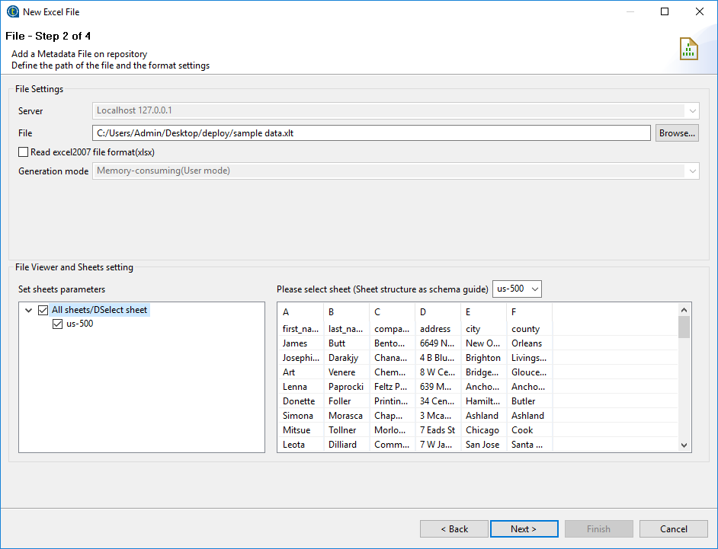

Step 5: Click on checkbox ‘set heading row as column name’ then refresh preview and click on next.

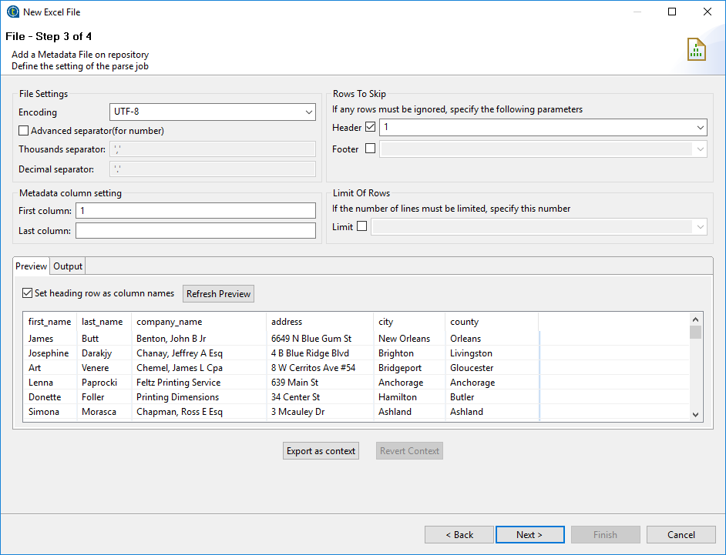

Step 6: Click on Finish.

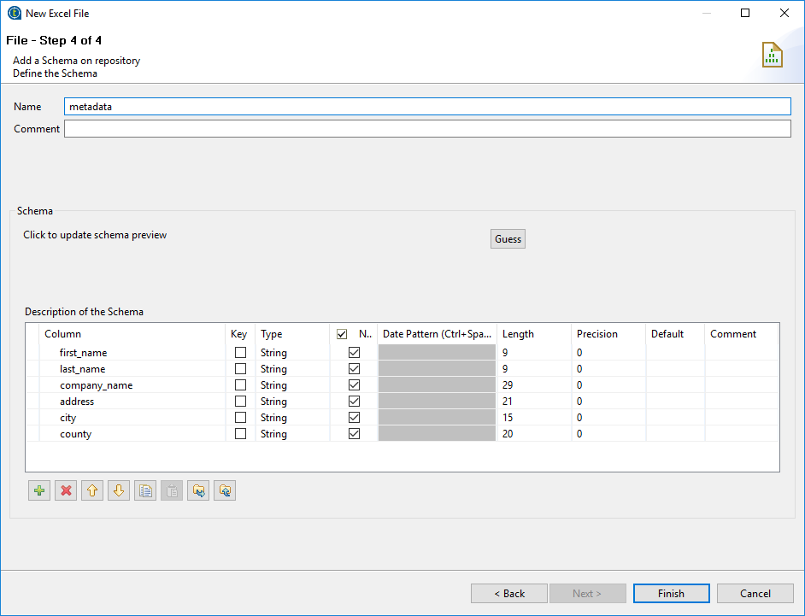

Step 7: Drag and Drop ‘Sample Excel file’ into the workspace as input file.

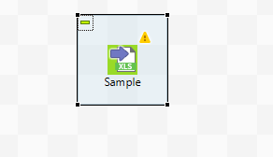

Step 8: Drag and Drop ‘tFileList’ and ‘tLogRow’ component then connect each other.

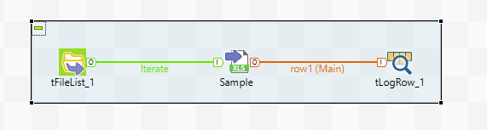

Step 9: Create context group.

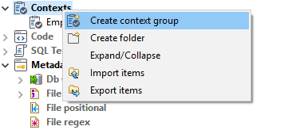

Step 10: Give name to the context group and click on next.

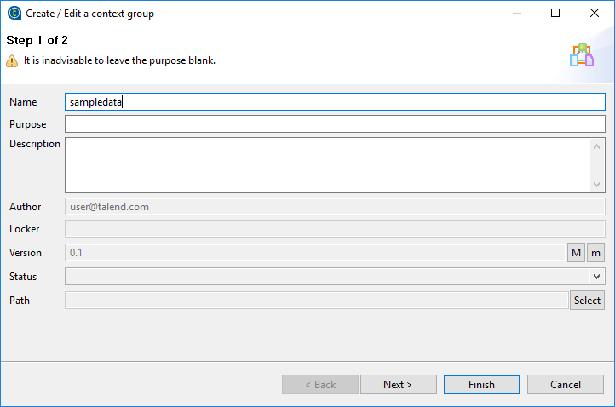

Step 11: Click on plus sign then add variable and set value shown as below.click on finish.

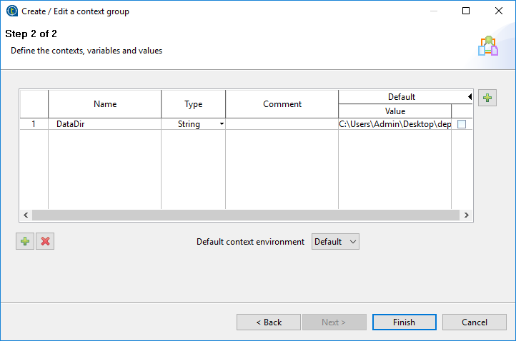

Step 12: Click on context tab and select option shows in below snap.

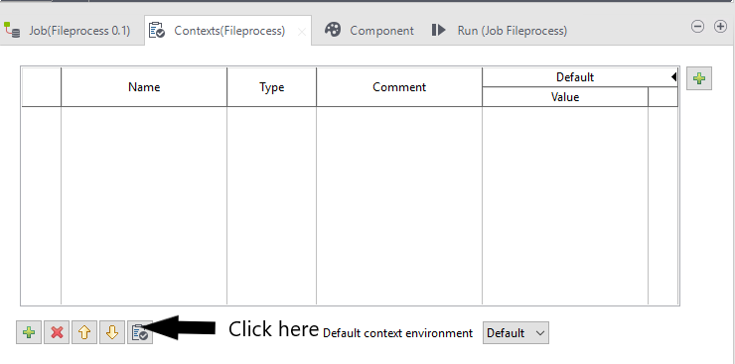

Select context variable and click on view then ok button is click.

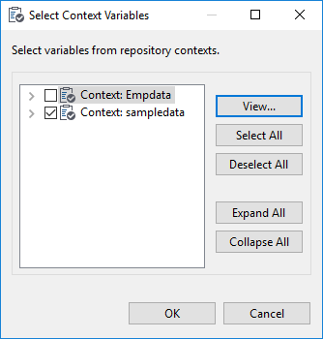

Step 13: Double click on ‘tFileList’ component and set properties as shown below.

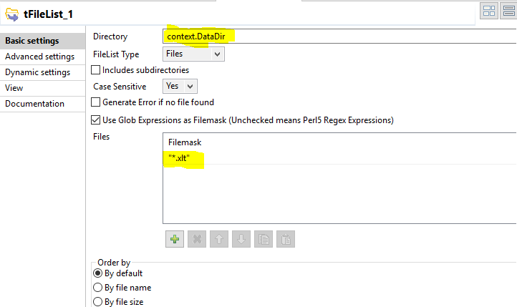

Step 14: Double click on Excel file component and set the below properties show in snap.

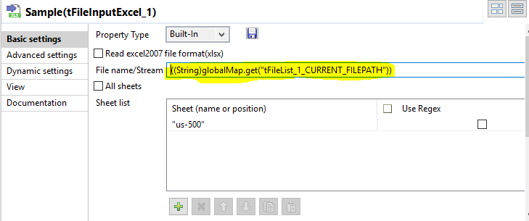

Step 15: Double click on ‘tLogRow’ component and select ‘Table’ option.

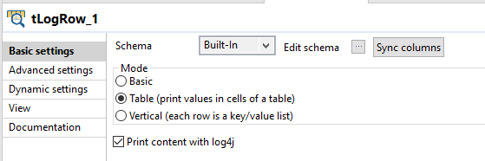

Step 16: Run the Job.

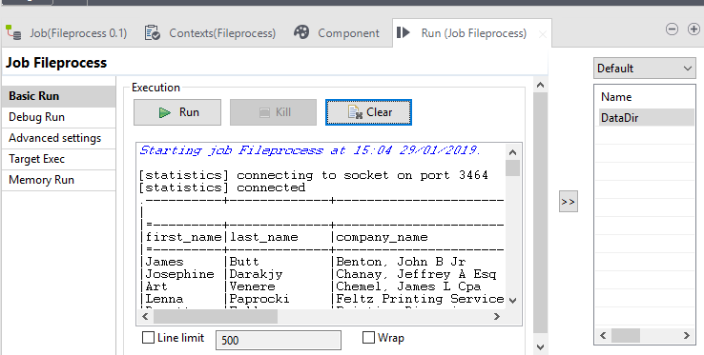

**Usage of ‘tFileDelete’ and ‘tSleep’ component in Talend**

Step 1: Create the job.

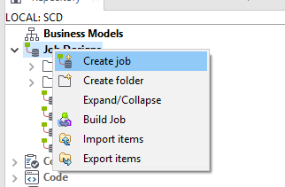

Give name and click on Finish.

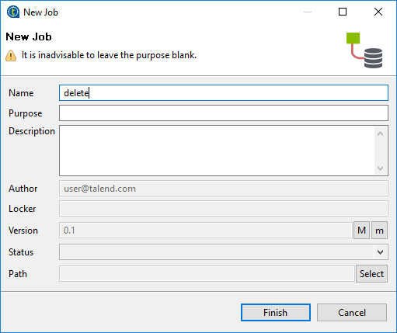

Step 2: Drag and Drop ‘tFileDelete_1’ and ‘tSleep_1’ component into the Workspace.

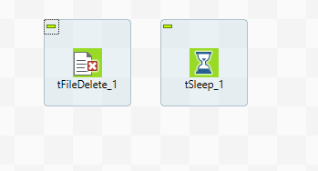

Step 3: Double click on ‘tFileDelete_1’ component and browse the file.

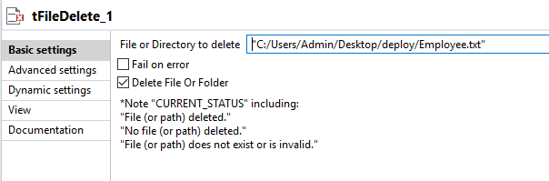

Step 4: Double click on ‘tSleep_1’ component and set the time.

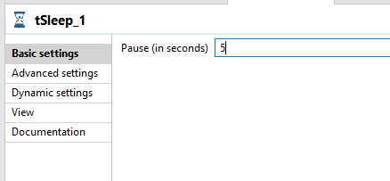

Step 5: Right click on ‘tFileDelete_1’ component and select ‘Trigger’ option then ‘onSubJobOk’ option. Same process for all components and connect with each other.

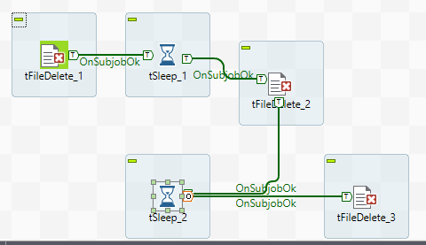

Step 6: Double click on ‘tSleep_2’ component and set the time.

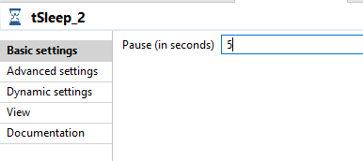

Step 7: Double click on ‘tFileDelete_2’ component and browse the folder.

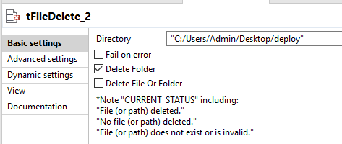

Step 8: Double click on ‘tFileDelete_3’ component and browse the folder.

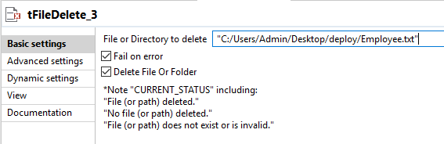

Step 9: Run the job.

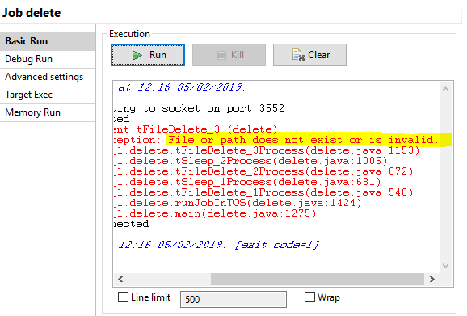

It give error because of I have selected fail on error option in component ‘tFileDelete_3’ and kill the job.

Step 10: Before deleting folder and file.

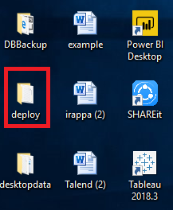

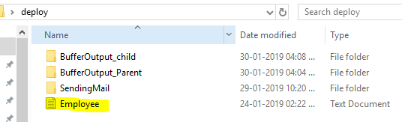

Step 11: After deleting.

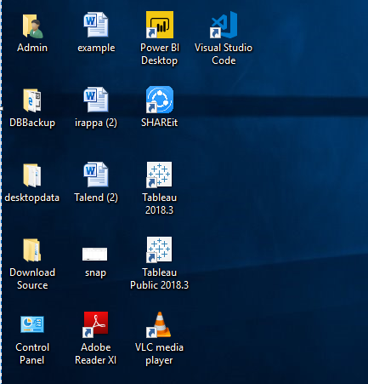

**Replicate component in Talend**

Step 1: Create the job.

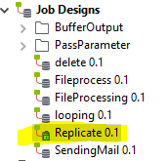

Step 2: Drag and Drop ‘tFileInputDelimited’ and ‘tReplicated’ component in to the workspace and connect with each other.

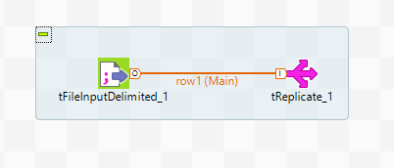

Step 3: Double click on ‘tFileInputDelimited’and browse file and set other properties.

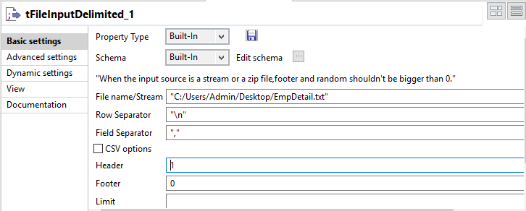

Click on Edit Schema and columns.

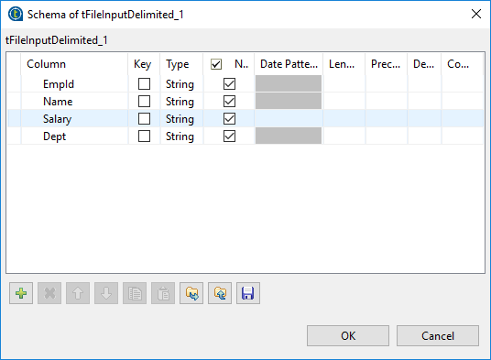

Step 4: Double click on ‘tReplicate’ component and Click on sync column and edit schema.

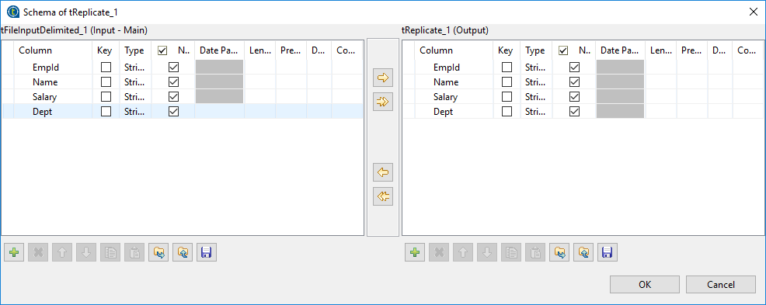

Step 5: Drag and Drop 2 times ‘tLogRow’ component into the workspace and connect to ‘tReplicate’ component.

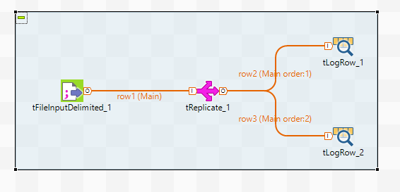

Step 6: Double click on ‘tLogRow’ component and click on sync column then select ‘Table’ option.

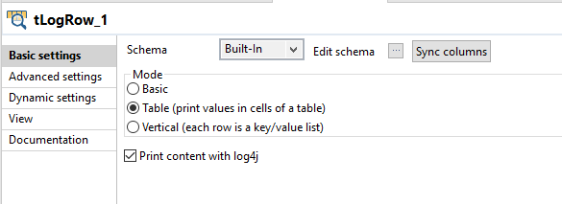

Click on Edit schema.

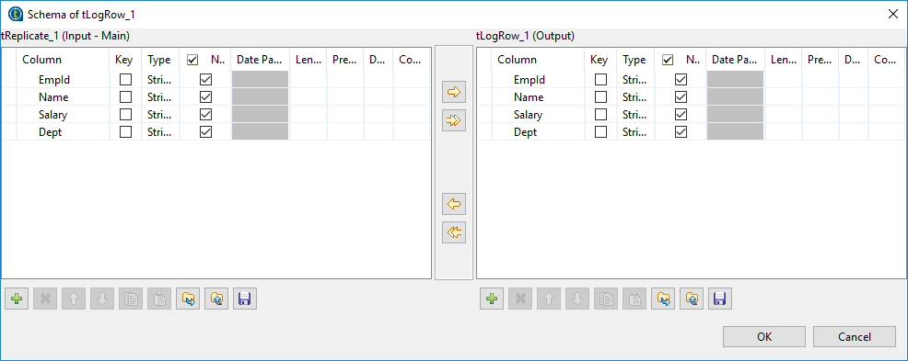

Step 7: Step 6 same for second ‘tLogRow’ component.

Step 8: Run the job.

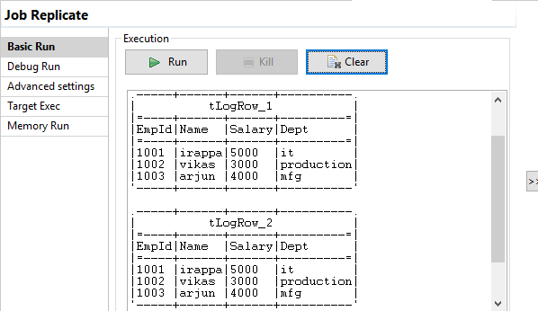

**Usage ‘tUnite’ component in Talend**

Step 1: Create the job.

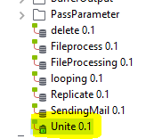

Step 2: Drag and Drop ‘tFileInputDelimited’ and ‘tUnite’ component in to the workspace and connect with each other.

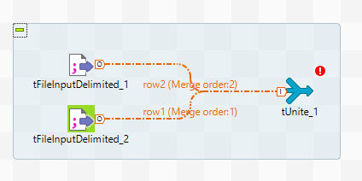

Step 3: Double click on ‘tFileInputDelimited_1’and browse file and set other properties.

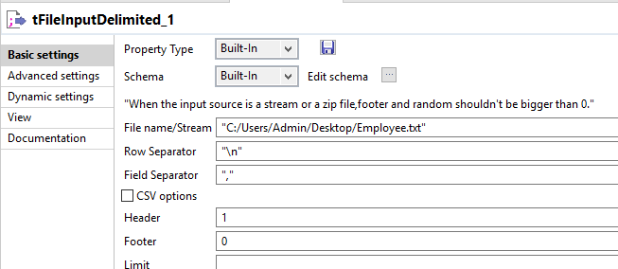

Click on Edit Schema and columns.

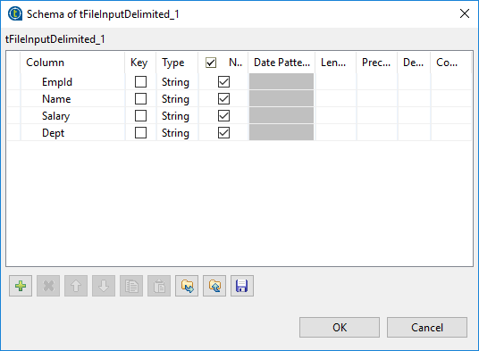

Step 4: Double click on ‘tFileInputDelimited_2’and browse file and set other properties.

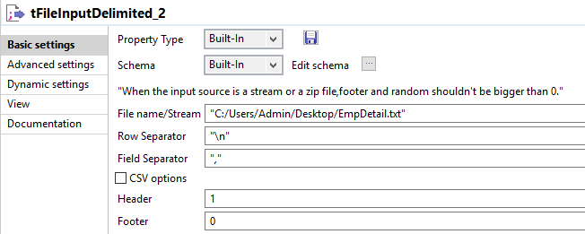

Click on Edit Schema and columns.

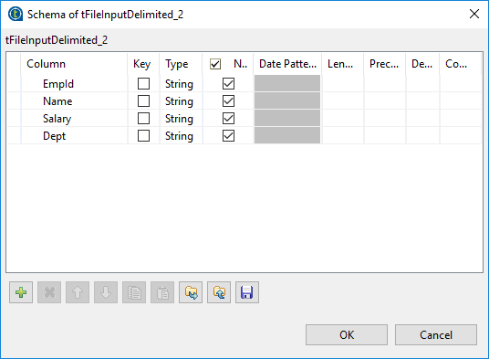

Step 5: Double click on ‘tUnite’ component and Click on sync column and edit schema.

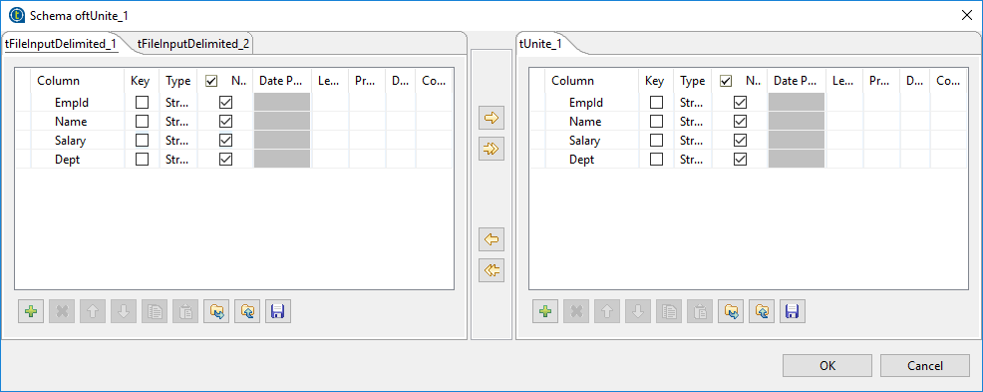

Step 6: Drag and Drop ‘tLogRow’ component into the workspace and connect to ‘tUnite’ component.

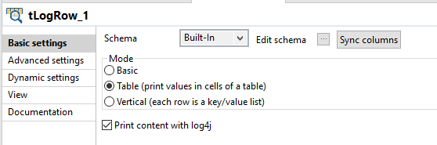

Click on Edit schema.

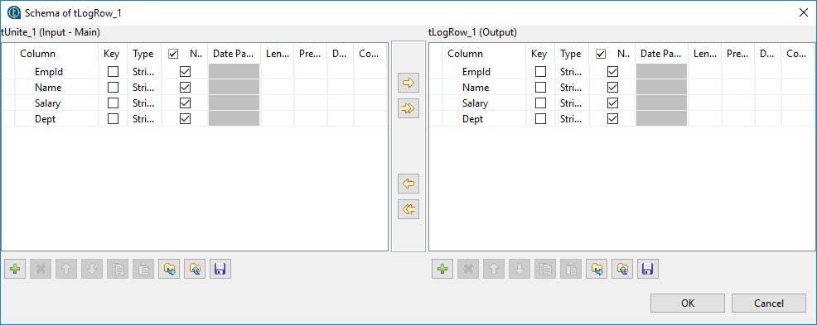

Step 7: Run the job.

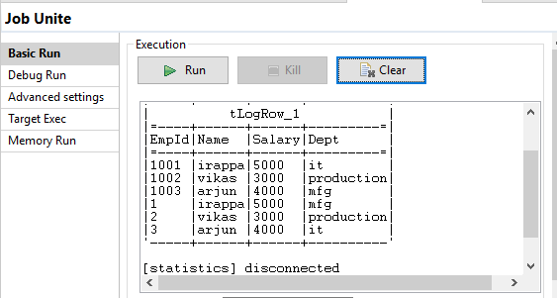

**File Properties component in Talend**

Step 1: Drag and Drop ‘tFileProperties’ and ‘tLogRow’ component in to workspace and connect to each other.

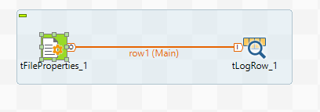

Step 2: Double click on ‘tFileProperties’ component and browse the file.

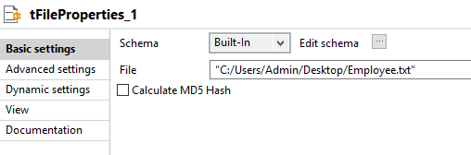

Click on Edit schema.

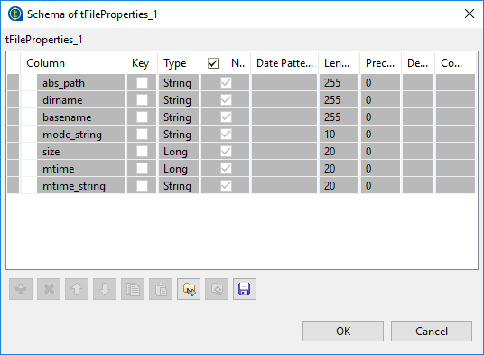

Step 3: Double click on ‘tLogRow’ component and select ‘Table’ option and click on sync column.

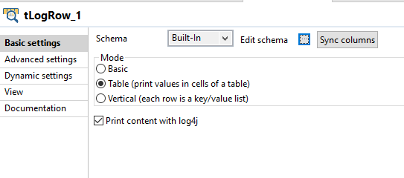

Step 4: Run the job.

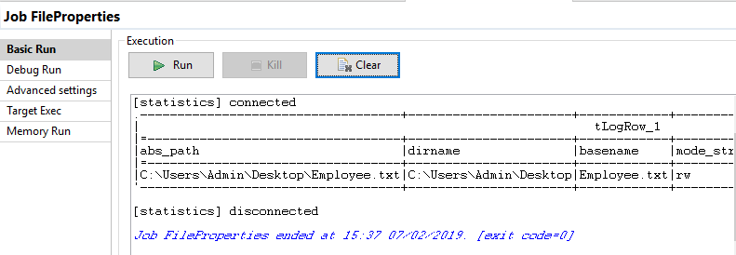

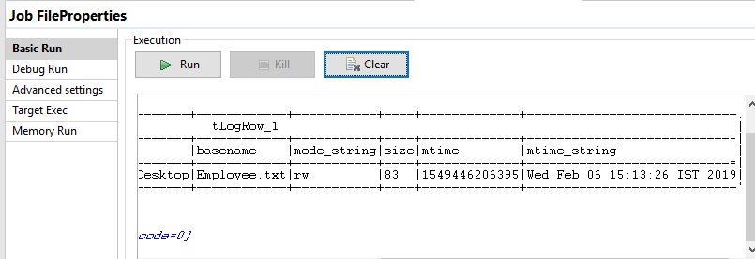

**Filter Columns in Talend**

Step 1: Drag and Drop ‘tFileInputDelimited’, ‘tFilterColumns’ and ‘tLogRow’ components in to workspace and connect to each other.

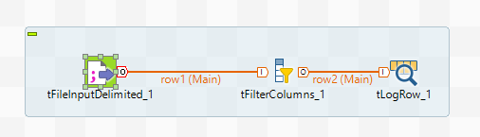

Step 2: Double click on ‘tFileInputDelimited’ component and browse the file then set other properties.

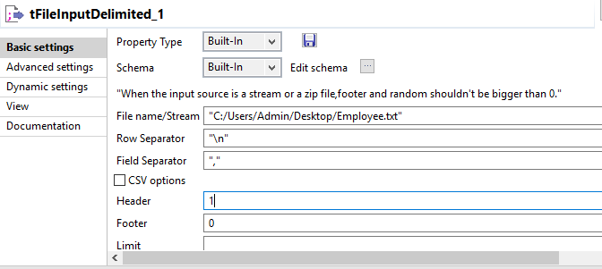

Click on Edit schema and add columns.



Step 3: Double click on ‘tFilterColumn’ component and click on sync table then edit schema and remove the ‘Dept’ column.

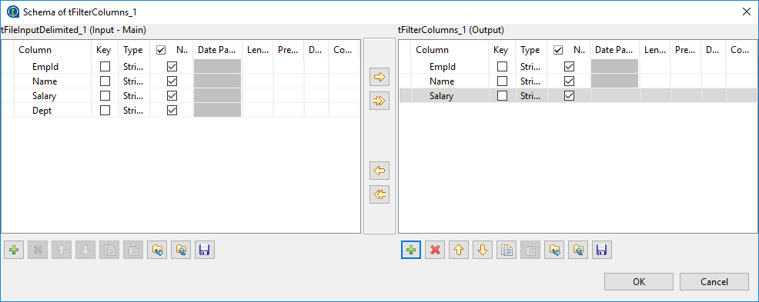

Step 4: Double click on ‘tLogRow’ component and click on sync table then select ‘Table’ option.

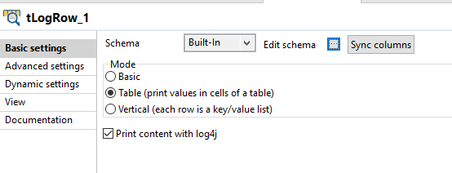

Click on Edit schema.

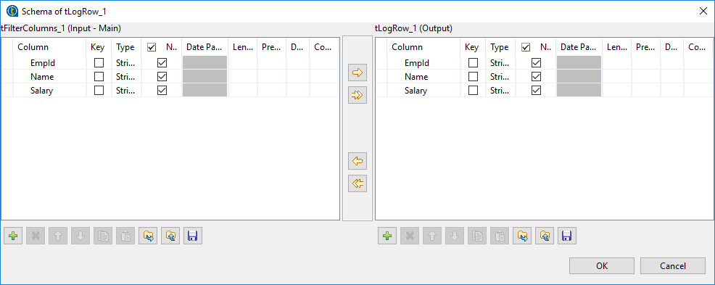

Step 5: Run the job.

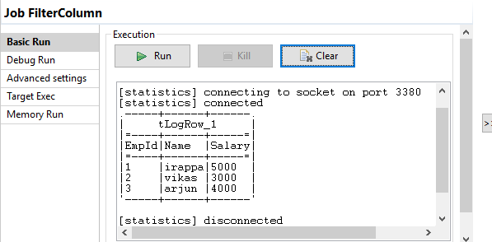

**Creating table in SQL Server using Talend**

Step 1: First I have created job.

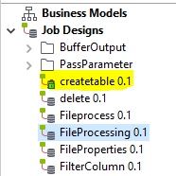

Step 2: Drag and Drop the ‘tCreateTable’ component in the workspace.

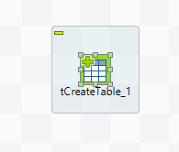

Step 3: Double click on ‘tCreateTable’ component and set the properties. As shown in below.

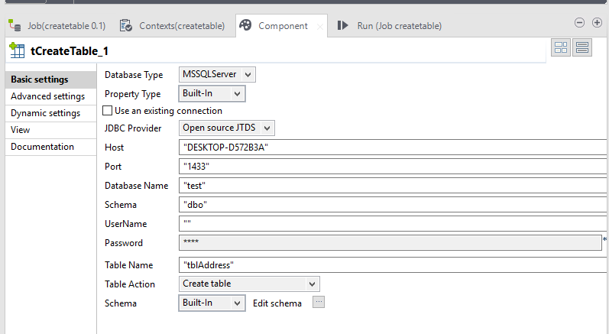

Step 4: Click on Edit Schema button.

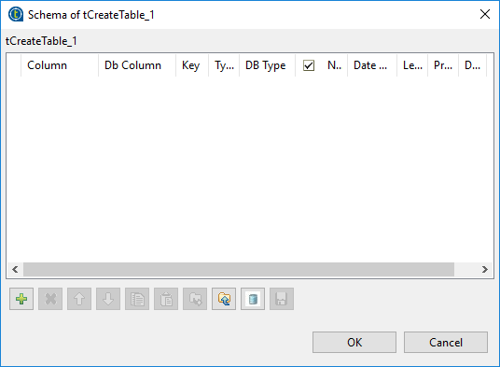

Step 5: Click on plus sign and add columns. Click on OK

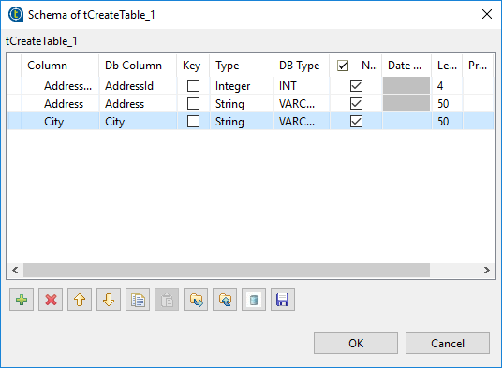

Step 6: Run the job.

Before database

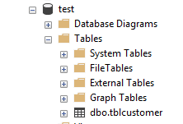

After running job see the database.

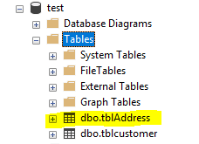

**Displaying selected data from Database table using Talend**

Step 1: Drag and Drop ‘tDBInput’ and ‘tLogRow’ component in to the workspace.

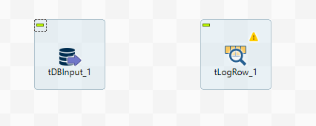

Step 2: ‘tDBInput’ and ‘tLogRow’ component and connect to each other.

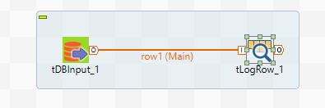

Step 3: Double click on ‘tDBInput’ component and set the properties and write query. As shown below.

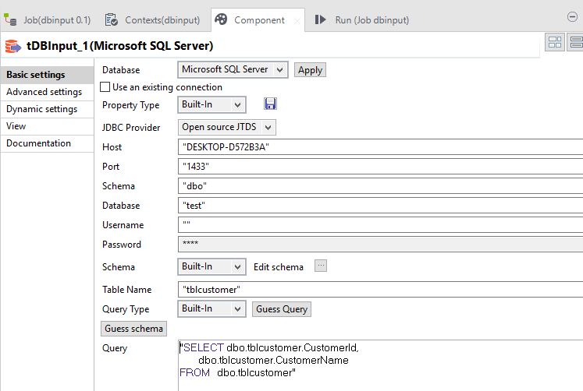

Step 4: Double click on ‘tLogRow’ component and select Table option also click on ‘sync columns’ button.

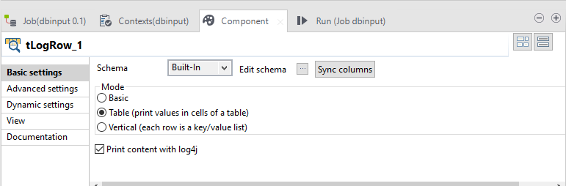

Step 5: Run the job.

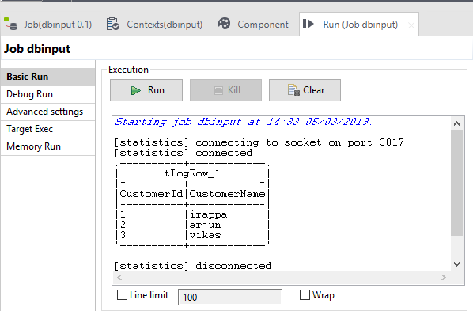

And also see in the database table.

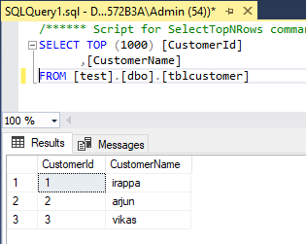

**Inserting rows in database table using Talend**

Step 1: Drag and Drop ‘tRowGenerator’ and ‘tDBOutput’ component in to the workspace.

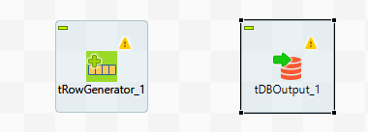

Step 2: ‘tRowGenerator’ and ‘tDBOutput’ component connect to each other.

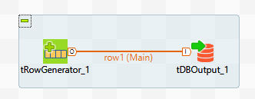

Step 3: Double click on ‘tRowGenerator’ component and column ‘Name’ and function.

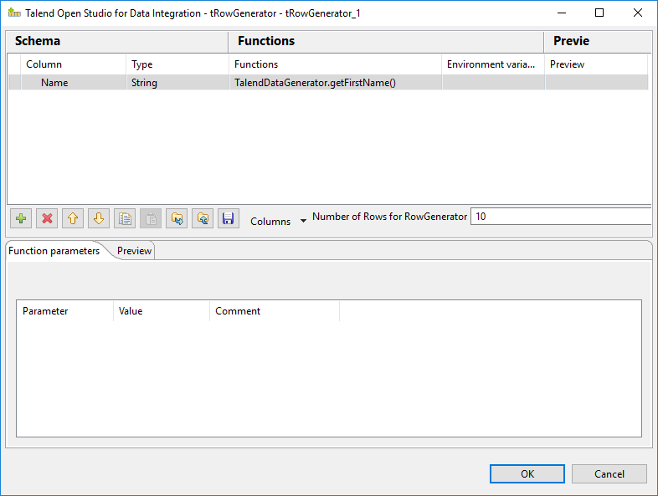

Step 4: Click on Preview button.

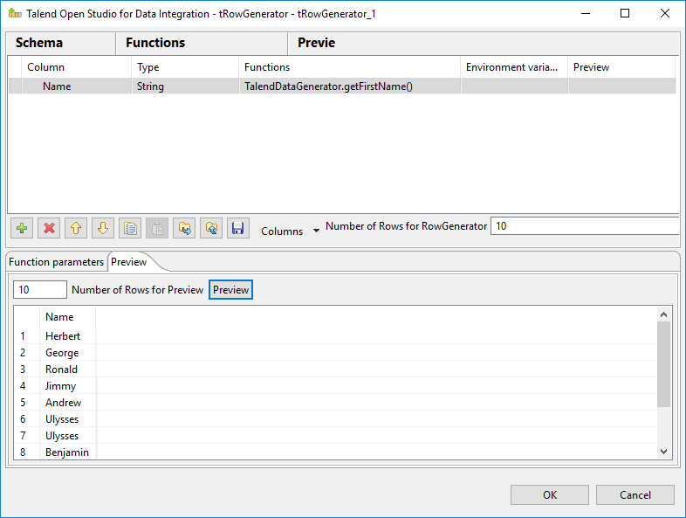

Step 5: Double click on ‘tDBOutput’ component and set properties as shown below.

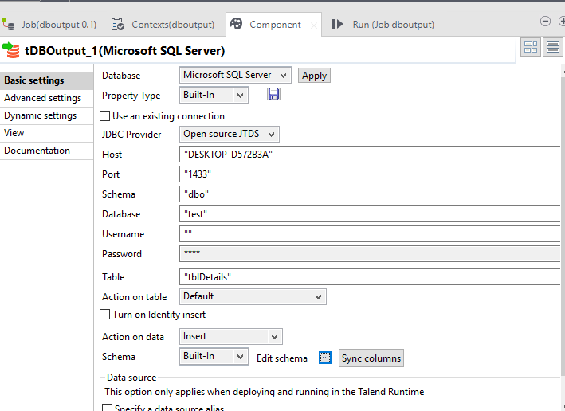

Step 6: Click on sync column and click on Edit schema.

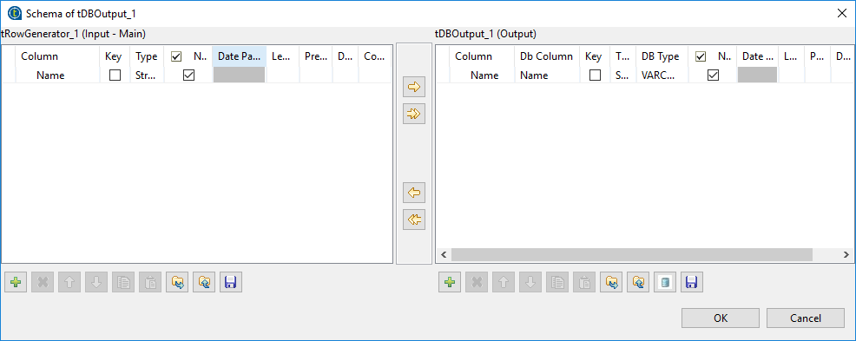

Step 7: Run the job.

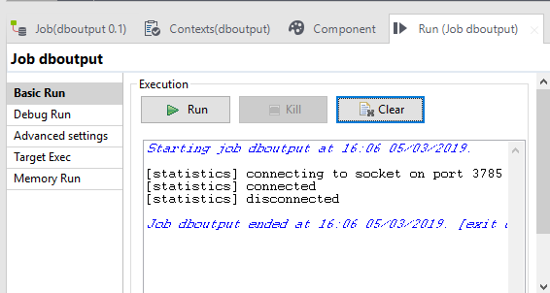

See the data in table present or not.

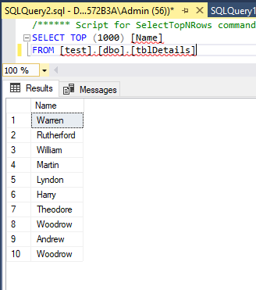

**Foreach component in Talend**

Step 1: Drag and Drop ‘tForeach’ and ‘tJava’ component in workspace.

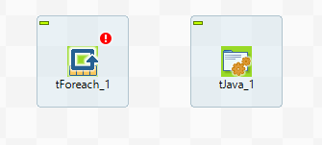

Step 2: Double click on ‘tForeach’.

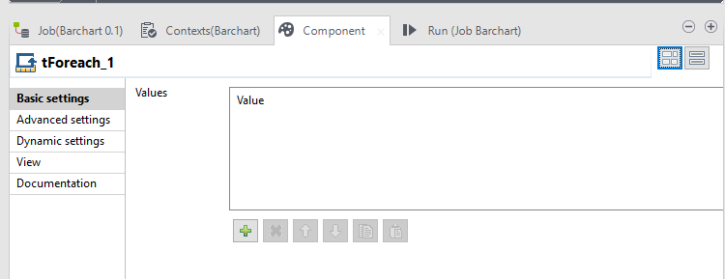

Step 3: Click on plus sign then add values in to the list.

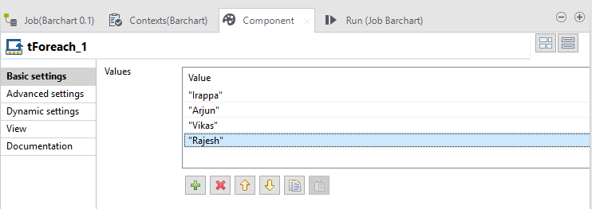

Step 4: Right click on ‘tForeach’ component and select row option then select iterate and drag on ‘tJava’ component and connecting to each other.

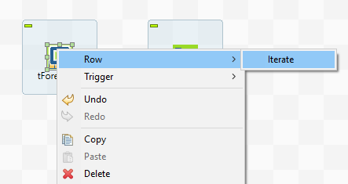

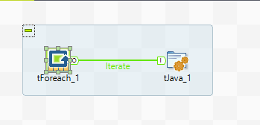

Step 5: Double click on ‘tJava’ component.

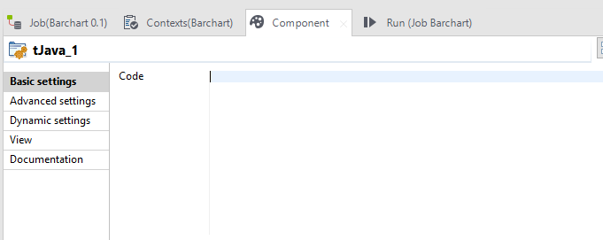

Step 6: Write the code as shown below.

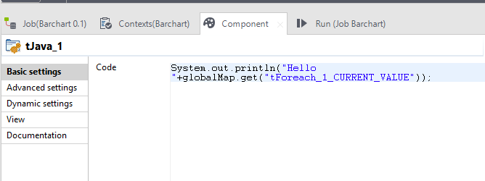

Step 7: Run the job.

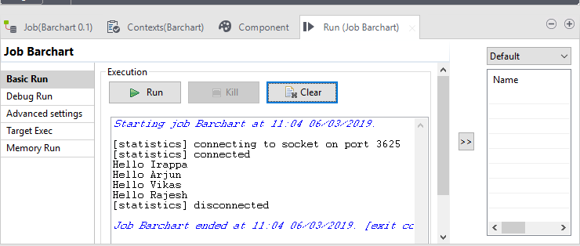

**Bar Chart in Talend**

Step 1: Drag and Drop ‘tPreJob’, ’tPostJob’, ‘tMap’, two ‘tFileDelete’, tBarChart’, two ‘tFileInputDelimited’ and three ‘tFileOutputDelimited’ into the workspace.

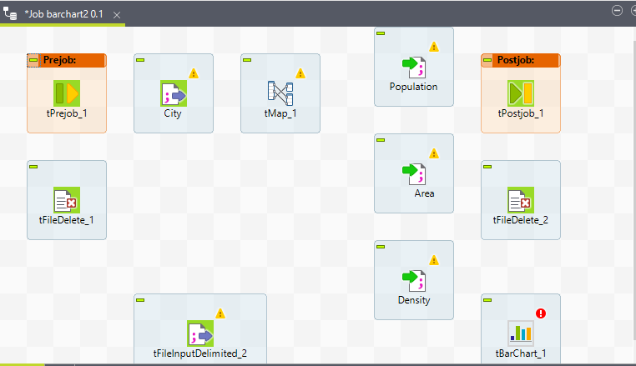

Step 2: Right click on ‘tPrejob’ component then select trigger option then select OnComponent option and connect with ‘tFileDelete_1’ component and also same steps are follows to the ‘tPostJob’ and ‘tFileDelete_2’ component.

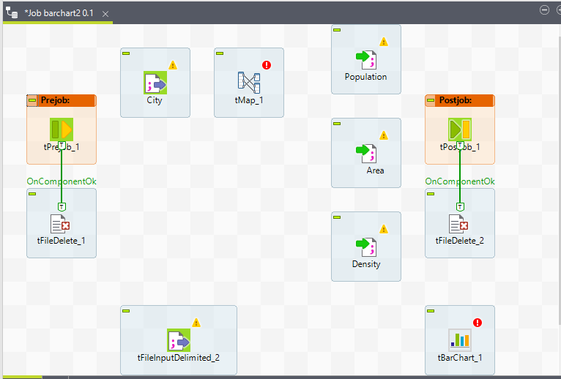

Step 3: Connect ‘City’ input file to ‘tMap’ component. Right click on city component then select row option then select main option.

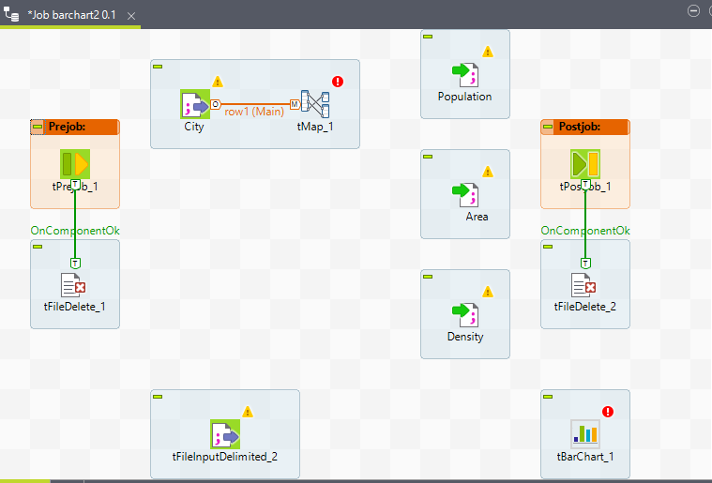

Step 4: Connect ‘tMap’ to ‘Population’ output file component. Right click on city component then select row option then select new output (main) option. Same for ‘Area’ and ‘Density’ output file. Give name to link.

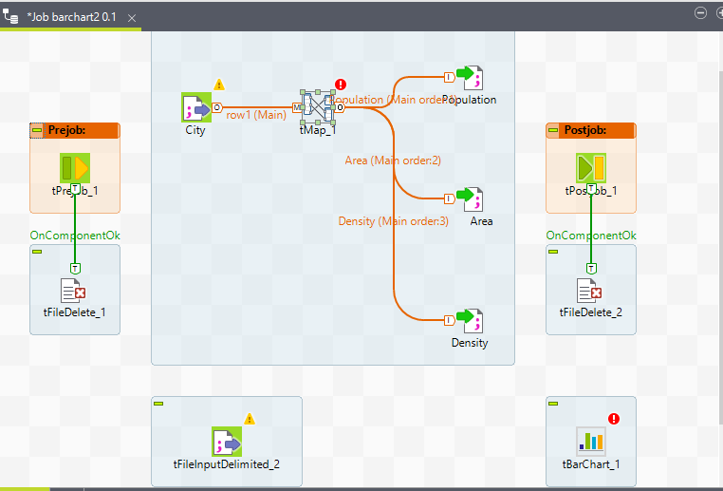

Step 5: Connect ‘tFileInputDelimited_2’ to ‘tBarChart’ component. Right click on ‘tFileInputDelimited_2’ component then select row option then select main option.

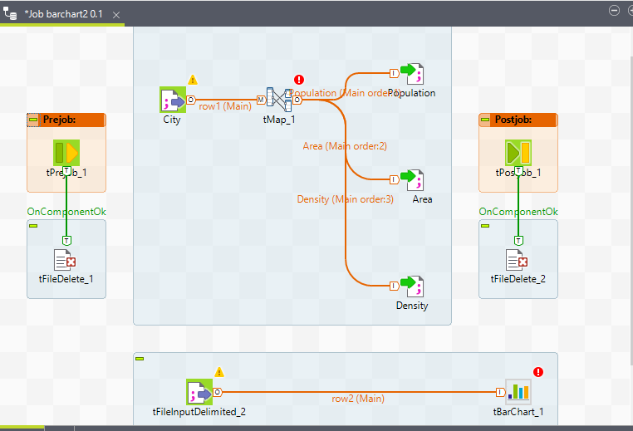

Step 6: Connect ‘City’ input file to ‘tFileInputDelimited_2’ component. Right click on ‘City’ component then select trigger option then select On SubJob Ok option.

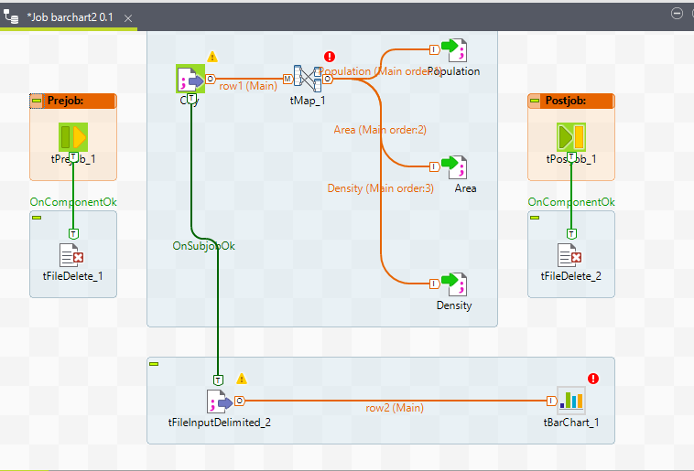

Step 7: Double click on ‘City’ file then browse the file and set the other properties.

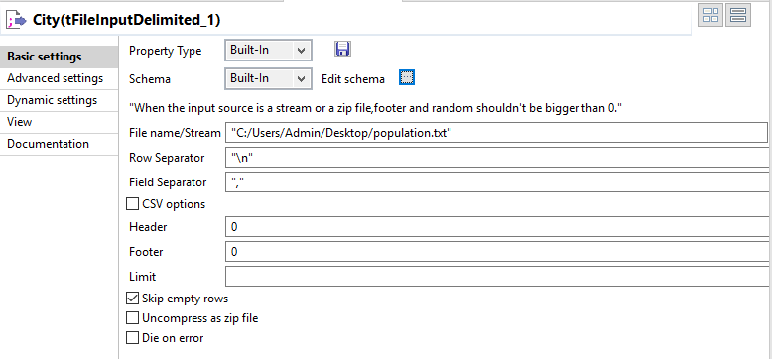

Step 8: Edit schema and add columns.

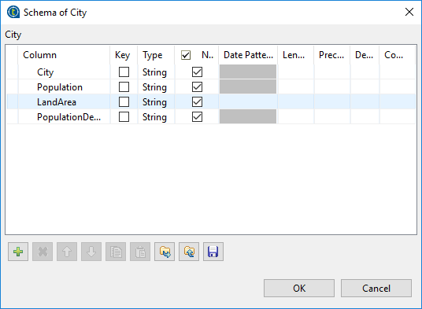

Step 9: Double click on ‘tMap’ component and drag and drop columns as shown below. Click on ok.

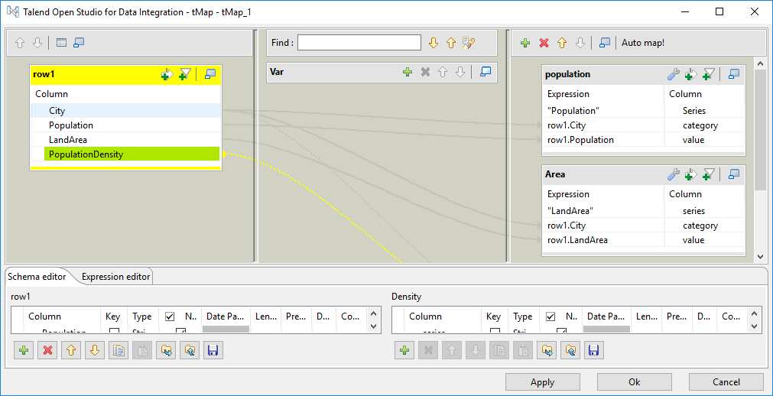

Step 10: Double click on ‘Population’ output file and set properties as shown below.

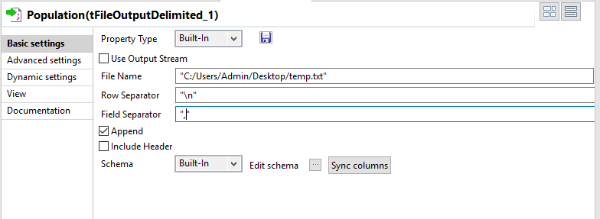

Step 11: Double click on ‘Area’ output file and set properties as shown below.

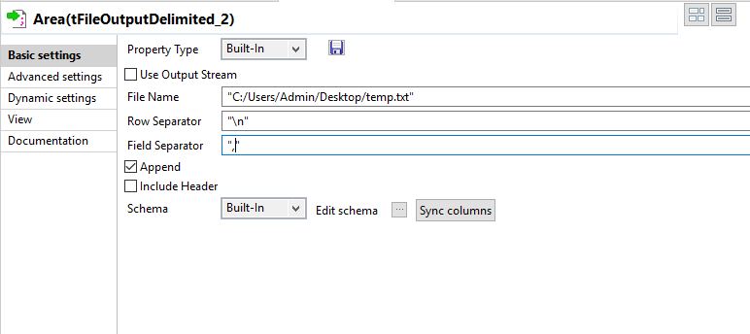

Step 12: Double click on ‘Density’ output file and set properties as shown below.

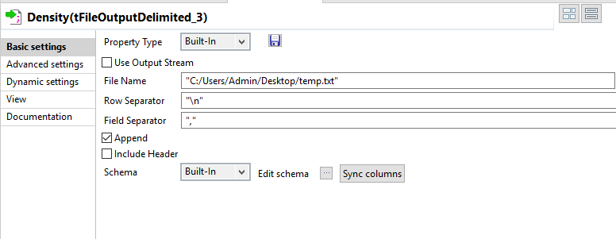

Step 13: Double click on ‘tFileInputDelimited_2’ component and set properties.

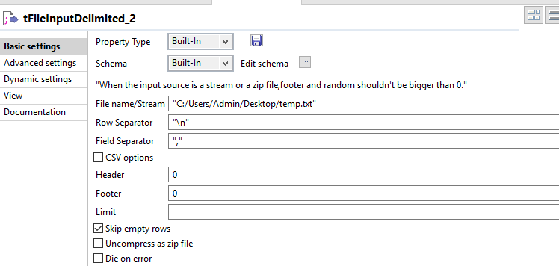

Step 14: Edit schema and add columns.

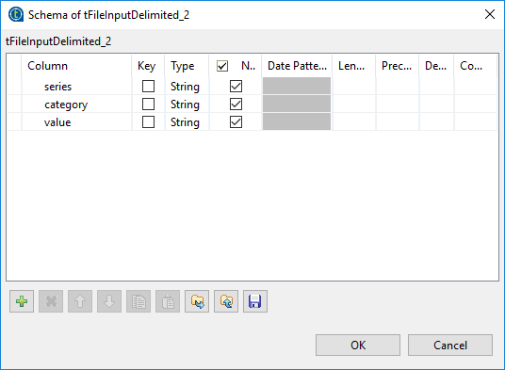

Step 15: Double click on ‘tBarChart’ and set properties as shown in below.

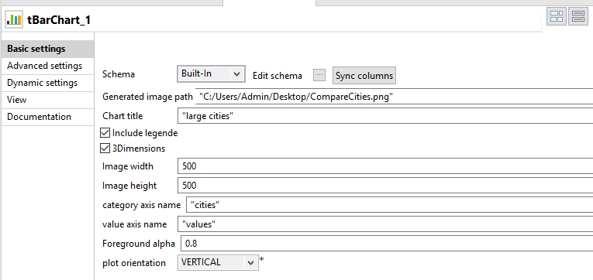

Step 16: Click on ‘sync columns’ and edit schema.

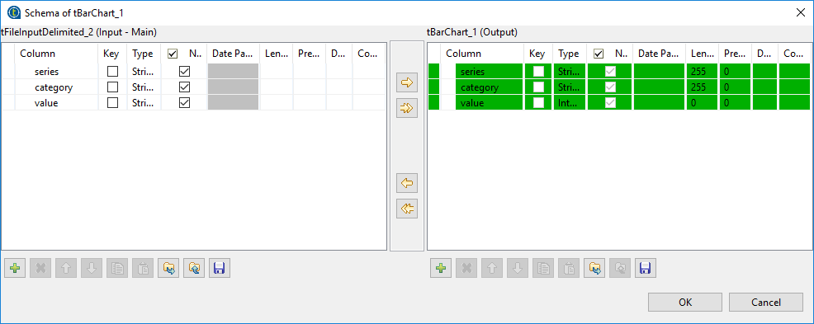

Step 17: click on arrow.

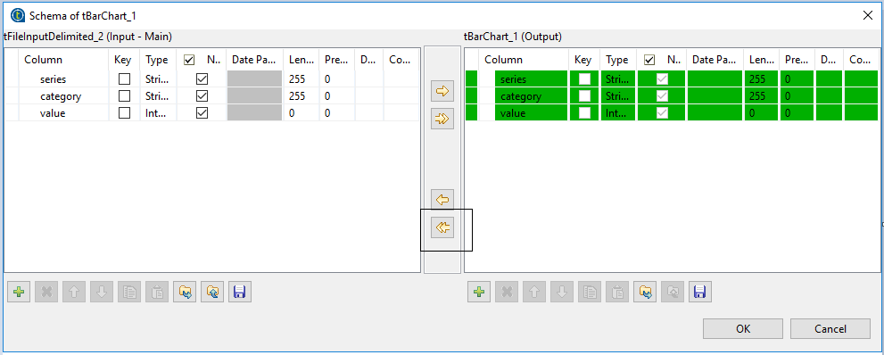

Step 18: Double click on ‘tFileDelete_1’ and browse the file.

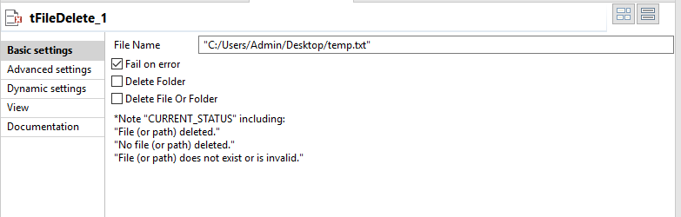

Step 19: Double click on ‘tFileDelete_2’ and browse the file.

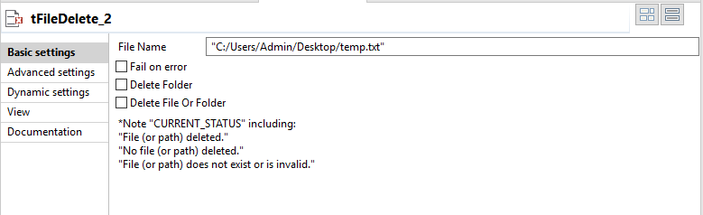

Step 20: Run the job.

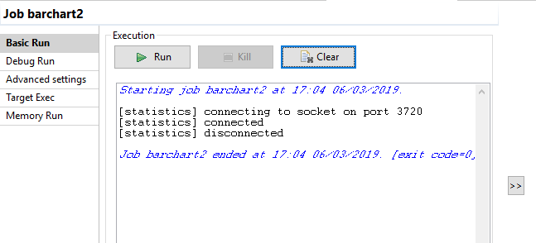

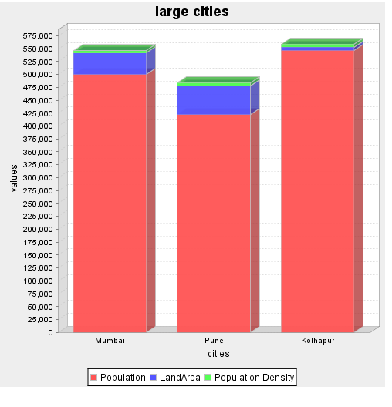

**Line Chart in Talend**

Step 1: Drag and Drop two ‘tDelete’, two ‘tFileInputDelimited’, ‘tMap’, ‘tLineChart’ and three ‘tFileOutputDelimited’ components in the design workspace.

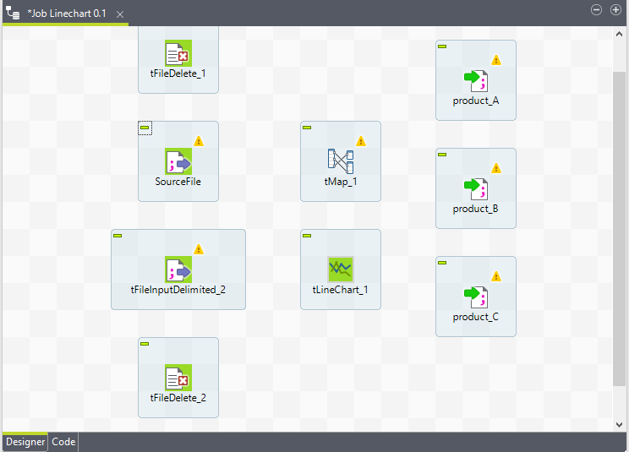

Step 2: Connect the ‘SourceFile’ input file to ‘tMap’ component. Right click on ‘SourceFile’ then select row option then select main option.

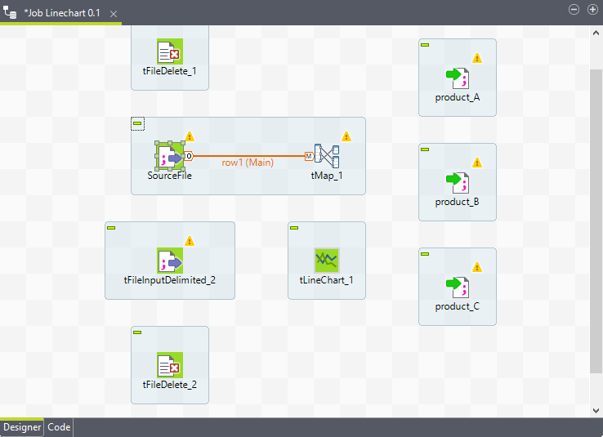

Step 3: Connect the ‘tMap’ to ‘product_A’ component. Right click on ‘tMap’ and select row option then select new ouput (main) option.Same step is follow for ‘product_B’ and ‘product_C’.

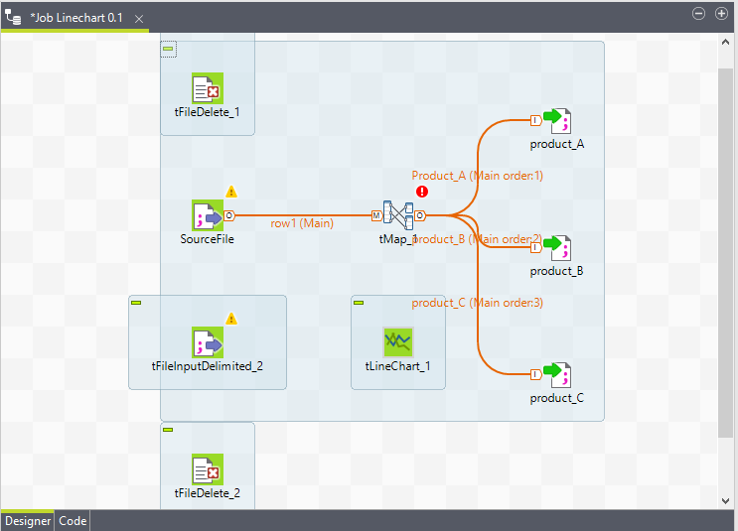

Step 4: Connect the ‘tFileInputDelimited_2’ to ‘tLineChart’. Right click on ‘tFileInputDelimited_2’ component and select row option then select main option and click on yes button.

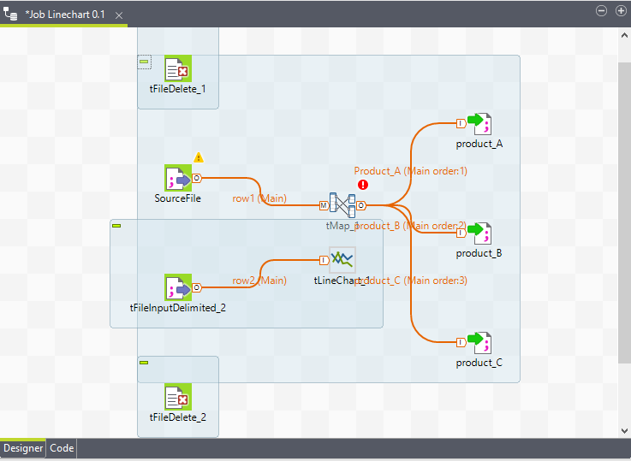

Step 5: Connect the ‘SourceFile’ to ‘tFileInputDelimited’ component. Right click on ‘SourceFile’ and select trigger option then select OnSubJobOk option.

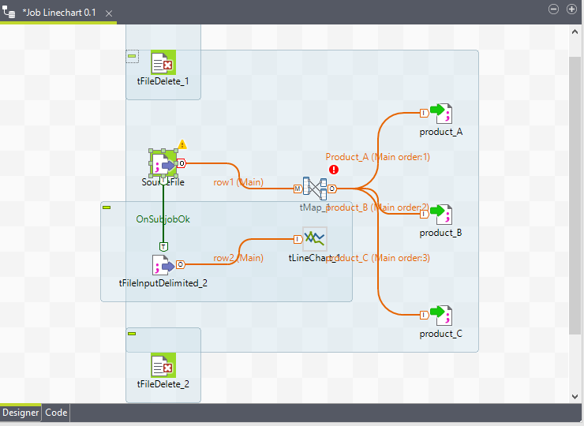

Step 6: Connect the ‘tFileDelete_1’ to ‘SourceFile’ input file component. Right click on ‘tFileDelete’ and select trigger option then select OnSubJobOk option.

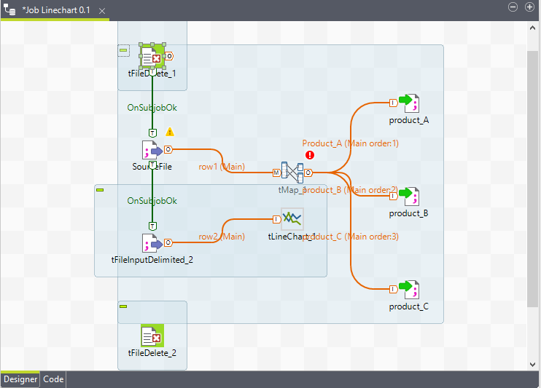

Step 7: Connect the ‘tFileInputDelimited_2’ to ‘tFileDelete_2’component. Right click on ‘tFileInputDelimited_2’ and select trigger option then select OnSubJobOk option.

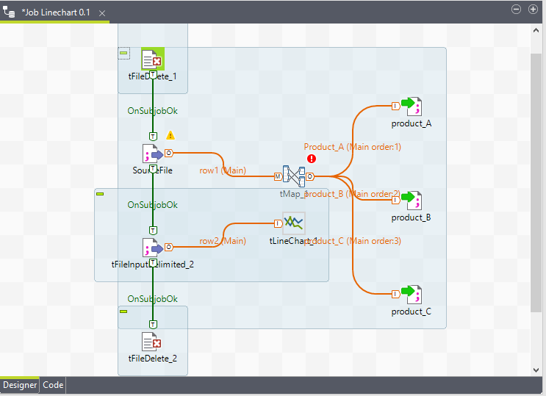

Step 8: Double click on ‘SourceFile’ and browse the file then set other properties.

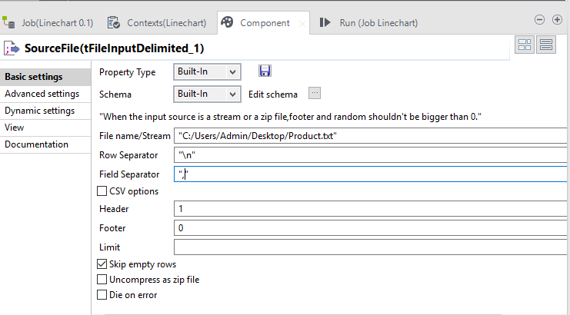

Step 9: Click on Edit Schema and add columns.

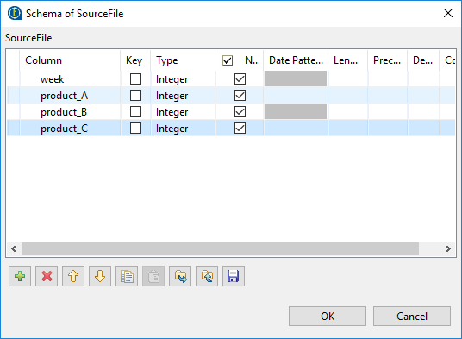

Step 10: Double click on ‘tMap’ component and columns on right hand side section as shown below.

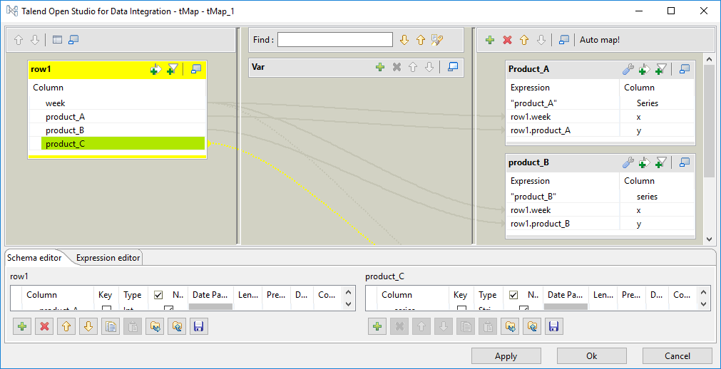

Step 11: Double click on ‘product_A’ file and set properties as shown below.

Same steps are used to ‘product_B’ and ‘product_C’ file.

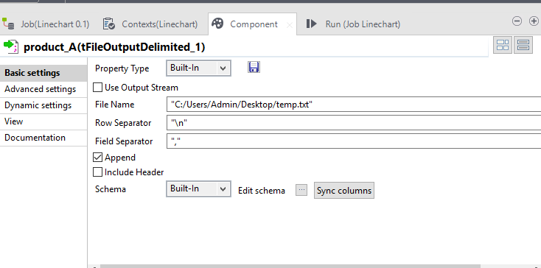

Step 12: Double click on ‘tfileInputDemilited_2’ component and set the properties.

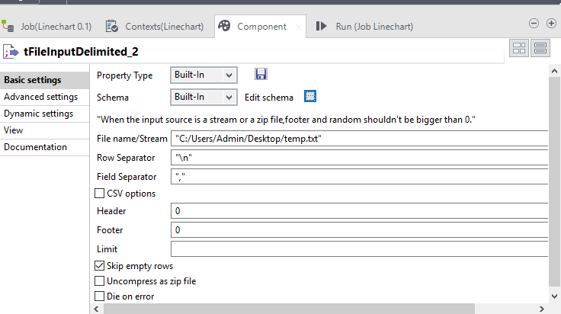

Step 13: Double click on ‘tLineChart’ component and set properties.

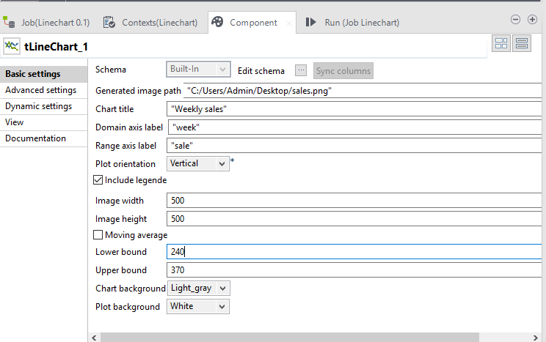

Step 14: Click on Edit Schema.

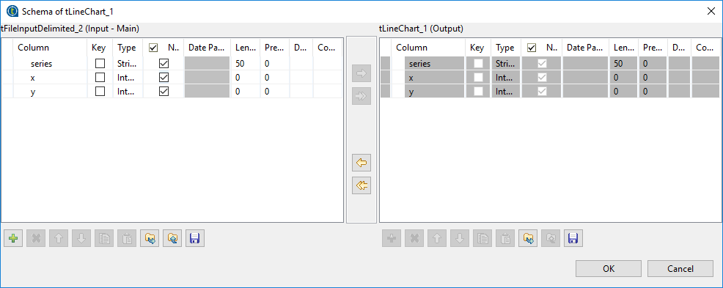

Step 15: Double click on ‘tFileDelete_1’ and set properties.

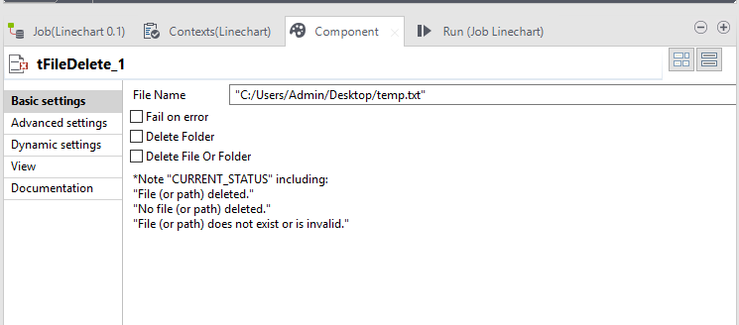

Step 16: Double click on ‘tFileDelete_2’ and set properties.

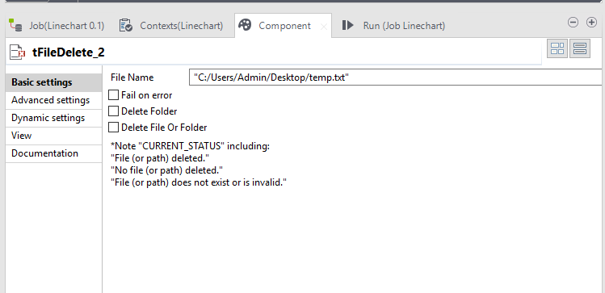

Step 17: Run the job.

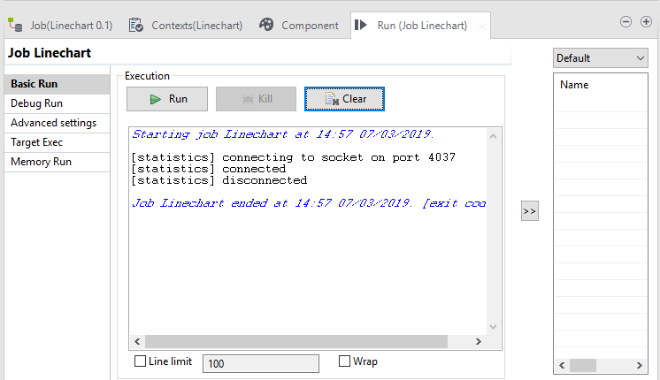

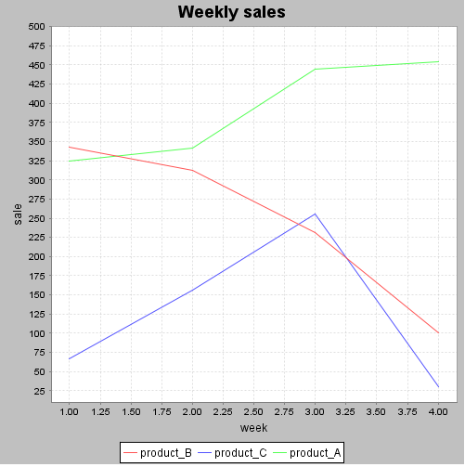

**Copies file one location to another location in Talend**

Step 1: Drag and Drop ‘tFileList’ and ‘tFileCopy’ component in to workspace.

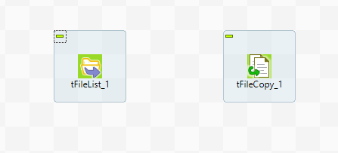

Step 2: Connect the ‘tFileList’ and ‘tFileCopy’ component each other. Right click on ‘tFileList’ select row option then select iterate option.

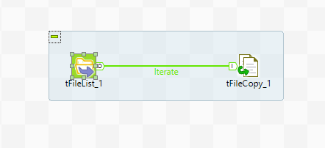

Step 3: I have create one folder as name ‘CopyFile’ and one file as name ‘product’.

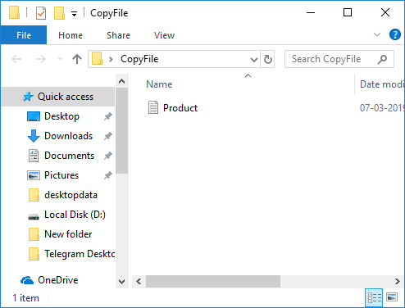

Step 4: I have created one folder in Drive D as name ‘Copy’.

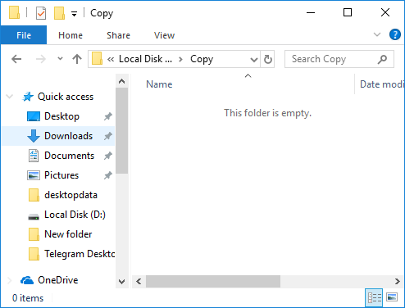

Step 5: Double click on ‘tFileList’ component and set the properties.

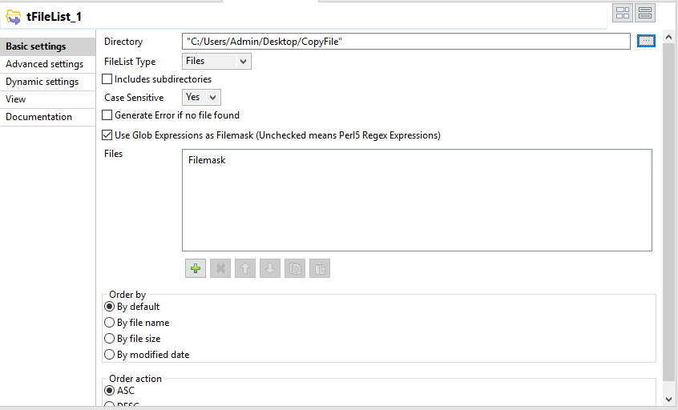

Step 6: Double click on ‘tFileCopy’ component and set the properties.

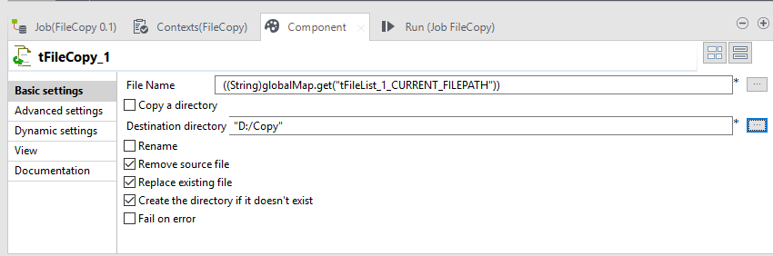

Step 7: Run the job.

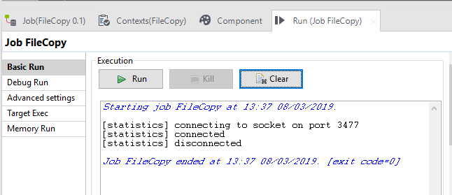

Before running job in Copy File folder

After running job Copy File Folder

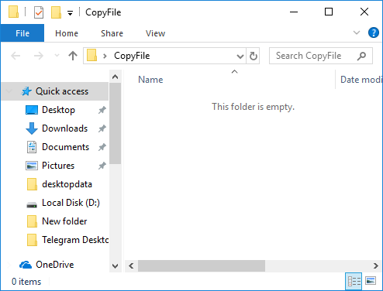

Before running job in Copy folder



After running job in Copy folder

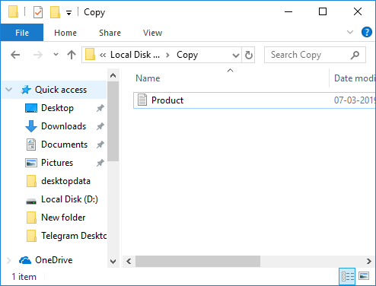

In the Copy file folder file not shows because I have select remove source file option in ‘tFileCopy’ component.